Ternary EuMg_{5+x}-type structures: Challenges in refining channel occupancies

M. Otteny, K. Köhler, M. Wendorff, C. Röhr

Institut für Anorganische und Analytische Chemie, Albert-Ludwigs-Universität Freiburg

markus.otteny@ac.uni-freiburg.de
The synthesis of polar intermetallic compounds and their structural chemistry is a key focus of our research. For the composition of approximately 1:5, the EuMg_{5+x} structure type, besides the very common CaCu₅-type, also occurs quite frequently. As indicated by the "x" in the eponymous compound, the exact number of atoms in the unit cell can vary [1], leading to challenges in structure refinement. In this work, we provide a summary of our findings on this structure type, based on studies of the ternary systems A–M–M’ (A = Ca, Sr, Ba; M = Mg, Zn; M’ = Zn, Cd, In) [2].
In the EuMg_{5+x}-type structure of Ba₃Mg_{5.2}Cd_{10.8} (P6₃/mmc, a=1023.10(5), c=1082.63(5) pm), the A atoms are arranged in rings of three, filling the voids within a topologically close-packed (t.c.p.) network of M atoms. The latter network is formed by vertex-sharing double tetrahedral stars (Fig. 1, red) leaving empty channels along [001]. The electron density distribution within these channels, which varies from compound to compound and even along an M:M’ phase width [e.g. in Ca(Mg_{y}Zn_{1-y})_{5+x} (y = 0.1 - 0.9)], gives rise to many questions regarding the atomic distribution and it's crystal-chemical interpretation [3].
We describe the channels as strings of corner connected cubes. These cubes are also part of the M network. In the investigated systems the filling of these cubes varies leading to different models for the overall structure. For Zn containing compounds Zn₂ dumbbells can be observed. In the Sr–Mg–In system additional reflexes can be observed which could be indexed with a rhombohedral unit cell
(P6₃/mmc → P31c → R3c, a = 1775.97(8), c = 3181.12(13) pm, Fig. 1). In this superstructure every third ‘cube’ is empty and heavily squeezed (Fig. 1, aquamarine), resembling less a cube and more a cluster consisting of six tetrahedra which share a common edge. Therewith, this structure motif fits the t.c.p. principle again.

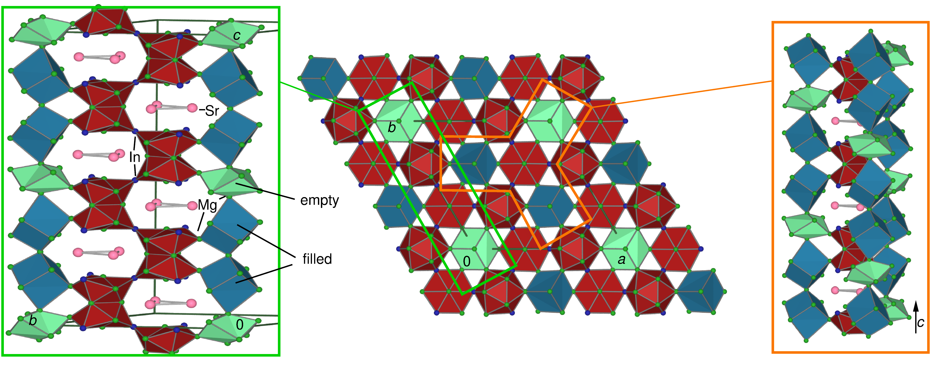
Figure 1. Structure of Sr₃Mg_{12.5}In_{3.1}, a superstructure of the EuMg_{5+x}-type.

[1] Mühlpfordt, W. (1997) Z. Anorg. Allg. Chem. 623, 985-989.

[2] Köhler, K. (2022) PhD thesis, University of Freiburg; K. Köhler, C. Röhr. (2019) Acta Cryst. A75, 424.

[3] Fredrickson, R. T., Fredrickson, D. C. (2023). Acta Cryst. B79, 320-329.

