# Kick starting the Scandinavian Crystallography Service

## K. E. Christensen1,2, L. Krause1,2

### 1Department of Chemistry, Aarhus University, Aarhus, Denmark, 2MAX IV Laboratory, Lund University, Lund, Sweden

### [kechristensen@chem.au.dk](mailto:kechristensen@chem.au.dk) or [kirsten.christensen@maxiv.lu.se](mailto:kirsten.christensen@maxiv.lu.se)

Single crystal X-ray diffraction is the preferred technique to solve the atomic structure of a crystalline material. Today, it is a routine technique in many research laboratories, however, the limited flux, spectral purity and focusing ability of a lab-source severely limits the size and quality of the crystals that can be measured. Moreover, many materials do not grow crystals that are large enough to be studied by this technique. Synchrotrons can close this gap; however, they are not commonly used for routine small molecule crystallography due to the required additional technical expertise and long lead times in the proposal-based access policy.

The Scandinavian Crystallography Service (SCS) seeks to remove this barrier and establish a point-of-entry for service crystallography inspired by the successful UK National Crystallography Service. It covers fundamental materials research as well as deep strategic studies of commercial interest and provides new synergies, scientific projects and structural insights using single crystal X-ray diffraction. The target demographic is any commercial or academic user, independent of the level of crystallographic experience.

SCS has access to SINCRYS, BioMAX and MicroMAX beamlines. This allows for data collections on a wide range of compounds with smaller unit cells that can benefit to be measured with higher intensity. Depending on user experience with X-ray single crystal diffraction there are different access levels such as ‘Data Only’, and ‘Full Structure analysis’. Samples are submitted by users throughout Scandinavia and further abroad.

SCS aims to offer easy, paid-for access to collect data on single crystals. For more details, please contact us on scs@maxiv.lu.se

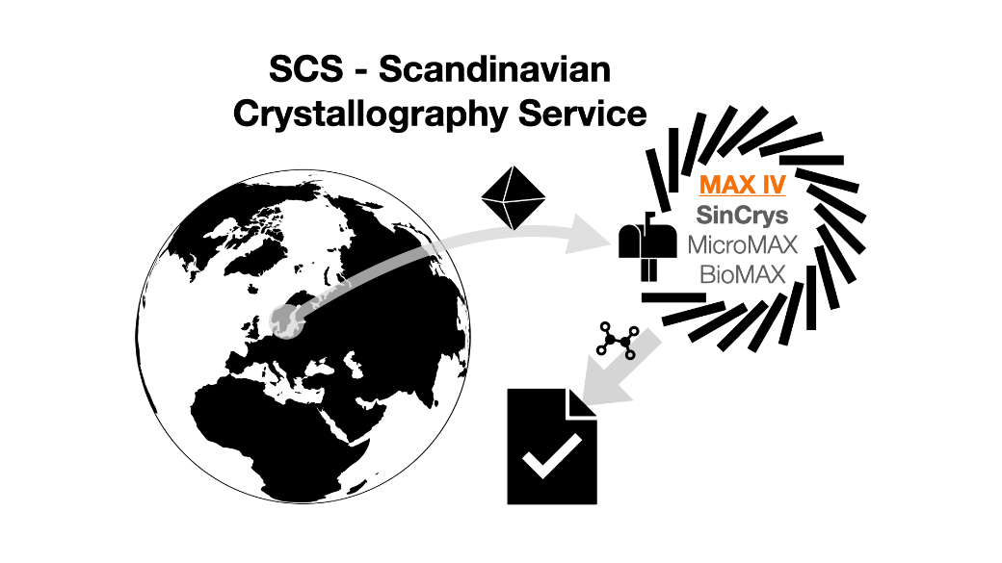

###### **Figure 1**. SCS is based in Sweden at MAX IV Laboratory but supports users throughout Scandinavia and further abroad.

We would like to acknowledge Novo Nordisk Foundation and National Committee for Research Infrastructure in Denmark for funding.