Cocrystals of 1,8-diacetylpyrene with TCNB:
their relative stability, mechanical and photoluminescent properties

J. Krzeszczakowska¹, A.Makal¹

¹University of Warsaw, Faculty of Chemistry, Biological and Chemical Research Centre, Warsaw, Poland

j.krzeszczakowska@uw.edu.pl
Cocrystallization, as a means to obtain cost-effective functional materials with predictable properties from neutral molecular building blocks has found applications in production of luminescent materials [1]. Comparative study of cocrystals with various substrate ratios should provide an opportunity to investigate materials containing different packing motifs. We present a study of three distinct cocrystals of 1,8-diacetyl-pyrene (bAP) with 1,2,4,5-tetra-cyano-benzene (TCNB) obtained by crystallization from various solvents and their structures determined by single-crystal X-ray diffraction combined with Hirshfeld Atom Refinement (HAR) [2]. The new crystalline materials vary in the bAP:TCNB ratios, molecular packing and symmetry. A common structural motif, accounting for noticeable anisotropy of thermal expansion coefficients and uniform orange photoluminescence in these cocrystals is an infinite ROD consisting of alternating bAP and TCNB moieties π-stacked in 1:1 or 2:1 ratios. Face-to-face π-stacking is one of the dominant interactions.

The unique propensity for crystal jumping in the cocrystals with 1:1 bAP:TCNB ratio has been tentatively ascribed to the presence of corrugated tapes of bAP and TCNB molecules linked with C—H … O and C—H … N interactions and the flattening of these tapes as a result of increased tape's thermal vibrations. Anisotropic Displacement Parameters obtained for this cocrystals from HAR and periodic calculations utilizing CASTEP[3] and CRYSTAL[4] programme are compared.

Periodic DFT calculations allowed us to predict relative stability of these cocrystals and their interconversion at 0K and room temperatures, respectively. NoMoRe [5] programe refining frequences obtained from periodic DFT calculations against experimental data empower deriving the thermodynamic properties and establishing elative stability of the cocrystals .

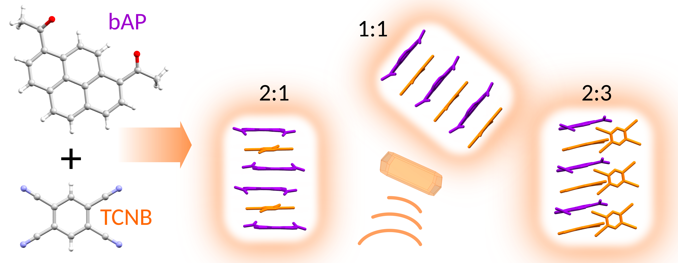
Figure 1. New cocrystals of 1,8-diacetyl-pyrene (bAP) with 1,2,4,5-tetra-cyano-benzene (TCNB)

[1] .Sun, H.; Peng, J.; Zhao, K.; Usman, R.; Khan, A.; Wang, M. (2017) Cryst Growth Des., 17, 6684–6691

[2] Jayatilaka, D. & Dittrich, B. (2008). Acta Cryst. A 64,(3), 383-393

[3] Clark, S. J., Segall, M. D., Pickard, C. J., Hasnip, P. J., Probert, M. I. J., Refson, K., Payne M. C. Z. fur Krist.- Cryst. Mater. (2005) 220, 567–570
[4] Dovesi, Saunders, Roetti, Orlando, Zicovich-Wilson, Pascale, Doll, Harrison, Bush, D’Arco, Lunell, Causà, Noël, Maschio,Erba, Casassa, Rerat, Michel (2017), CRYSTAL17 User’s Manual, Torino
[5] Hoser, A. A. & Madsen, A. Ø. (2016). Acta Cryst. A , 72, (2), 206-214
We acknowledge financial support from National Science Foundation grant OPUS 2021/41/B/ST4/02760 and Poland’s high-performance computing infrastructure PLGrid for computational resources, grant PLG/2024/017316. The successive assistance of Liliana Siewierska iduring crystallization and in single crystal data collection is greatly appreciated.

