Multi-level protein dynamics orchestrates S-adenosyl-L-homocysteine hydrolase catalysis

K. Brzezinski¹, K. Wozniak¹, P. H. Malecki¹, M. Gawel¹, M. Stepniewska¹

¹Department of Structural Biology of Prokaryotic Organisms, Institute of Bioorganic Chemistry, Polish Academy of Sciences, Z. Noskowskiego St. 12/14, 61-704 Poznan, Poland

kbrzezinski@ibch.poznan.pl
Protein dynamics is of fundamental importance to protein function, influencing enzymes' structural integrity and catalytic efficiency. A striking example of such a phenomenon is S-adenosyl-L-homocysteine hydrolase (SAHase), an essential regulator of cellular methylations, which controls cellular S-adenosyl-L-homocysteine (SAH) concentration [1]. SAHases form a homotetramer, with each subunit folded into three domains [2]. Two principal domains (substrate- and cofactor-binding) are connected by a hinge element. During the hydrolytic cycle, subunits oscillate between two conformational states: closed (substrate-bound) and open (with a product released). However, the role of regions of the substrate-binding pocket in regulating SAHase dynamics has yet to be fully explained. Moreover, a mode of conformational changes of subunits within the tetramer during the catalytic cycle has been elusive.
To understand in a more detailed manner the structure and dynamics of SAHases, we performed integrative structural biology studies, including, among others, crystallographic and Cryo-EM Single-Particle Analyses (SPA) of bacterial SAHase from Pseudomonas aeruginosa. Our results reveal the high complexity of conformational changes of the enzyme during the catalytic cycle and the crucial role of protein dynamics in SAHase activity. In particular, we demonstrated the importance of amino acid residues located in two poles of the substrate-binding pocket, which are not directly related to the catalytic reaction (Fig.1). The first pole is involved in the coordination of K⁺ ion, stabilizing the enzyme-substrate complex in the closed conformation for a time interval required to complete the catalytic cycle. The formation of the K⁺ coordination site induces order and accurate positioning of a key Q65 residue to promote the binding of the substrate [3]. The second pole is a "molecular gate" formed by a conserved pair of H323-F324 residues. It controls the accessibility of the active site from the solvent region and is involved in the removal of the product of the reaction. Both areas are involved in subunit oscillations and substrate binding (SAH) or product release (adenosine) during the catalytic cycle. Indeed, mutations within two poles of the substrate-binding pocket inactivate or significantly decrease (Q65A and Q65N) or inactivate (H323A and F324A) the enzyme activity and affect ligand binding. The significant flexibility of protein particles allowed us to analyze the tetramer's conformational heterogeneity and the enzyme's dynamics using Cryo-EM SPA. The results indicate that within the tetramer, only two subunits can bind a ligand (e.g., the substrate) simultaneously, rather than all four subunits.

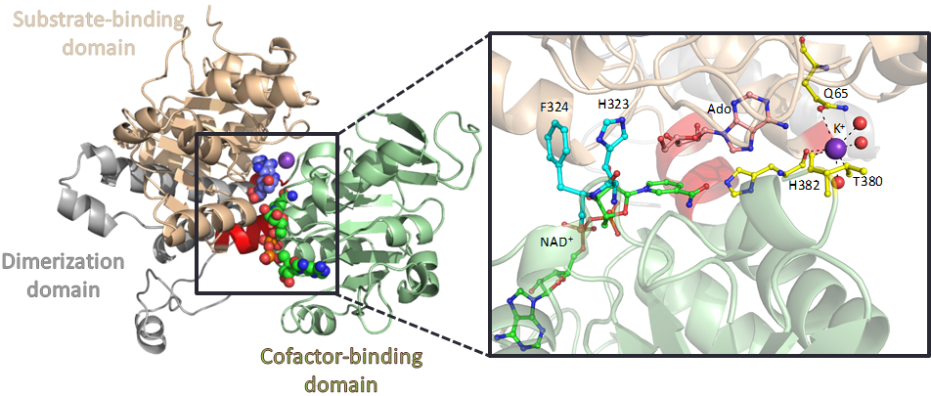

Figure 1. Two poles of the substrate-binding pocket are involved in ligand binding/removal and the subunit oscillations.

[1] Chiang, P. K. (1998). Pharmacol. Ther. 77, 115.

[2] Brzezinski, K. (2020). Biomolecules 10, 1682.

[3] Czyrko, J., Sliwiak, J., Imiolczyk, B., Gdaniec, Z., Jaskolski, M., Brzezinski, K. (2018). Sci. Rep. 8, 11334.
This work was funded by the National Science Centre, Poland: SONATA BIS 2018/30/E/NZ1/00729.

