**Polymorphism of fenamic acids and their salts**

**Marta S. Krawczyk1, Irena Majerz 2**

*1Faculty of Pharmacy, Department of Basic Chemical Sciences, Wroclaw Medical University, Borowska 211A, Wroclaw, 50-556, Poland*

*2Faculty of Pharmacy, Wroclaw Medical University, Borowska 211A, Wroclaw, 50-556, Poland*

*Email of communicating: marta.krawczyk@umw.edu.pl*

Fenamic acids blong to the subclass of non-steroidal anti-inflammatory drugs (NSAIDs) [1]. This group of drugs includes mefenamic, tolfenamic, fufenamic, meclofenamic acids and niflumic acid. 2-Anilinobenzoic acid, also called simply fenamic acid, is the parent compound for these acids, however, due to its high gastrointestinal side effects, it is not used as a drug. A review of the CSD database [2] has revealed that fenamic acids exhibit polymorphism. In particular, flufenamic and tolfenamic acids crystallize in many polymorphic forms [3,4]. The polymorphism of fenamic acids appears to be primarily caused by the rotation of phenyl rings around the nitrogen-carbon bonds. Consequently, their polymorphs differ not only in their molecular packing, which impacts hydrogen bonding networks and other weak interactions, but also in the spatial arrangement of the rings. In the search for new drugs with a broad spectrum of action, we have formed salts of fenamic acids with other medicinal substances and in the case of these compounds there is also the possibility of conformational polymorphism occurring. Similarly, the polymorphs of the fenamic acids salts differ in the interplanar angle [5, 6, 7] which causes differences in packing in the crystal. Conformational and packing analysis in the studied crystals of fenamates has been carried out with reference to the literature data.

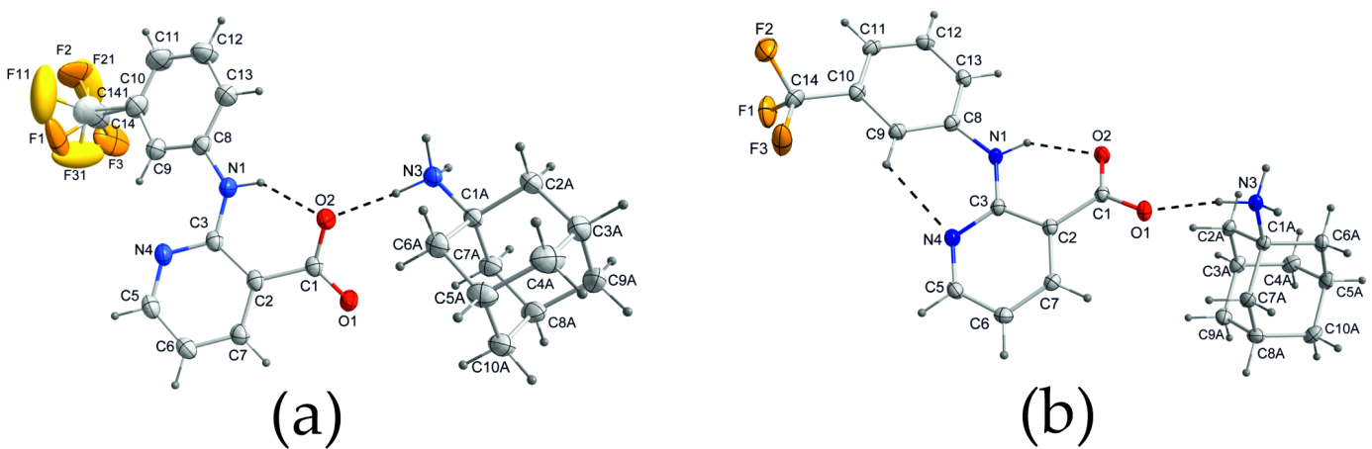

**Figure 1**. Molecular structures of (a) polymorph I and (b) polymorph II of amantadinium niflumate [6].

References:

[1] Díaz-González, F.; Sánchez-Madrid, F. (2015). *Eur. J. Immunol*., **45**(3), 679.

[2] C. R. Groom, C. R., Bruno, I. J., Lightfoot, M. P. & Ward, S. C. (2016) ) Acta Cryst. B**72**, 171.

[3] López-Mejías, V., Kampf, J.W. & Matzger, A. J. (2012). *J. Am. Chem. Soc*., **134**, 9872.

[4] Sacchi, P., Reutzel-Edens, S. M. & Cruz-Cabeza, A. J. (2021) *CrystEngComm*, **23**, 3636.

[5] Krawczyk, M. S. & Majerz, I. (2022) *Cryst. Growth Des*. **22**, 1554.

[6] Krawczyk, M. S., Krawczyk, M. K. & Majerz, I. (2023) *CrystEngComm*, **25**, 6748.

[7] Krawczyk, M. S., Krawczyk, M. K. & Majerz, I. (2025) Acta Cryst. B**81**, 92*.*