## Structural and conformational analysis of dimethyl, diethyl, and dipropyl sulfides under high pressure

## N. Sacharczuk1, A. Olejniczak1, A. Katrusiak1, V. Lavin2, M. Podsiadło1

### 1Faculty of Chemistry, Adam Mickiewicz University, Uniwersytetu Poznańskiego 8, Poznań, 61-614, Poland

### 2Departamento de Física, IUdEA and MALTA-Consilider Team, Universidad de La Laguna, Apartado de Correos 456, E-38200 San Cristóbal de La Laguna, Santa Cruz de Tenerife, Spain

### natsac@amu.edu.pl

Investigations of sulfur-containing organic compounds under high-pressure conditions have attracted significant interest due to their unique structural and electronic properties that emerge upon compression. Herein, we present a comprehensive structural and vibrational analysis of three alkyl sulfides: dimethyl sulfide (DMS), diethyl sulfide (DES), and dipropyl sulfide (DPS), studied using high-pressure X-ray diffraction (XRD) complemented by Raman spectroscopy.

Previous investigations revealed that DMS crystallizes in the triclinic space group *P͞*1 (phase α).[1] High-pressure Raman spectroscopy [2] reveals significant structural rearrangements under compression, with transitions identified at 1.30 GPa, 3.60–5.80 GPa, and 17.20 GPa. Our high-pressure XRD studies confirmed these findings and identified two previously unknown polymorphs: between 1.80 and 2.20 GPa, DMS crystallizes in the triclinic space group *P͞*1 (phase β), and beyond 2.80 GPa, it transitions into a monoclinic space group *P*21/*n* (phase γ), which persists up to 5.20 GPa. We also report the first crystal structures for DES and DPS under high-pressure conditions. DPS crystallizes in a monoclinic *Cc* space group at ambient pressure and low temperature, with a *gauche-gauche* (GG) conformation. Above 1.55 GPa, it transitions into a triclinic *P͞*1 space group with a *trans-gauche* (TG) conformation, demonstrating its flexibility in adapting molecular arrangements under pressure. Our research focused on the torsion angles involving the sulfur atom, which is why we defined the conformations using simplified TG and GG terminology, with torsion angles *τ*₁ and *τ*₂ representing rotations adjacent to the central C-S bond (CC-CSC-CC). See Figure 1.

Our results for DES show that the high-pressure solid form matches the low-temperature crystal structure, maintaining a stable   
*trans–trans* (TT) conformation across the studied pressure range, stabilizing the monoclinic *P*21/*n* space group. Raman spectra from both conditions showed consistent features.[3] These findings help deepen our understanding of sulfur-containing molecular materials and highlight high-pressure methods as valuable tools for exploring new crystal structures.

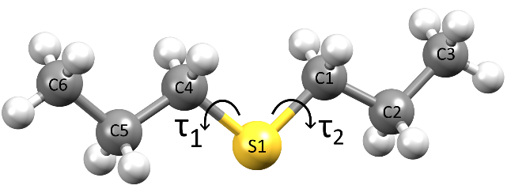

###### Figure 1. DPS with torsion angles τ₁ and τ₂. Torsion angles C6-C5-C4-S1 and C3-C2-C1-S1 were considered only in the *trans* conformation.

#### [1] Mitzel, N. W.; Losehand, U. Dimethyl-, Disilyl- and Digermylsulfide: Different Intermolecular Contacts in the Solid State. *Zeitschrift fur Naturforsch. - Sect. B J. Chem. Sci.* **2004**, *59* (6), 635–638

#### [2] Qin, Z., Zhan, X., Zhang, Q. High-Pressure Phases of a S-Based Compound: Dimethyl Sulfide. *J. Phys. Chem. A* **2017**, *121* (32), 5983–5990.

#### [3] Ohta, M.; Ogawa, Y.; Matsuura, H.; Harada, I.; Shimanouchi, T. Vibration Spectra and Rotational Isomerism of Chain Molecules. IV. Diethyl Sulfide, Ethyl Propyl Sulfide, and Butyl Methyl Sulfide. *Bull. Chem. Soc. Jpn.* **1977**, *50* (2), 380-390.

This study was supported by the National Science Centre (grant no. 2020/37/B/ST4/00982).