New co-crystals of piracetam with carboxylic acids: synthesis and structural studies

I. Bruchmann¹, L. Mazur¹

¹Institute of Chemical Sciences, Maria Curie-Sklodowska University, Pl. M. Curie-Skłodowskiej 2, 20-031 Lublin, Poland

E-mail: liliana.mazur@mail.umcs.pl
Co-crystals are attracting more and more attention as functional materials, in general, and as pharmaceutical solids in particular. Multicomponent crystals just like single-component solids can be polymorphic [1]. Furthermore, the total number of crystal forms for a given molecule available via co-crystallization can be increased through stoichiometric variations and solvates formation [2].
The aim of this study was to examine the possibility of co-crystal formation between piracetam (PC) - an old nootropic drug [3] and mesaconic (MES), salicylic (SAL) and 3,5-dihydroxybenzoic (DHB) acids. Particular attention was paid to adducts propensity to polymorphism and solvates formation. The other goal was to investigate the influence of experimental conditions, such as synthesis method, stoichiometric ratio of the components or polarity of the solvent used on the resulting solids. This was accomplished by applying a wide spectrum of co-crystal screening techniques; e.g. solution crystallization, slurring, neat grinding (NG), liquid-assisted grinding (LAG). The single crystal X-ray diffraction analysis, supported by the powder X-ray diffraction and the IR spectroscopy were used to study the molecular structure, composition and synthon preferences in the obtained multicomponent crystals.
The studies confirmed that piracetam can form stable co-crystals with all selected carboxylic acids. Moreover, as in the case of the pure drug [4] they can be polymorphic. Depending on the polarity of the solvent used for solution crystallization and milling, two polymorphs of PC-MES (1:1) and two polymorphs of PC-SAL (1:1) co-crystals were obtained (Fig. 1). In turn, PC-DHB (1:1) is available in its unsolvated form and as a solvate with 1,4-dioxane. All detected multicomponent crystal forms are accessible via solution crystallization, some via NG or LAG, however, solution crystallization and LAG, using the same solvent can lead to different outcomes.

PC-SAL (triclinic, P-1) | PC-SAL (monoclinic, P2₁/c)
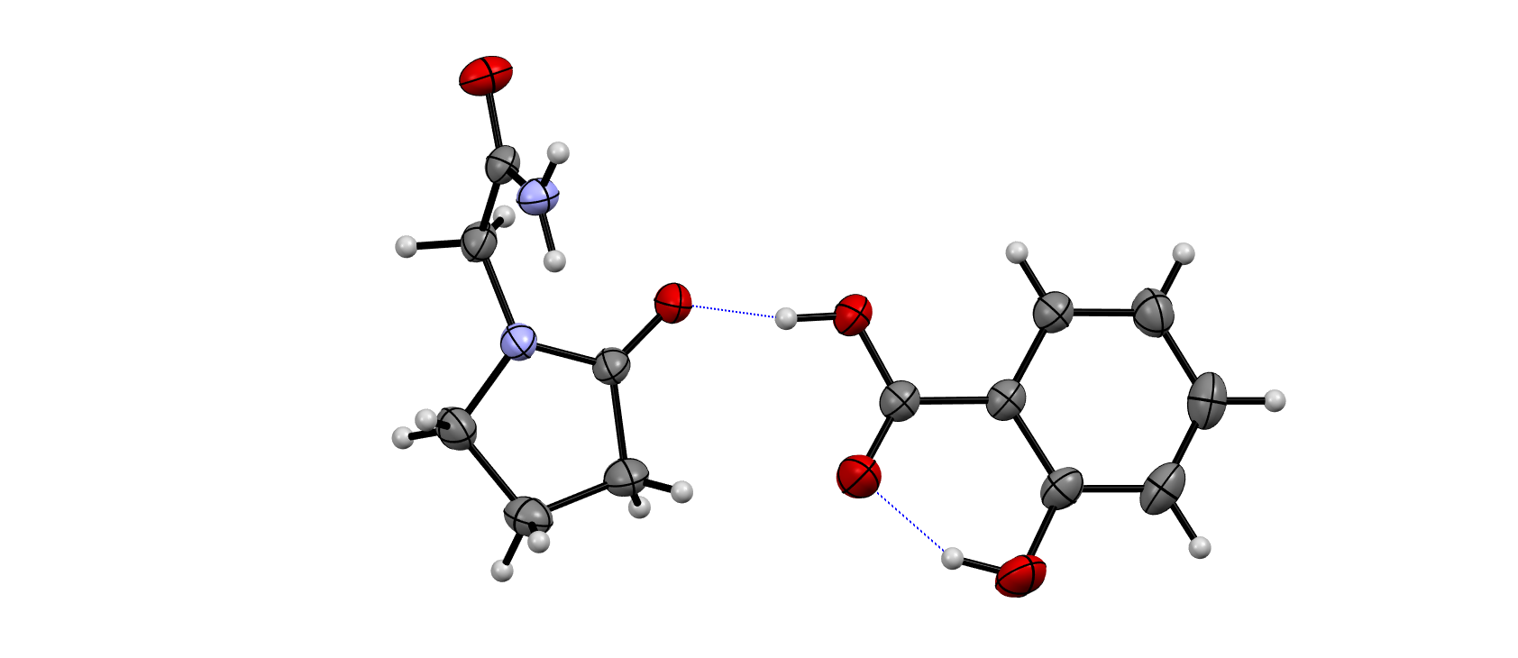 | 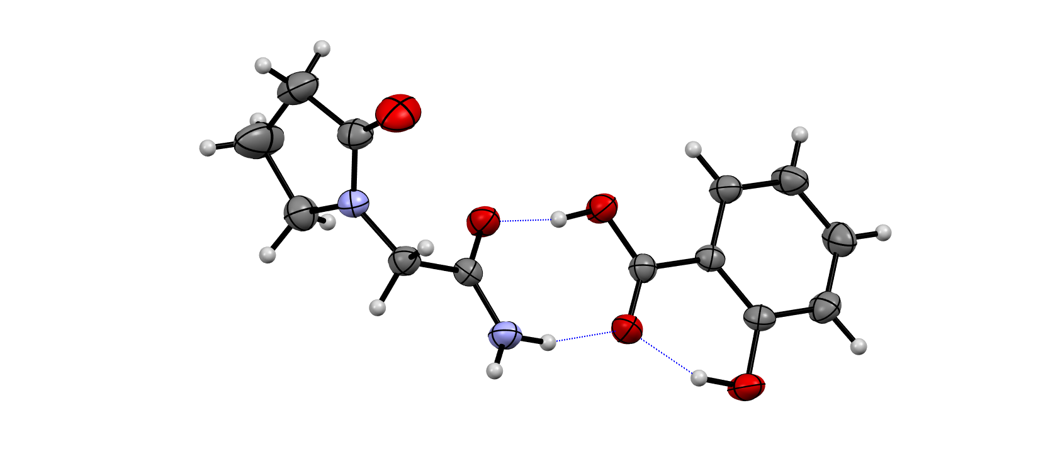

Figure 1. Asymmetric unit in crystals of the polymorphs of PC-SAL (1:1).

[1] Aitipamula, S., Chow, P. S., Tan, R. B. H. (2014). CrystEngComm, 16, 3451.
[2] Saikia, B., Pathak, D., Sarma, B. (2021). CrystEngComm, 23, 4583.
[3] Winblad B. (2005). CNS Drug Reviews, 11(2), 169.
[4] Upadhyay P. P., Mishra, M. K., Ramamurty, U., Bond, A. D. (2021). CrystEngComm, 23, 1226.

