# Modulated structure of the composite (Ca,Yb)0.83CuO2

## O. Zaremba, V. Lesnianska, L. Akselrud, R. Gladyshevskii

### Department of Inorganic Chemistry, Ivan Franko National University of Lviv, Kyryla i Mefodiya St. 6, 79005 Lviv, Ukraine,

### oksana.zaremba@lnu.edu.ua

The oxygen-containing systems *A*–*R*–Cu–O (*A* = alkaline-earth, *R* = rare-earth metal) have been intensively studied since the discovery of high-temperature superconductivity in the Ba2YCu3O7 compound. However, these investigations continue to be relevant today. The literature provides insights into investigations of component interactions in numerous systems with different alkaline and rare earths, except for systems with radioactive promethium. We did not find any data for calcium-containing systems with cerium and ytterbium, and this study presents a precise determination of the modulated crystal structure of the (Ca,Yb)0.83CuO2 cuprate, discovered by us.

A polycrystalline sample of nominal composition Ca0.53Yb0.3CuO2 was synthesized by solid-state reaction, starting from high-purity powders of CaCO3, Yb2O3, and CuO. The reagents were mixed and ground in an agate mortal for 10 minutes manually. Then the mixture was heated in a corundum crucible, using a muffle furnace (1000°C, 24 h, in air), in order to decompose the carbonate. After that, the obtained mixture was re-ground, pressed into a pellet and sintered in the same way. Finally, the sample was again ground, re-pressed and additionally annealed for one week. The composition was confirmed by SEM and EDX analysis (Tescan Vega 3 LMU, Oxford Instruments energy-dispersive X-ray analyser, Aztec ONE system). X-ray diffraction data were collected on a Proto AXRD Benchtop diffractometer (Cu *K*α radiation). The structure was determined using the WinCSD software package [1] for crystallographic calculations.

Under the conditions of our experiment, a single-phase polycrystalline sample was obtained. We determined the crystal structure of the quasi one-dimensional cuprate (Ca0.53(1)Yb0.30(1))CuO2 by a superspace approach. The compound consists of two interpenetrating subsystems formed by CuO2 chains and (Ca,Yb) atoms, respectively. The structure parameters were refined in superspace group *B*2/*m*11(0*pq*)0*s*, using powder X-ray diffraction data and the Rietveld method. The lattice parameters refined to *a* = 6.1688(1), *b* = 5.4620(2), *c* = 2.83340(9) Å, *α* = 104.9(3)°. The modulation vector components were 0, *p* = 0.9585(4), *q* = 0.8261(1). The Cu atoms are characterized by square coordination of O atoms. The (Ca,Yb) atoms sit at the centres of distorted O6 octahedra. The positional modulation of the (Ca,Yb) and O atoms changes the formal oxygen environment of the (Ca,Yb) atoms to tetrahedral. The Cu–O distances vary from 1.8 to 2.2 Å. The structure is similar to the modulated composite structure of Ca0.83CuO2 [2].

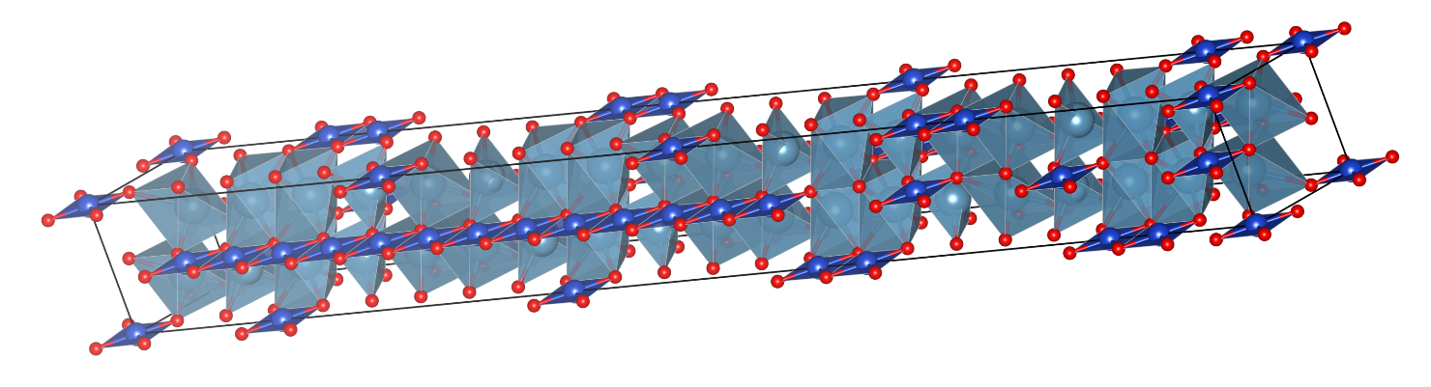

###### **Figure 1**. Visualisation of the modulated structure of the (Ca,Yb)0.83CuO2 composite.

#### [1] Akselrud, L. & Grin, Yu. (2014). *J. Appl. Crystallogr*. **47**, 803.

#### [2] Miyazaki, Y., Onoda, M., Edwards, P. P., Shamoto, S. & Kajitani, T. (2002). *J*. *Solid State Chem*. **163**, 540.