Structural and Magnetic Chirality in NiCo₂TeO₆
R. Scatena [1], N. Qureshi [2], A. Vibhakar [1], K. Beauvois [3], A. Bombardi [1], F. Carneiro [1], C. J. Won [4] and S.-W. Cheong [5]
[1] Diamond Light Source, Harwell Science and Innovation Campus Didcot OX11 0DE, Oxfordshire, UK
[2] Institut Laue-Langevin, 71 avenue des Martyrs, CS 20156, 38042 Grenoble Cedex 9, France
[3] Université Grenoble Alpes, CEA, IRIG, MEM, MDN, 38000 Grenoble, France
[4] Laboratory for Pohang Emergent Materials and Max Planck POSTECH Center for Complex Phase Materials, Pohang Univ. of Science and Technology, Dept. Phys., Pohang, Korea
[5] Rutgers Center for Emergent Materials and Department of Physics and Astronomy,
Rutgers University, Piscataway, NJ, 08854, USA

The chiral nature of our surroundings is evident both structurally and functionally, and it appears to be a crucial aspect of life. However, understanding and investigating chirality at the atomic scale remains a significant challenge. Structural chirality can be measured using X-rays through the interference of the anomalous scattering factor, which produces subtle intensity variations that differentiate enantiomers, whereas both non-resonant and resonant magnetic scattering can be used to assess inversion domains in non collinear magnetic structure via the helicity of the probe, see [1] and references therein. Similarly, polarized neutrons allow the assessment of magnetic chirality and inversion domains [1], whereas structural chirality is measured exclusively via the tiny relativistic Schwinger term [1].
This study investigates the chiral, polar, and magnetoelectric compound NiCo₂TeO₆ [2,3]. This material adopts a structural configuration derived from the corundum R3c symmetry of Al₂O₃, but the substitution of Co and Te at the Al site disrupts the inversion and c-glide symmetry, leading to ferri-chiral structural arrangements, with often both chirality present in the same crystal.
By employing an approach similar to that used for Ba₃NbFe₃Si₂O₁₄ [1], we establish the connection between magnetic and structural chirality in NiCo₂TeO₆, as depicted in Fig. 1.
Although a clear theoretical framework of the microscopic interactions driving the chirality of NiCo₂TeO₆ is still missing, our experimental results provide a sound foundation to understand the origin of this phenomenon and to future application of the magnetoelectric properties of this system.

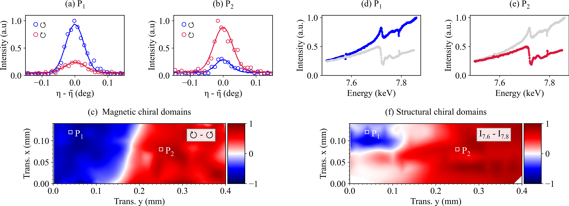

Fig. 1. Scans of a magnetic peak measured with circularly polarized light at positions (a) P1 and (b) P2. (c) Magnetic chiral domains mapped by beam translation and polarization intensity differences. (d, e) X-ray dispersion at P1 and P2. (f) Structural chiral domains mapped through intensity variations. Positions P1 and P2 are marked in (c) and (f).
1. N. Qureshi et al. Phys. Rev. B 102, 054417 (2020).
2. X. Wang et al. APL Mater. 3, 076105 (2015).
3. N. Qureshi et al. to be submitted to Phys Rev B

