# Diffuse scattering in sanidines

## C. Wiggers1,2, E. M. Schmidt1,2, D. A. Chaney3

### 1MARUM – Center for Marine Environmental Sciences, University of Bremen, Bremen, Germany

### 2Crystallography and Geomaterials Research, Faculty of Geosciences, University of Bremen, Bremen, Germany

### 3ESRF – European Synchrotron Radiation Facility, Grenoble, France

*cwiggers@uni-bremen.de*

Sanidine is the high-temperature, monoclinic polymorph of potassium feldspar. It is typically found in felsic rocks, often incorporating significant amounts of sodium due to rapid cooling. Sanidine's crystal structure has four non-equivalent tetrahedral sites where Al and Si are tetrahedrally coordinated by four oxygen ions, forming a framework of corner-sharing AlO4 and SiO4 tetrahedra. In this disordered alkali feldspar, Al3+ and Si4+ are randomly distributed across all four tetrahedral sites. In the other potassium feldspars, Al and Si are fully ordered in triclinic microcline and partially ordered in monoclinic orthoclase. In this study, we investigate possible differences in local ordering due to different thermal treatments with single crystal diffuse scattering.

Diffuse scattering in Sanidines has been suggested to be a result of the distorted aluminosilicate framework [1], where diffuse streaks manifest the strain propagation through the sample due to the different ionic radii of Al and Si. The incorporation of Na in K-feldspars is another possible source for experimentally observed diffuse scattering. Here, we study the diffuse scattering experimentally – Figure 1 shows the asymmetric bowtie diffuse scattering that we observe in natural Sanidine samples from Vesuvio, Italy.

The process of symmetry breaking Al/Si ordering in feldspars is onsets at temperatures above 500 °C [2]. In our diffuse scattering studies, we observe changes in the diffuse scattering, for the sample in-situ heated to 1000 °C (Fig. 1B), quenched to 30 °C (Fig. 1C) and annealed for one week at 1050 °C and slow cooled (Fig. 1C). We assign the differences in the experimentally observed diffuse scattering to an interplay of potential K/Na and Al/Si ordering processes that vary with cooling rate. In the future, we envision that by comparing the diffuse scattering of sanidines with different compositions and thermal histories we can make the diffuse scattering a potential geo-speedometer for cooling rates.

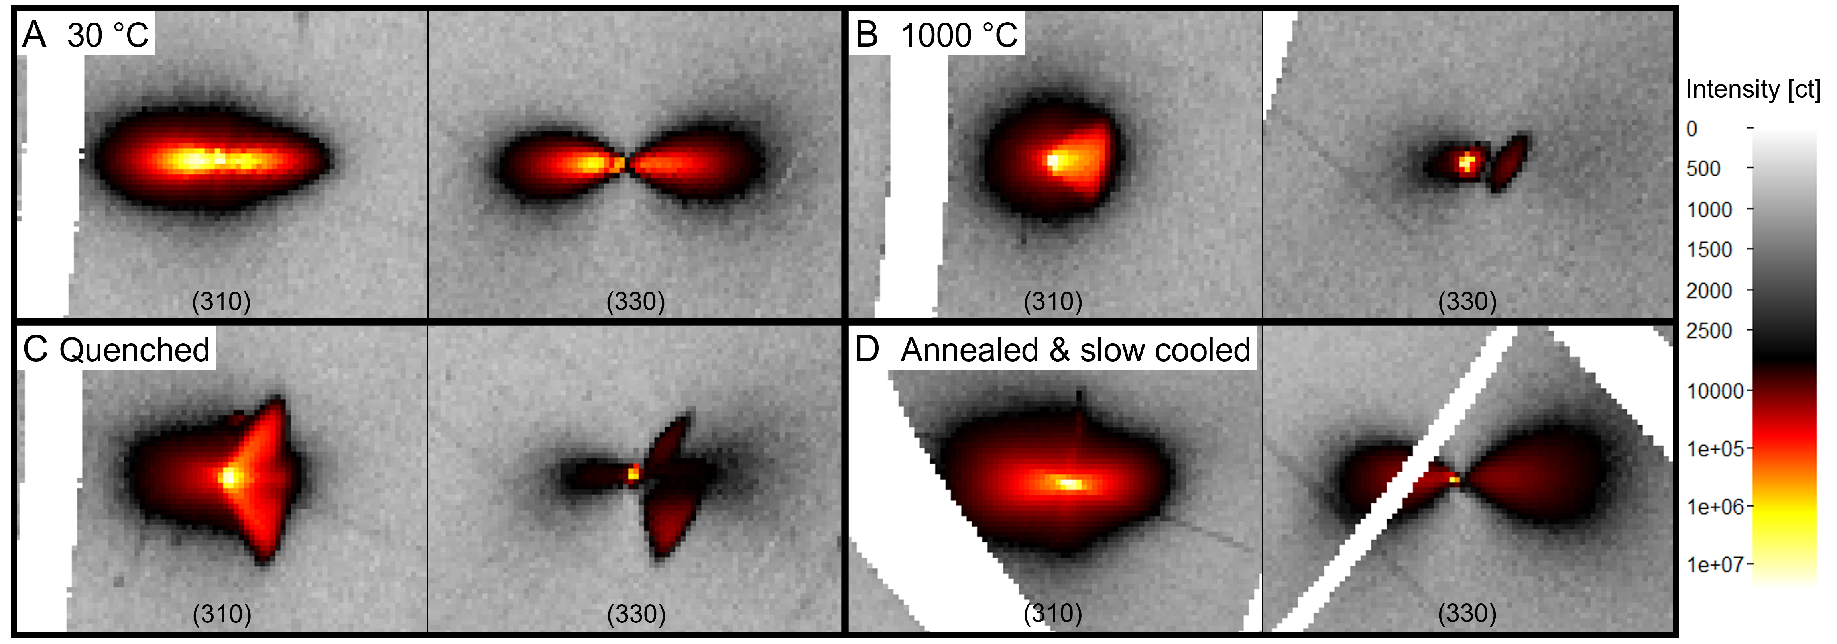

**Figure 1**. **:** Diffuse scattering in the hk0-plane in Sanidine from the Vesuvio, Italy. A. Untreated crystal. B. Insitu at 1000 °C. C. Quenched to 30 °C. D. Different crystal from the same sample that was annealed at 1050 °C for one week and slowly cooled over 8 hours.

#### [1] Pleger, S., (1996) *Zeitschrift für Kristallographie* 211, 293-298

#### [2] Brown, W.L., Parsons, I., (1989), *Mineralogical Magazine*, 53, 25-42

The project is funded through the Cluster of Excellence „The Ocean Floor – Earth’s Uncharted Interface“ and supported by GLOMAR – Bremen International Graduate School for Marine Sciences, University of Bremen.