# Annamycin – structural chemistry and nanoparticle delivery system

## M. Ziemniak1,2, M. Mielecki1, J. Gubernator1, R. Borowski1, K. Wozniak2, M. Olejniczak1, B. Pająk-Tarnacka1

### 1WPD Pharmaceuticals, Poland, 2University of Warsaw, Faculty of Chemistry, Poland

### [beata.pajak@wpdpharmaceuticals.com](mailto:beata.pajak@wpdpharmaceuticals.com), [mziemniak@chem.uw.edu.pl](mailto:mziemniak@chem.uw.edu.pl)

Anthracycline inhibitors of topoisomerase II are potent cytotoxic agents used in cancer treatment. Annamycin is a next-generation anthracycline drug, incorporating several structural changes that enhance its therapeutic profile and significantly reduce the cardiotoxicity.

Comprehensive crystallographic data on annamycin, a structurally complex and pharmaceutically important anthracycline, has been lacking. We address this gap by presenting detailed crystallographic analyses of two annamycin solvates—one with water and isopropanol (Ann-Iso), and another with THF and water (Ann-THF)—which unexpectedly assemble into remarkably similar supramolecular architectures despite their different solvents. Both structural X-ray models were refined using Hirshfeld Atom Refinement, which provide much better hydrogen atom positioning than canonical spherical refinement. Both solvates exhibit novel helical structural motifs stabilized by hydrogen bonding and π-stacking interactions, resulting in well-defined chirality and specific crystal lattice channels. Our findings reveal that a diverse array of non-covalent interactions, including hydrogen and halogen bonds, π-π stacking, and dispersive interactions, which governs molecular assembly in annamycin solvates crystals. These structural insights not only inform drug formulation strategies and the understanding but also provide a basis for comparative analysis with related anthracyclines, potentially guiding the rational design of improved derivatives. Additionally, computational studies, including periodic DFT calculations and charge-density analysis, support and extend these results, offering better conceptual understanding of Ann-Iso and Ann-THF molecular crystals.

We also developed long-circulating pegylated unilamellar nanoliposomes as carriers for annamycin. Using extrusion methods and thin lipid film formation, we screened various lipid compositions (SPC, DMPC, DMPG, DSPG, etc.) to optimize stability and encapsulation efficiency. Our formulation achieved highly stable nanoparticles with diameters below 150 nm, encapsulation efficiency exceeding 95%, and drug:lipid weight ratios as high as 1:20. These long-circulating nanoparticle formulations, featuring enhanced permeability and retention effect (EPR), represent promising candidates for preclinical and clinical testing, potentially enabling combinatorial therapies that induce drug synergism while countering MDR effects.

.

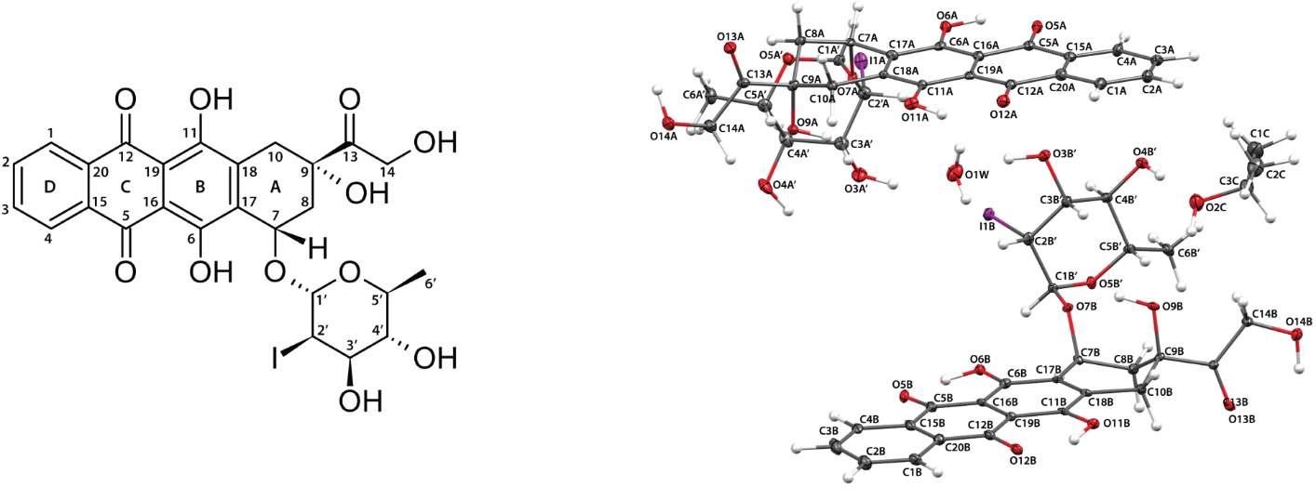

###### **Figure 1**. Annamycin structural formulae with carbon atom numbering (left), structure of Ann-Iso asymmetric unit.

This project is co-financed by the European Union from the European Regional Development Fund under the Smart Growth Operational Program 2014-2020. Project is implemented as part of the National Center for Research and Development: Proposal No 6/1.1.1/2020 – “Fast track. Priority I: Support for conducting R&D works by enterprises, Sub-measure 1.1.1. Industrial research projects and Experimental development work projects carried out by companies. Contract No: POIR.01.01.01-00-1913/20-00.