# N-glycosylation-driven dimerization: finding the sweet spot in myeloperoxidase biosynthesis

## U. Leitgeb1, P. Furtmüller1, I. Fegerl1, V. Pfanzagl1

### 1Institute of Biochemistry, Department of Natural Sciences and Sustainable Resources, BOKU University, Muthgasse 18, Vienna, Austria

### urban.leitgeb@boku.ac.at

Myeloperoxidase (MPO) is a heme-containing enzyme that plays a key role in neutrophil-mediated killing of phagocytosed viruses and microbes. During the neutrophilic oxidative burst, MPO generates (pseudo)hypohalous acids from hydrogen peroxide (H2​O2​) and (pseudo)halide ions within the phagosome [1]. Mature MPO exists as a homodimer composed of two monomers linked by a single interdomain cysteine disulfide bond and with each monomer containing five N-glycosylation sites [2]. The biosynthesis of MPO involves multiple steps. Starting in the endoplasmic reticulum (ER) MPO undergoes co-translational glycosylation followed by cleavage of the signal peptide and heme co-factor insertion. The resulting proMPO leaves the ER and is further processed by cleavage of the propeptide, excision of a hexa-peptide, dimerization and finally storage in the neutrophils azurophilic granules (Fig 1A) [3]. Despite the biological importance of MPO, its biosynthesis is not fully understood, and only limited information exists regarding the precise sequence and location of the post-ER processing steps. Furthermore, the role of the five N-glycosylation sites during biosynthesis and their importance for MPO activity remain mostly unknown.

In this study, we focus on the dimerization step of MPO biosynthesis and investigate how MPO N-glycosylation influences this process.

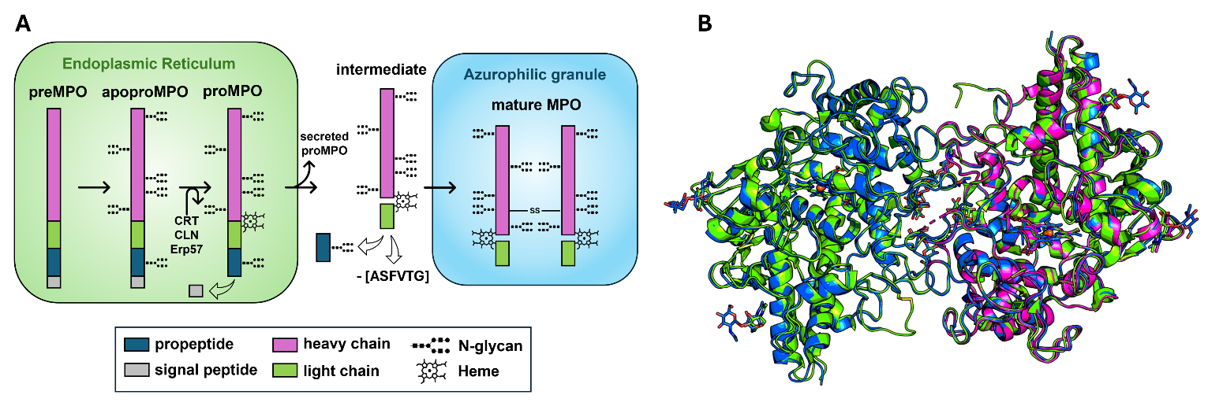

###### **Figure 1:** (A) Schematic representation of MPO biosynthesis. (B) Overlay of crystal structures of dMPO (green), mMPO (blue) and mMPOdg (magenta)

We present X-ray structural and SAXS data of native dimeric MPO (dMPO), monomeric MPO (mMPO) and deglycosylated monomeric MPO (mMPOdg) combined with biochemical and biophysical analyses. While the crystal structure of mMPO is still a dimer and shows only minor differences to dMPO, mMPOdg crystallizes as a monomer (Fig. 1B), in a different space group and with a different crystal morphology. Additionally, our SAXS data show a clear difference in homodimer affinity between mMPO and mMPOdg. Finally, mMPO and mMPOdg exhibit the same enzymatic activity as dMPO while DSC and ECD data indicate a reduced thermostability compared to the native enzyme. Taken together, our data highlighting the importance of MPO N-glycans for dimer formation and consequently for a higher protein stability. This suggests a crucial role in MPO biosynthesis, facilitating correct assembly of the mature enzyme and proper packaging into the azurophilic granules.

#### [1] Segal, A. W. (2005). How neutrophils kill microbes. *Annu. Rev. Immunol.* **23**, 197–223.

#### [2] Zeng, J. & Fenna, R. E. (1992). X-ray crystal structure of canine myeloperoxidase at 3 Å resolution. *J. Mol. Biol.* **226**, 185–207.

#### [3] Nauseef, W. M. (2018). Biosynthesis of human myeloperoxidase. *Arch. Biochem. Biophys*. **642**, 1–9.