# Crown ether-cation/π interactions – crystallographic and computational perspective

## K. A. Ćeranić1,2, M. M. Petković2, D. P. Malenov3

### 1Innovative Centre of the Faculty of Chemistry, Studentski trg 12-16, 11158 Belgrade, Serbia, 2University of Belgrade – Faculty of Physical Chemistry, Studentski trg 12, 11158 Belgrade, Serbia, 3University of Belgrade – Faculty of Chemistry, Studentski trg 12-16, 11158 Belgrade, Serbia

### malenov@chem.bg.ac.rs

Cation/π and host-guest interactions are inarguably among the most important interactions of alkali and alkaline earth metal cations [1, 2]. Relatively poor amount of solid-state data on cation/π interactions was enriched by using crown ethers decorated with aromatic groups, showcasing intramolecular cation/π interactions of trapped alkali metal cations [3]. Wanting to assess the mutual influence of host-guest and cation/π interactions, we have studied intermolecular interactions between alkali and alkaline earth metal cations nested in crown ethers and C6 aromatic rings, by the means of database mining and quantum chemical calculations.

By searching the Cambridge Structural Database (CSD, version 2024.3.0) [4], a total of 118 crown ether-cation/π interactions were found. The formation of cation/π interactions of coordinatively unsaturated cations (no additional ligands) tends to result in displacement of cation from the crown ether core (crystal structure MEPPAZ, Fig. 1). The tendency was persistent, but less pronounced for more saturated cations (crystal structure ROTPUN, Fig. 1), showcasing the opposing effect of additional ligands.

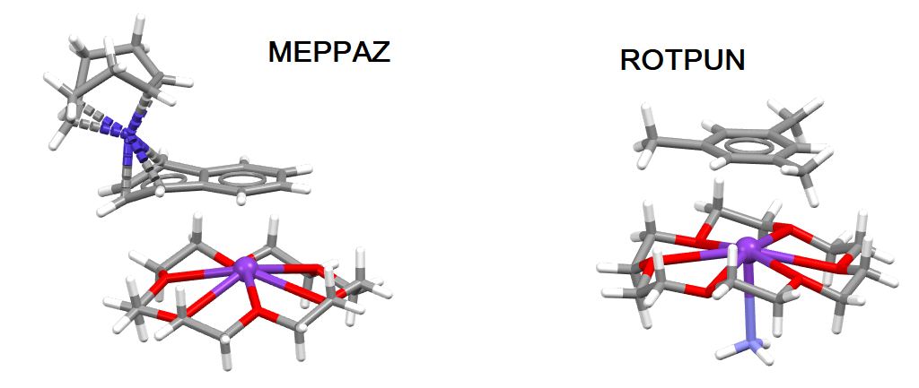

###### **Figure 1**. Cation/π interactions between aromatic rings and coordinatively unsaturated (CSD crystal structure MEPPAZ) and coordinatively saturated K+ (CSD crystal structure ROTPUN) trapped in the 18-crown-6 macrocycle

Alkali and alkaline earth cations display distinct behavior upon their trapping in a macrocycle due to the differences in their radii, charges, and polarizabilities. The Interacting Quantum Atoms approach [5] was employed to investigate the influence of the crown ether and the additional ligands on the nature and strength of the cation/π interactions. In particular, the nature of cation dictates the sign of its energy change upon coordination.

#### [1] Ćeranić, K. A., Zarić, S. D. & Malenov, D. P. (2025) *Dalton. Trans.* **54**, DOI: 10.1039/D5DT00395D.

[2] Ćeranić, K., Milovanović, B. & Petković, M. (2023) *Phys. Chem. Chem. Phys.* **25**, 32656.

[3] Gokel, G. W., Barbour, L. J., De Wall, S. L. & Meadows, E. S. (2001) *Coord. Chem. Rev.* **222**, 127.

[4] Groom, C. R., Bruno, I. J., Lightfoot, M. P. & Ward, S. C. (2016) *Acta Cryst.* **B72**, 171.

[5] Blanco, M. A., Martin Pendas, A. & Francisco, E. (2005) *J. Chem. Theory Comput.* **1**, 1096.

The funds needed for this work to be done are provided by the taxpayers of the Republic of Serbia and distributed to the authors by the Ministry of Science, Technological Development and Innovations (agreements No. 451-03-137/2025-03/200146, 451-03-136/2025-03/200288 and 451-03-136/2025-03/200168). The authors would like to dedicate this work to all the students and teachers who stood against corruption and the collapse of educational system in Serbia during the 2024/2025 academic year.