# Preliminary results on the new ternary intermetallic compound Cu5(As,Sb)2 in the Cu-As-Sb system

## M. Mödlinger1, Alessia Provino1, Pavlo Solokha1, Serena De Negri1, Federico Caglieris2,3, Cristina Bernini2, Pietro Manfrinetti1,2

### 1 Department of Chemistry, University of Genoa, Via Dodecaneso 31, 16146 Genoa, Italy, 2 Institute SPIN-CNR, Corso F. M. Perrone 24, 16152 Genova Genoa, Italy, 3 Department of Physics, University of Genoa, Via Dodecaneso 33, 16146 Genoa, Italy

[*marianne.moedlinger@edu.unige.it*](mailto:marianne.moedlinger@edu.unige.it)

### 

Studying the ternary system Cu-As-Sb, the new intermetallic compound Cu5(As,Sb)2 has been identified. In this study, we present structural results based on single crystal and powder X-ray diffraction data. Formation and thermal stability have been probed by Differential Thermal Analysis (DTA) and Differential Scanning Calorimetry (DSC). Metallographic and chemical analysis (SEM-EDXS) were performed for providing information on the microstructure and the chemical composition of the intermetallic compound.

A compositional range of Cu (68.9-71.9 at%), As (23.2-28.6 at%) and Sb (2.4-5.1 at%) has been found for this ternary compound. Similarly to the pure binary Cu5-xAs2 , the new phase was also found to crystallize also in the orthorhombic Mg5Ga2-type (oI28, *Ibam* n. 72) [1]. Like the binary parent, forming peritectically and existing in between 709-300 °C [2], it also forms peritectically and is a high-temperature phase. The lattice parameters have been detected in the range of a = 5.968-5.977(1) Å; b = 11.55-11.565(3) Å; c = 5.530-5.573(3) Å for the high-temperature Mg5Ga2-type. A structural change to a primitive cubic structure likely happens on lowering the temperature and before decomposing into Cu3-xAs and Sb. The low-temperature cubic phase is currently under investigation; preliminary results show a lattice parameter of a= 7.465 (1) Å.

Some physical properties (electrical resistivity and magnetic susceptibility) have been measured on polycrystalline bulk samples of rhombic Cu5(As,Sb)2 retained at room temperature, as metastable phase, by quenching. We have found that is a good metal with electrical resistivity decreasing monotonically with decreasing the temperature.

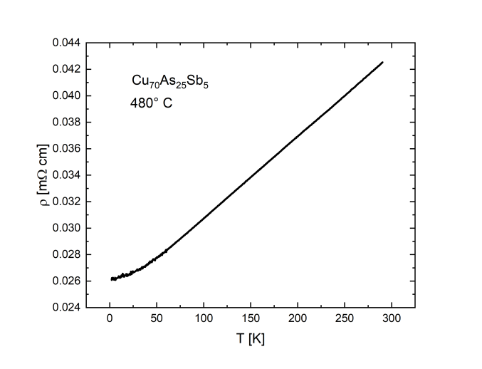

###### **Figure 1**. Resistivity of the new Cu5(As,Sb)2 intermetallic compound.

#### [1] Pavlyuk, N., Dmytriv, G., Pavlyuk, V. *et al*. *J. Phase Equilib. Diffus*. **43** (2022) pp. 458-470. <https://doi.org/10.1007/s11669-022-00985-2>

#### [2] Subramanian, P.R., Laughlin, D.E. *Bulletin of Alloy Phase Diagrams* **9** (1988) pp. 605-618. <https://doi.org/10.1007/BF02881964>