## Is it worth crystallizing phosphatases in the age of AI-based structural modeling?

## K. Kurpiewska1, J. Sławek2

### 1Biocrystallography Group, Department of Crystal Chemistry and Crystal Physics, Faculty of Chemistry, Jagiellonian University, Kraków, Poland, 2 SOLARIS National Synchrotron Radiation Centre, Kraków, Poland

### katarzyna.kurpiewska@uj.edu.pl

Recent advances in deep learning have dramatically expanded the scope of protein structure prediction by enabling accurate modeling not only of individual proteins but also of their interactions with ligands, nucleic acids, and small molecules. This development raises a fundamental question in structural biology: is experimental crystallization still necessary, particularly for functionally conserved enzyme families such as phosphatases? In this work, we model a representative set of phosphatases using AlphaFold 3 and analyze the structural features in detail for one selected enzyme. We compare the AI-generated model with its experimentally determined crystal structure to examine differences in side-chain positioning, and active site conformation.

*Bacteroides thetaiotaomicron* is a bacterium found in the human gut that plays a crucial role in the digestion of polysaccharides [1]. One of the proteins produced by this bacterium is phosphatase, an enzyme involved in regulating numerous biochemical processes by removing phosphate groups from various substrates. *E. coli* RIL bacterial cells (BL21 strain) with the pMCSG7 plasmid modified to include the gene for the studied protein from *Bacteroides thetaiotaomicron* (VPI-5482 strain) were used for the protein expression. For the purification of recombinant proteins, metal affinity chromatography using a Ni-NTA agarose resin was employed. The crystallization was performed using the hanging drop vapor diffusion method. The crystallization solution consisted of a 1.5M NaCl solution, the drop consisted of 1 μl of protein solution (20 mg/ml) and 1 μl of the Pact Premier I MD1-29 (0.2M MgCl2 · 6H2O, 0.1M HEPES, 20 % w/v PEG 6000, pH 7) from Molecular Dimensions.

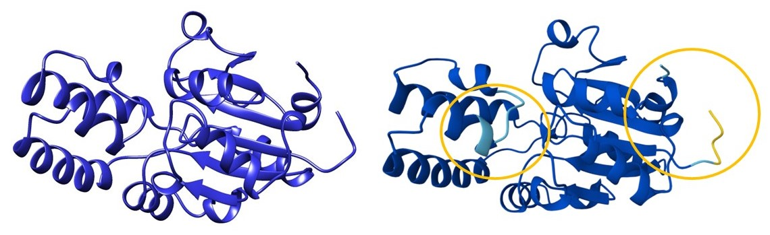

**Figure 1.** Crystal structure and AlphaFold3 model of phosphatase from *Bacteroides thetaiotaomicron*. The region of greatest uncertainty is marked with a yellow circle.

This poster presents preliminary observations from the comparison and outlines the broader context of using AI-based modeling alongside crystallographic data. Our findings suggest that although AI models can streamline early-stage structural analysis, experimental crystallization remains valuable when high-resolution details or ligand-bound conformations are required. This poster discusses the evolving balance between computational prediction and empirical validation, offering practical criteria for deciding when crystallization is still "worth it."

#### [1] Zocco, M.A. et al. (2007) *Digestive and Liver Disease*, 39, Issue **8**, 707.

*Acknowledgements*

*The study was carried out using research infrastructure purchased with the funds of the European Union in the framework of the Smart Growth Operational Programme, “ATOMIN 2.0 - ATOMic scale science for the INnovative economy” under the Strategic Programme Excellence Initiative at Jagiellonian University.*