Investigation of the crystallization behavior of propylammonium salts derived from (RS)- and (S)- chlocyphos.

A. Leborgne¹, G. Gabode¹, A. Hoser²

¹Normandie Univ, Univ Rouen Normandie, SMS-EA3233, Place Emile Blondel, 76130, Mont-Saint-Aignan, France
Faculty of Chemistry, University of Warsaw, Pasteura 1, 02-093 Warsaw, Poland

alexis.leborgne2@univ-rouen.fr
Even if two enantiomers share many properties such as melting point, boiling point or density, they exhibit opposite optical activity and often different biological effects. In biology, chirality is crucial: one enantiomer can be the active pharmaceutical ingredient, while the other may be less active or even harmful. Ensuring the correct enantiomer is used is a matter of safety, but achieving this requires specific conditions that must be investigated. Racemic mixtures (50/50 R and S) can sometimes be separated if they crystallize as conglomerates — physical mixtures of enantiopure R and S crystals — allowing selective crystallization of one enantiomer. The main limitation is that only 5–10% of racemates crystallize as conglomerates [1]. The remaining 90–95% form racemic compounds, where both enantiomers coexist in the same crystal lattice, preventing chiral separation. To overcome this, systems must be modified to favor conglomerate formation, through approaches such as cocrystals, solvates, salt formation, or chemical modification. This strategy has been demonstrated on chlocyphos, a chiral molecule of interest. This molecule crystallizes as a racemic compound but after a salt screening, the formation of a conglomerate has been emphasized with the formation of a salt with certain alkyl amines [2]. Polymorphism (in the powder) has also been spotted for the propylammonium salt, which constitute another problematic of this project. In doing so, this work will be focused on the crystallization of the propylammonium salt of (RS)- and (S)- Chlocyphos under different crystallization conditions. Throughout this work, the solvent seems to play a major role in the crystallization. Indeed, (RS)- and (S)- Chlocyphos salts show different behaviors depending on the crystallization solvent. Forms A and B of the (S)- Chlocyphos salt have been spotted, respectively in pure ethanol (or iso-propanol) and in a mixture of ethanol-water. The conglomerate (RS)- Chlocyphos has been obtained in a previous study in methanol, which has not yet been reproduced [3]. After obtaining single crystals, an accurate structure determination by Single Crystal X-ray Diffraction Measurement can be performed, emphasizing the different crystal packing. Then, it will be possible to calculate the reticular energies of the different crystal structures (CRYSTAL calculations) and thus assess to the relative stability of the different forms. This poster aims at gaining insight on the crystallization of the propylammonium salt of (RS)- and (S)- Chlocyphos (Figure 1).
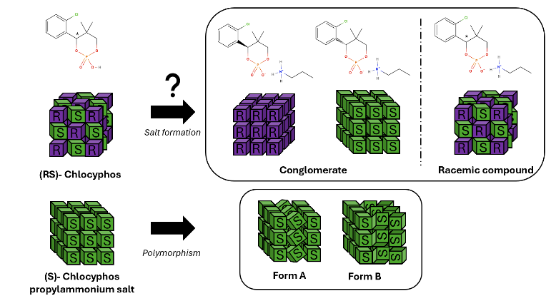

Figure 1. Visual representation of the studied systems.

[1] Jacques, J., Collet, A., Wilen, S. H., (1994). Enantiomers, Racemates, and Resolutions.

[2] Mbodji, A., Gbabode, G., Sanselme, M., Couvrat, N., Leeman. M., Dupray, V., Kellogg, R. M., Coquerel, G., . (2019). Family of Conglomerate Forming Systems Composed of Chlocyphos and Alkyl-Amine. Assessment of their Resolution Performances by Using Various Modes of Preferential Crystallization. Crystal Growth & Design.

[3] Mbodji, A. (2020). Discovering Conglomerates for Chiral Resolution by Crystallization. Normandie University.

[4] Dyk, K., Kinzhybalo, V., Czernel, G., Grudziński, W., Horak, Y., Butenko, S., Kamiński, D. M. (2023). Solvent induced Conformational Polymorphism. CrystEngComm.

