# Coordination mode preferences of 1,2,3-triazoles: monodentate versus bidentate

## P. Le Garff1,R. Jalmakhanbetova2,R. M. Losus1, W. Dehaen2, L. Dobrzańska1

### 1Nicolaus Copernicus University in Toruń, Faculty of Chemistry, 87-100 Toruń, Poland, 2KU Leuven, Department of Chemistry, 3001 Leuven, Belgium

###  PhD Student, Paul Le Garff; paul-legarff@doktorant.umk.pl

### 

1,2,3-triazoles represent a versatile class of compounds with significant importance in various fields of chemistry, including medicinal chemistry [1], materials science [2], and coordination chemistry [3]. The development of new ways of synthesis, in particular the Cu-catalyzed 1,3-dipolar cycloaddition reaction between an azide and an alkyne, known as click chemistry [4], has rendered this scaffold readily accessible.

In line with our studies on coordination compounds with heterocyclic ligands, we present a series of copper (II) complexes obtained with a new 1,2,3-triazole ligand, namely 2-(1-methyl-1H-1,2,3-triazol-4-yl)-1H-benzo[d]imidazole (**L**). The structures of the metal complexes were analysed by SCXRD, revealing that the complexation reactions lead to the formation of a range of products, which differ by coordination mode or degree of hydration. The molecular/crystal structures will be presented, as well as the preferences of the ligand towards particular coordination modes. These will be discussed in detail and supported by the results of computational studies.

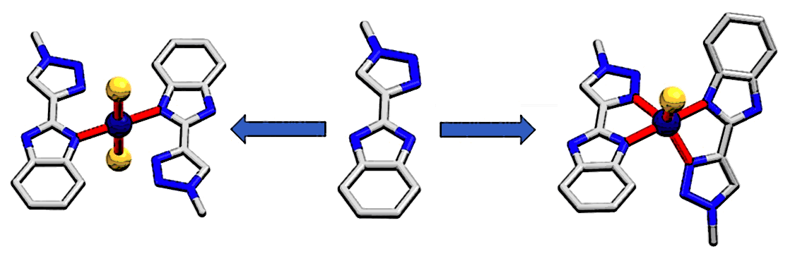

.

###### **Figure 1**. Coordination modes (monodentate, left; bidentate, right) of the ligand (**L**, middle)

#### [1] K. Bozorov et al., *Bioorg Med Chem*., 2019, 27, 3511.

#### [2] S. Kantheti et al., *RSC Adv*., 2015, 5, 3687.

#### [3] P. A. Scattergood et al., *Coord. Chem. Rev*, 2017, 350, 136.

#### [4] V. Castro, H. Rodriguez, and F. Albericio, *ACS Comb. Sci*., 2016, 18, 1.