# Halogen bond triad: Three individual N···I halogen bonds in one cocrystal

## S. van Terwingen1

### 1Institute of Inorganic Chemistry, University of Vienna, Währinger Straße 42, 1090 Vienna, Austria

### steven.van.terwingen@univie.ac.at

Because of their promising properties for advanced materials, halogen bonds (XBs) have gained extensive interest in various scientific communities, such as material science, theoretical chemistry and crystal engineering. Halogens exhibit an anisotropic electron density distribution, especially if they are bound to an electron-withdrawing group. This anisotropicity creates an electron-deficiency on the opposite site of the halogen’s σ-bond, thus called *σ-hole* [1]. Lewis bases can donate their lone pair to the σ-hole forming an XB.

Most often perfluorinated halobenzenes are used as XB donors [2], as they combine rigidity, stability and a strong σ-hole. In this study we present the 1:3 cocrystal of 1,3,5-trifluoro-2,4,6-triiodobenzene (TFTIB) with benzotriazole (BTA) as the XB acceptor. In the cocrystal, three symmetry independent N···I halogen bonds are found, making them ideal candidates for a direct comparison within the same solid. TFTIB · 3 BTA (**1**) crystallizes in the triclinic space group *P*-1 with *Z*= 2 (Fig. 1, left).

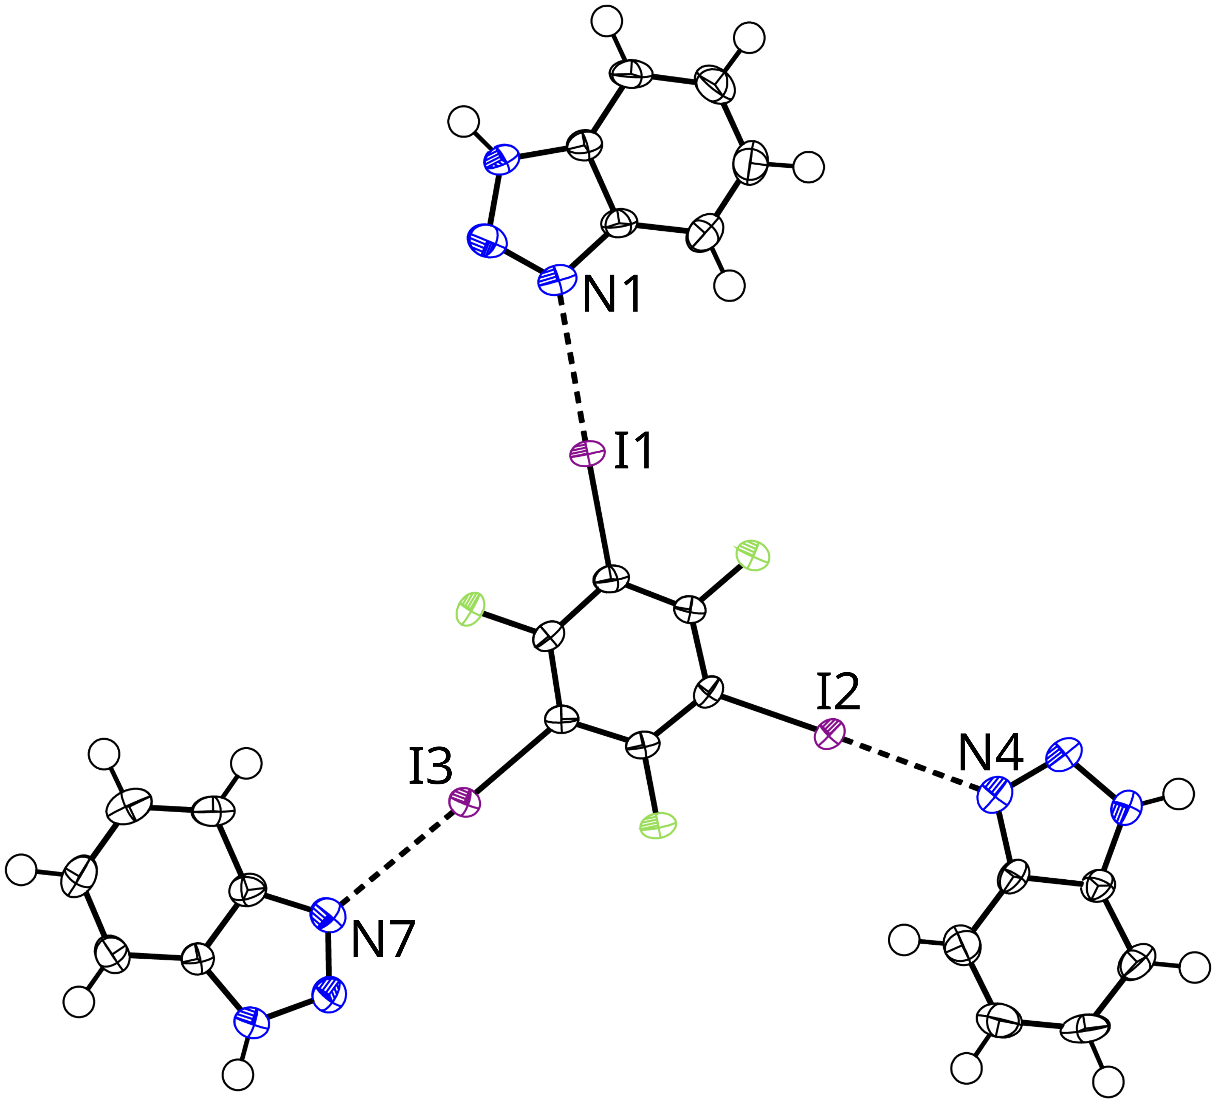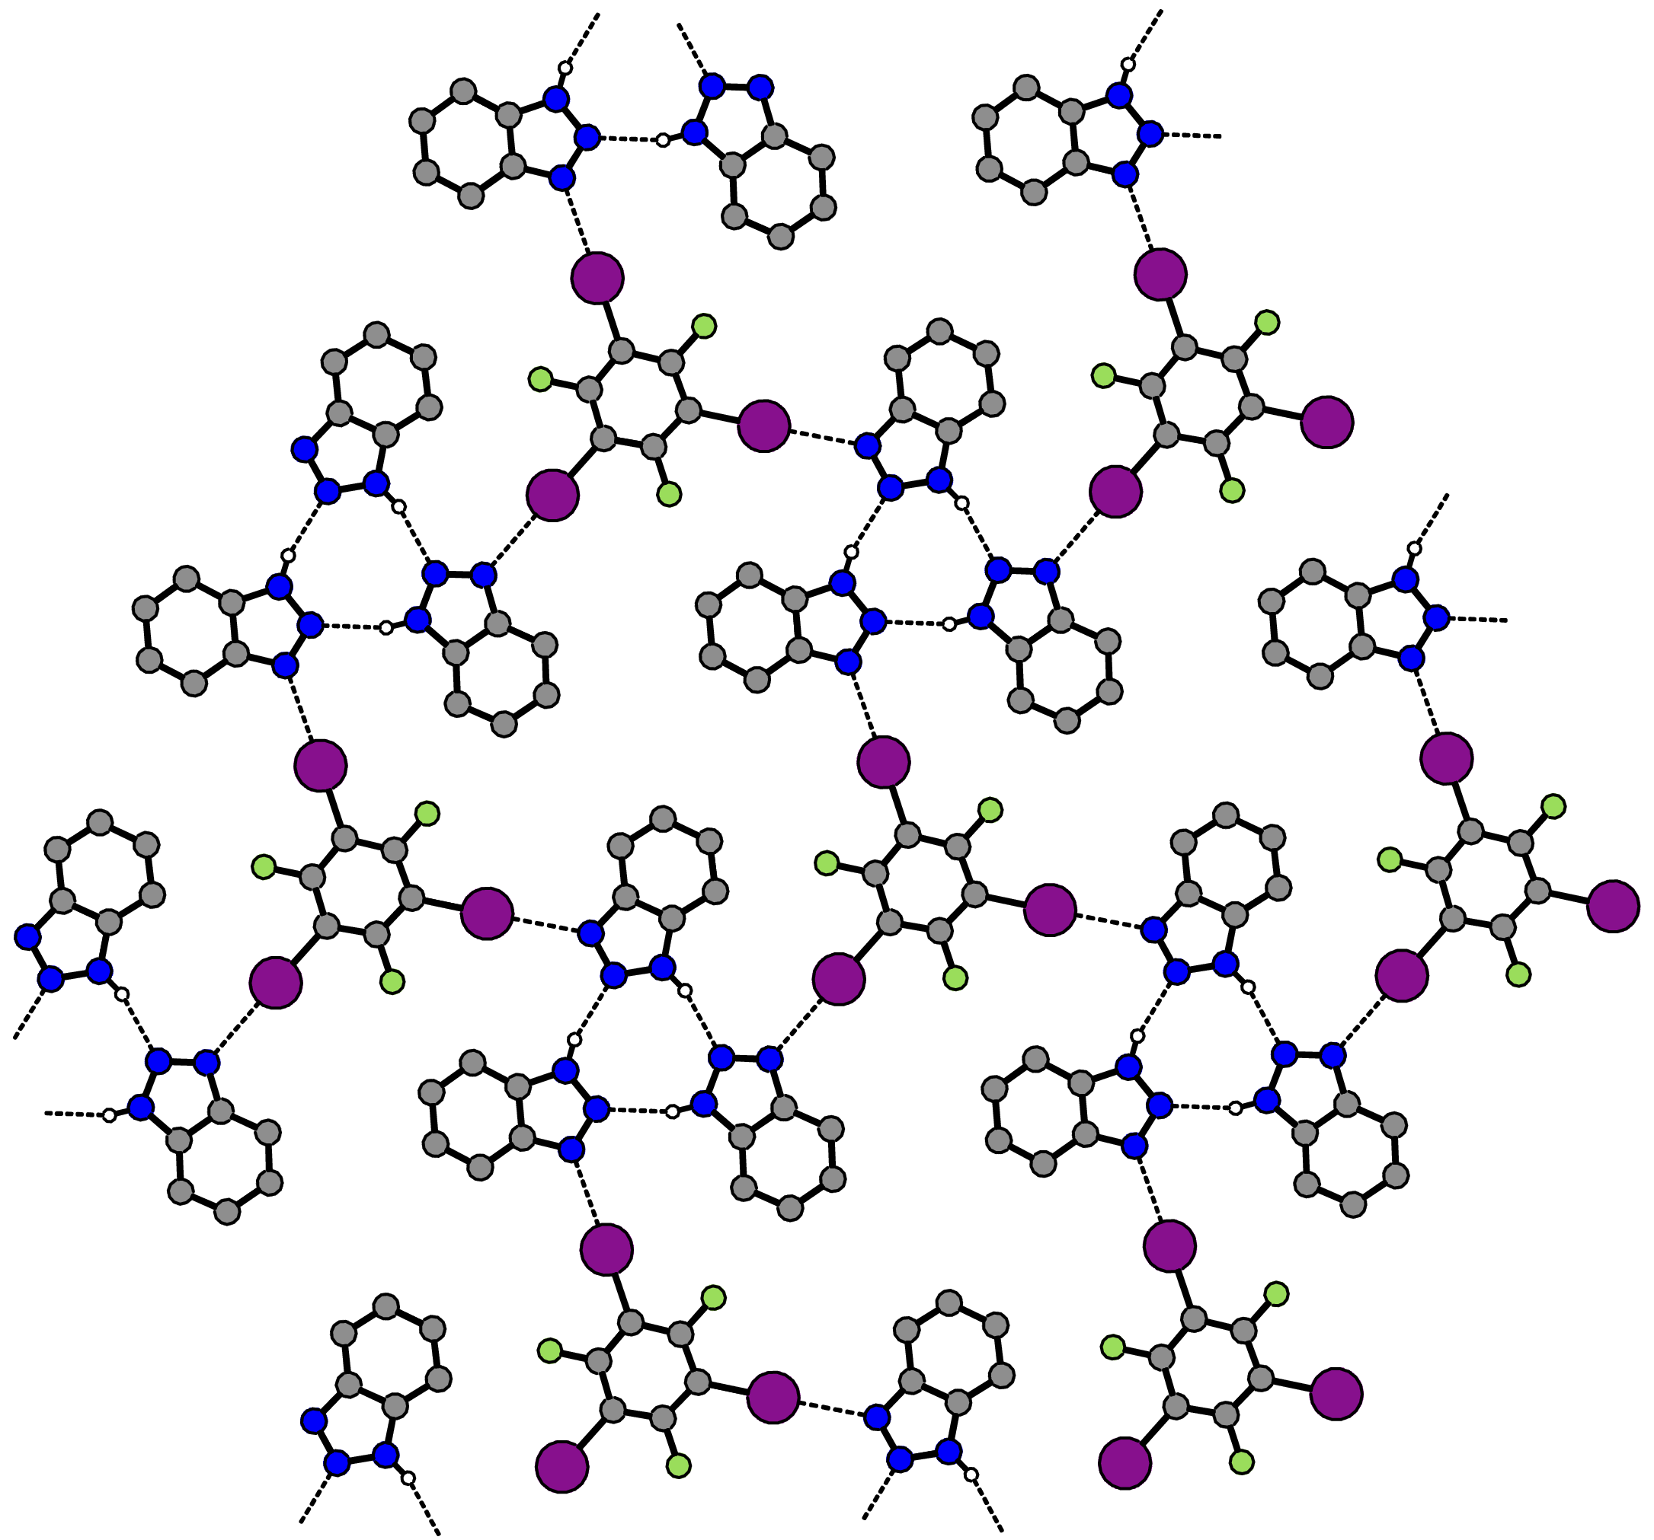**Figure 1.** Left: Displacement ellipsoid plot [3] of **1** (90% probability, XBs marked as dashed lines). Selected distances (Å): I1···N1 2.8763(19) Å, I2···N4 2.8706(19) Å, I3···N7 2.892(2) Å. Right: Perpendicular view of the two-dimensional extended structure in the (1 1 −1) plane found in **1**.

All three I···N contacts are much shorter than the sum of their van der Waals radii (3.65 Å) [4] and all C–I···N angles are close to being linear, suggesting a strong interaction. The cocrystal forms a two-dimensional net consisting of halogen and hydrogen bonds in the (1 1 −1) plane (Fig. 1, right). One might expect a threefold symmetry from the structure, reflected in threefold axes in the center of gravity of the TFTIB molecule or in the middle of the hydrogen bonded trimer of BTA. However, this is not given in the actual crystal symmetry. It becomes more obvious taking a look at the different layers of the net in [1 1 −1] direction, as the layers are shifted to one another breaking any possible threefold symmetry. The dominant interaction between adjacent layers is π-stacking.

Additional insights are gained from a quantum mechanical single-point calculation to derive the electron density *ρ* and the electrostatic potential *φ* and perform an analysis according to Bader’s *Quantum Theory of Atoms in Molecules* (QTAIM) [5]. In the future, we will investigate XB adducts like **1** with the help of electron diffraction, to gather more knowledge about this fascinating interaction.

[1] T. Clark, M. Hennemann, J. S. Murray, P. Politzer, *J. Mol. Model.* **2007**, *13*, 291–296.

[2] G. Cavallo, P. Metrangolo, R. Milani, T. Pilati, A. Priimagi, G. Resnati, G. Terraneo, *Chem. Rev.* **2016**, *116*, 2478–2601.

[3] A. L. Spek, *Acta Crystallogr.* **2009**, *D65*, 148–155.

[4] S. S. Batsanov, *Russ. Chem. Bull.* **1995**, *44*, 18–23.

[5] R. F. W. Bader, *Atoms in Molecules: A Quantum Theory*, Clarendon Press, Oxford, UK **1990**.

*This research was funded in whole or in part by the Austrian Science Fund (FWF) [10.55776/ESP9899224].*