# Isothiouronium salt at the borderline of disorder and solid solution of polymorphs

## V. Eigner1, L. Žofáková1, M. Hušák1

### 1University of Chemistry and Technology, Prague, Technická 5, Prague 166 28, Czech Republic

### eignerv@vscht.cz

The isothiouronium salts are a variable group of compounds produced by S-alkylation of thiourea [1]. The hydrogen atoms of positively charged isothiouronium group often form charge assisted hydrogen bonds with corresponding anion. For this reason they were used in anion receptor design [2], recently they were investigated for their ability to form anticandidal polymers [3]. Among the most notable is their activity against the lung and prostate cancer cell lines [4].

In our studies we have focused on isothiouronium salts bearing trifluoromethyl groups. Among them 2-(3,5-bis(trifluoromethyl)benzyl)isothiouronium bromide stood out with its significant disorder over two positions. Forming two conformations, conformation 1 with C9-S8-C7-C1 torsion angle value of -119.8(2)°, and conformation 2 with torsion angle value of ‑68.5(4)°. This is a rare case, when a majority of the molecule is disordered, but the crystal structure itself remains almost unchanged. The conformation change results in switching of π stacking interactions. We have noticed variability of lattice parameters of large single crystal fragments, mostly affecting the monoclinic β angle, which varies from 90.848(1)° to 91.321(4)° while the occupancy ratio varies from 0.590(4):0.410(4) to 0.359(4):0.641(4). The dependence appears to be linear, from which we extrapolated the β angle of expected pure conformations, resulting in β angles of 90.051° and 92.023°. We have utilized DFT calculations to evaluate the ideal lattice parameters of both conformations with calculated β angle values of 90.167° and 93.088°. According to the DFT calculations the conformation 1 is more stable than conformation 2 with energy difference of -1.49262 kcal/mol.

The structure was measured in temperature range 130 to 290 K, to evaluate the possibility of temperature related conformation change. Throughout the whole temperature range the occupancy ratio varies only within the limit of estimated standard deviation from 0.358(4):0.642(4) to 0.362(4):0.638(4).

From the higher stability of conformation 1, difference in lattice parameters, and disorder ratio stability we assume the pure conformations 1 and 2 are two distinct polymorphic forms and the structures studies are their solid solutions.

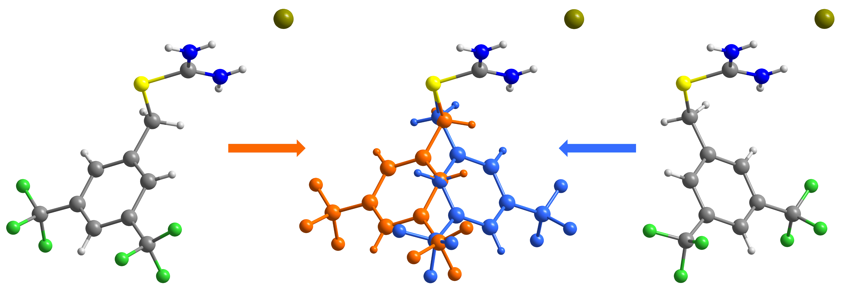

###### **Figure 1**. The disorder of two positions of 2-(3,5-bis(trifluoromethyl)benzyl)isothiouronium bromide

#### [1] Speziale, J. A. (1950) *Org. Synth.* **30**, 35–37.

#### [2] Seong, H. R., Kim, D.-S., Kim, S.-G., Choi, H.-J., Ahn, K. H. (2004) *Tetrahedron Lett.* **45**, 723–727.

#### [3] El-Zahed, M. M., Kiwaan, H. A., Farhat, A. A. M., Moawed, E. A. & El-Sonbati, M. A. (2023). *Iran. Polym. J.* **32**, 71–79.

#### [4] Alcolea, V., Plano, D., Karelia, D. N., Palop, J. A., Amin, S., Sanmartín, C. & Sharma, A. K. (2016). *Eur. J. Med. Chem.* **113**, 134–144.

This research was supported by the project 23-05293S of the Czech Science Foundation.