# Structural variability of dimeric copper(II) salicylate(2-) complexes

## M. Lištiak1, R. Varga1, J. Moncoľ1

### 1Institute of Inorganic Chemistry, Technology and Materials, Slovak University of Technology, Radlinskeho 9, 81237 Bratislava, Slovak Republic

### Email: jan.moncol@stuba.sk

Salicylated copper complexes exhibit interesting biological properties such as anti-convulsant, antimicrobial, superoxide dismutase mimetic, cytotoxic activities [1-4] as well as showing promising chemotherapeutic potential [3].

In the framework of the study of potenial applications in bioinorganic chemistry, several dimeric copper(II) salicylate(2-) complexes were prepared and structurally characterized. The compounds have the general formula [Cu(X-sal)(bpy)]2 where X-sal are the anions(-) of 3-chlorosalicylic (3-Clsal), 4-chlorosalicylic (4-Clsal), 4-bromosalicylic (4-Brsal), 3,5-dichlorosalicylic (3,5-Cl2sal) and 3,5-diiodosalicylic (3,5-I2sal) acids. All of these complexes have a dimeric molecular structure (Figure 1) but but differ in the manner of bridging the salicylate(2-) anion as a ligand. In the studied series, the modes of the salicylate(2-) anions were observed: one bridging phenolic oxygen atom, one bridge carboxyl oxygen atom, and three bridge carboxylate atoms (oxygen-carbon-oxygen atoms) (Figure 1).

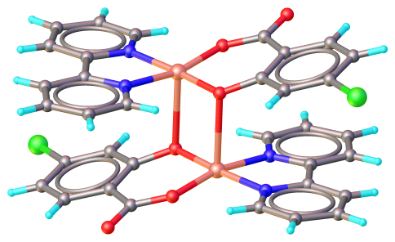 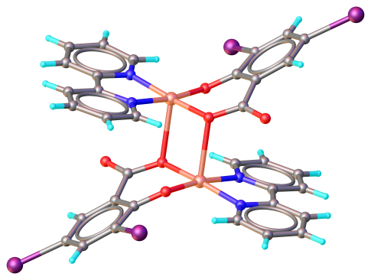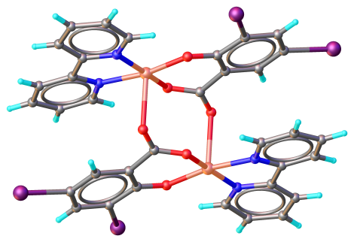

###### **Figure 1**. Molecular structure of the complex [Cu(4-Clsal)(bpy)]2 and two isomers of the complex [Cu(3,5-I2sal)(bpy)]2.

The dimer complexes show further structural features of interest. The crystal structures of the two isomers of [Cu(3,5-I2sal)(bpy)]2 are examples of bond isomerism of the bridging 3,5-diiodosalicylate(-) anion. The [Cu(4-Clsal)(bpy)]2 complex shows a temperature-induced phase transition, and the [Cu(3-Clsal)(bpy)]2 complex exists in several pseudopolymorphs.

The crystal structure of the complex with anion(2-) of 3-bromosalicylic acid (3-Brsal) is polymeric, unlike previous dimer complexes. This polymer complex has the formula [Cu(3-Brsal)(bpy)]*n* and the 3-bromosalicylate(2-) anion is a three-atom bridge.

#### [1] Lemoine, P., Viossat, B., Morgant, G., Greenaway, F. T., Tomas, A., Dung, N.-H. & Sorenson, J. R. J. (2002). *J. Inorg. Biochem.* **89**, 18.

#### [2] Geraghty, M., Sheridan, V., McCann, M., Devereux, M. & McKee, V. (1999). *Polyhedron*, **18**, 2931.

#### [3] O'Connor, M., Kellett, A., McCann, M., Rosair, G., McNamara, M., Howe, O., Creven, B. S., McClean, S., Kia, F.-A., O"Shea, D. & Devereux, M. (2012). *J. Med. Chem.* **55**, 1957.

#### [4] Jozefíková, F. Lišťiak, M., Valentová, J., Zahradníková, E., Varga, R., Samoľová, E., Litecká, M., Lušpai, K., Puchoňová, M., Malček Šimnková, M. & Moncoľ, J. (2025). *Eur. J. Inorg. Chem.* in press..

Acknowledgements: This work was supported by the Scientific Grant Agency of the Slovak Republic (Project VEGA 1/0686/23).