Structural biology with Neutron Macromolecular Diffractometer at ESS

Swati Aggarwal^{1,2,} Justin Bergmann¹, Aaron Finke ^{1,3}, Daniel Lundström¹, Ana Gonzalez⁴, Esko Oksanen^{1,2}

1European Spallation Source ESS AB, Lund, Sweden, 2Division of Computational Chemistry, Lund University, Lund , Sweden

3Department of Molecular Biology and Genetics, Aarhus University, Aarhus, Denmark

4MX-group, MAX IV Laboratory, Lund, Sweden

Swati.aggarwal@ess.eu
Keywords: Automated X-ray data collection, room temperature, X-ray and neutron diffraction, crystal shipment

Neutron macromolecular crystallography is mainly driven by its ability to locate hydrogen atoms in biological macromolecules. This is interesting not only for fundamental understanding of biological processes such as enzyme catalysis or proton pumping, but also for pharmaceutical development. NMX has a small beam with a low divergence, so it can reap the full benefit of the ESS flat moderators. The time-averaged brightness at ESS design power is expected to be 10-15 times higher than the best existing reactor instruments. This combined with the 5-20-fold improvement in signal-to-background ratio from the TOF technique makes NMX a world-leading instrument even at low accelerator power. As many of the scientifically most interesting systems crystallise in large unit cells, the capability to resolve large unit cells by the combination of TOF and increasing the crystal-to-detector distance widens the scope of macromolecular neutron crystallography to entirely new systems such as membrane proteins. With Europe’s most advanced and high-power neutron spallation source being constructed in Lund, the need for automation of RT data collection at BIOMAX beamline at MAXIV is emerging. This study is primarily focused on designing a portable crystal mounting setup to prevent crystal dehydration and collect both neutron and X-ray data from the same crystal (Figure 1). The crystals will be further mounted on a goniometer by using a robotic sample changer. Using such automated system will be advantageous and brings in the flexibility of exploring remote data collection at room temperature in near future.
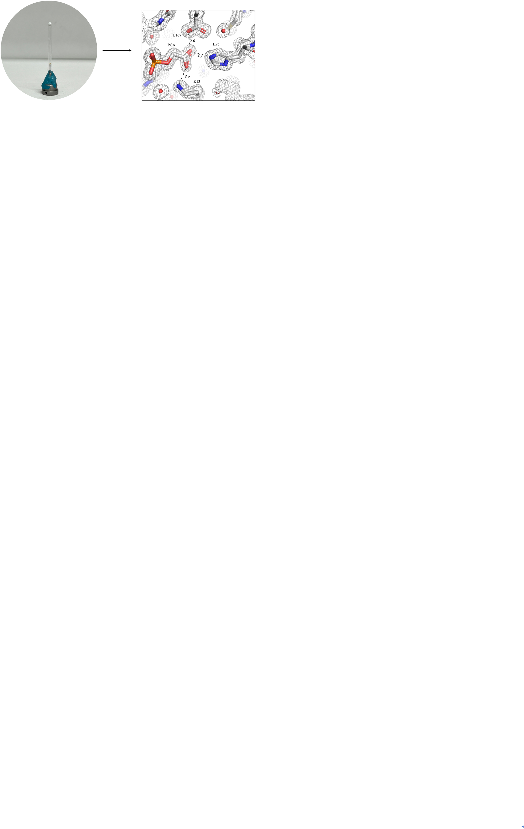
Figure 1. Sample mount for RT data collection of Triose phosphate isomerase (TIM) from Leishmania mexicana. The crystals of TIM variant E97Q diffracted X-rays at a resolution of 1.5 Å at room temperature. 2mFo-DFc electron density map of active site contoured at 1.0σ level is shown in right image.

