# Metastability in carbon nano bowls for sustainable thermal storage: a playground for studying molecular cooperativity in soft matter

## M. Gaboardi1,2,3*, B. Braunewell3, V. Di Lisio3, D. Cangialosi3, J. Siegel4, and F. Fernandez-Alonso3,5,6

### 1University of Rome Tor Vergata, Via Della Ricerca Scientifica 1, 00133, Rome, Italy. 2INFN Tor Vergata, Via Della Ricerca Scientifica 1, 00133, Rome, Italy. 3Materials Physics Center, CSIC-UPV/EHU, Paseo Manuel de Lardizabal 5, 20018 Donostia - San Sebastian, Spain. 4Department of Chemistry, University of Hong Kong, Pokfulam Road, Hong Kong SAR. 5Ikerbasque, Basque Foundation for Science, Bilbao 48013, Spain. 6Donostia International Physics Center (DIPC), Donostia-San Sebastian 20018, Spain.

### *mattia.gaboardi@uniroma2.it

Thermal storage materials may be key to reducing CO2 emissions owing to their ability to capture excess heat and release it on demand, thereby improving energy efficiency. Unlike conventional sensible heat-based systems, latent-heat stores enable controlled release of the accumulated energy in response to external stimuli. As part of a broader research effort [1,2], we investigated novel carbon-based molecules, amongst which corannulene (CA) – a bowl-shaped, rigid molecule with pentagonal symmetry – emerged as one of the most promising candidates.

In this study, we employed temperature-dependent powder and single-crystal synchrotron diffraction, complemented by QuasiElastic Neutron Scattering (QENS) and Fast Scanning Calorimetry (FSC), to establish a relationship between metastability and molecular dynamics in CA’s crystal structure. Despite the apparent simplicity, CA exhibits a rich and complex thermophysical and structural behaviour. The most common low-temperature monoclinic crystal form of CA, obtained via solution crystallization or sublimation, consists of uniquely folded tetramers (C20H10)4 held together by van der Waals forces [3]. Upon heating, the system undergoes polymorphic changes while manifesting stochastic (plastic) behaviour (see also Fig. 1) [4,5]. When fast cooled, vitrification can be imposed on the system, followed by new crystalline phases obtained upon reheating.

Our findings establish a direct link between stochastic molecular motions, structural rearrangements, and kinetic behaviour, ultimately tracing the progressive loss of order preceding the final liquid state.

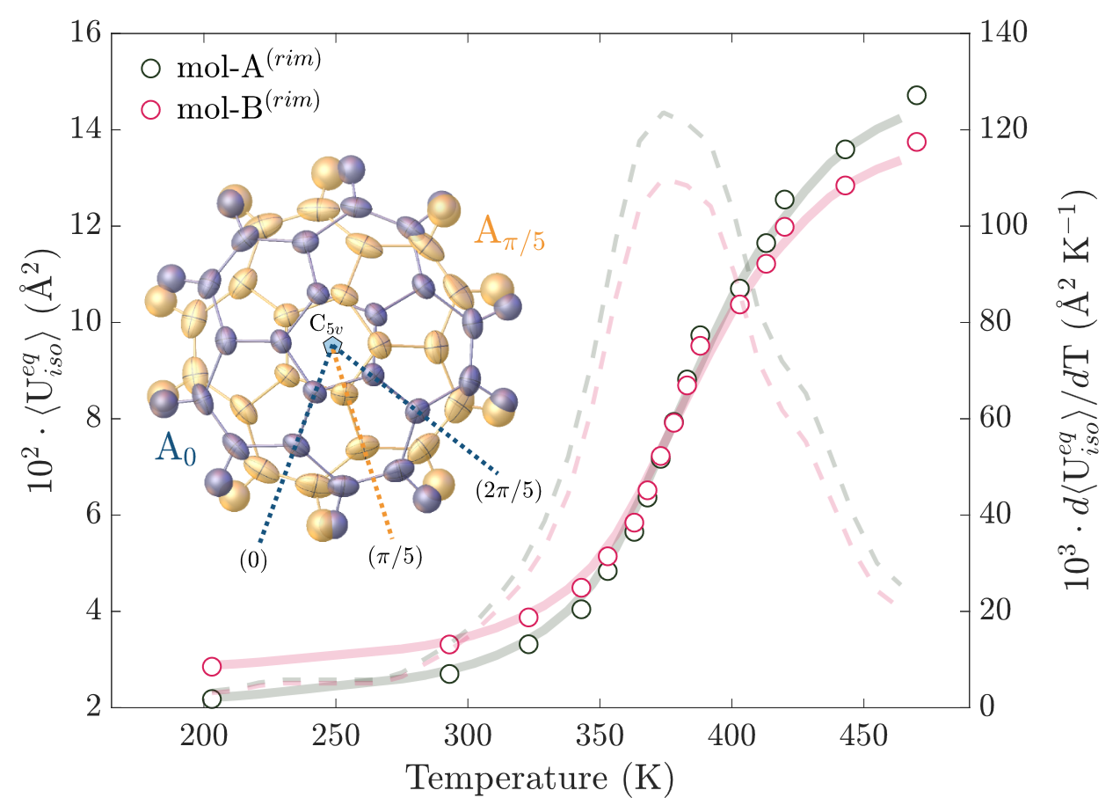

###### **Figure 1**. Two of the four disordered states (inset, highlighted in blue and yellow colour) in the crystal and the temperature evolution of the respective equivalent isotropic parameters relative to the rim carbons.

[1] T.S. Northam de la Fuente, M. Gaboardi, K.M. Ismail, V. Di Lisio, D. Cangialosi, A. Otero-de-la-Roza, P.B. Coto, F. Fernandez-Alonso, *Metastability and polymorphism in dihydroxybenzenes – implications for thermal energy storage*, Energy Adv. 3 (2024) 413–418.

[2] T.S. Northam de la Fuente, I. Vettori, K.M. Ismail, M. Gaboardi, V. Di Lisio, D. Cangialosi, P.B. Coto, A. Otero-de-la-Roza, F. Fernandez-Alonso, *New materials for the recovery and storage of thermal energy*, EPJ Web Conf. 310 (2024) 00008.

[3] J.C. Hanson, C.E. Nordman, *The crystal and molecular structure of corannulene*, C20H10, Acta Crystallogr. Sect. B Struct. Crystallogr. Cryst. Chem. 32 (1976) 1147–1153.

[4] M. Gaboardi, F. Pratt, C. Milanese, J. Taylor, J. Siegel, F. Fernandez-Alonso, *The interaction of hydrogen with corannulene, a promising new platform for energy storage*, Carbon N. Y. 155 (2019) 432–437.

[5] M. Gaboardi, I. Silverwood, B. Braunewell, J. Siegel, F. Fernandez-Alonso, *Emergence of dynamical disorder and phase metastability in carbon nanobowls*, Carbon N. Y. 183 (2021) 196–204.