## Subtle changes leading to massive consequences: a case study of two isostructural cocrystals exhibiting negative linear compressibility (NLC)

## E. Patyk-Kaźmierczak1, M. Kaźmierczak1

### 1Faculty of Chemistry, Adam Mickiewicz University in Poznań, Uniwersytetu Poznańskiego 8, 61-614 Poznań, Poland

### ewapatyk@amu.edu.pl

Most crystals exhibit positive compressibility, i.e., their dimensions decrease with pressure. However, in rare cases, an expansion in one (negative linear compressibility – NLC) or two directions (negative area compressibility – NAC) can occur.[1] Materials showing such an unusual response are promising candidates for use as optical sensors and in telecommunication systems required to function under high pressure.[1] Among the two unusual compressibility behaviours, cases of NLC are more common; however, only a handful show pressure-induced expansion of significant magnitude, and the most exceptional effects are usually observed for framework materials.[2] There are several mechanisms that can be linked to NLC in crystals, one being the deformation of specific motifs, such as wine rack or honeycomb.[2] Although the presence of these motifs increases the chances of a crystal to show NLC, the magnitude and the pressure range in which it is exhibited are hard to predict.

Recently, two isostructural cocrystals of 1,2-bis(4-pyridyl)ethane (ETY), with fumaric (FUM) and succinic (SUC) acids were investigated under pressure to reveal that they both exhibit NLC.[3,4] Although in both cases molecules aggregate to form almost identical H-bonded wine rack structures (Fig. 1), the response of ETYFUM and ETYSUC to pressure is not the same. ETYFUM, was found to show NLC of a magnitude comparable to framework materials (*K*NLC= -24 TPa⁻¹), persisting over a wide pressure range (0.1 MPa–3.6 GPa).[3] Meanwhile, NLC in ETYSUC is significantly weaker. The only difference between two cocrystals lies in the molecular structure of FUM and SUC and concerns the hybridization of α-carbon atoms

and the number of α-hydrogen atoms. Although this subtle difference does not affect the packing preference of coformers at 0.1 MPa/298 K, it has far-reaching consequences on their response to compression, including the magnitude of NLC and phase stability. The presence of two hydrogen atoms instead of one at the α-carbon atoms was directly linked to the phase transition of the ETYSUC cocrystal above 2.9 GPa and was found to be the cause behind reducing the NLC.[4]

The presented results not only introduce an organic crystal, ETYFUM, as an exceptional NLC material and discuss the structural features behind its response to high pressure but also offer a comparative analysis of two structurally related crystals aimed at understanding the structure-property relationship behind NLC.

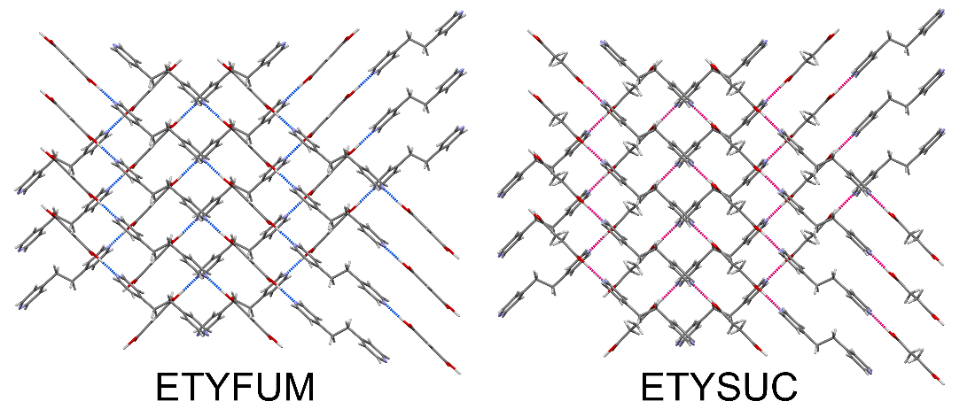

###### **Figure 1**. Wine rack motifs formed by ETY and FUM/SUC molecules in ETYFUM and ETYSUC cocrystals at 0.1 MPa/298 K.

#### [1] Baughman, R. H., Stafström, S., Cui, C. & Dantas, S. O. (1998). *Science* **279**, 1522.

#### [2] Cairns, A. B. & Goodwin, A. L. (2015). *Phys. Chem. Chem. Phys.* **17**, 20449.

#### [3] Patyk-Kaźmierczak, E. & Kaźmierczak, M. (2024). *Chem. Commun.* **60**, 10310.

#### [4] Patyk-Kaźmierczak, E., Szymańska, K. & Kaźmierczak, M. (2025). *IUCrJ* **12**, 88.

The funding from National Science Centre, Poland (grant No. UMO-2020/39/D/ST4/00260) is kindly acknowledged.