# From intrinsic octameric clusters to wires and tapes – the diversity of water structures stabilized by unclosed cryptands

## K. Dąbrowa1, M. Ceborska2

*1*Institute of Organic Chemistry, Polish Academy of Sciences,Kasprzaka 44/52, 01-224 Warsaw, Poland

*2*Faculty of Mathematics and Natural Sciences, Cardinal Stefan Wyszyński University, Wóycickiego 1/3, 01-938 Warsaw, Poland

### m.ceborska@uksw.edu.pl

Unclosed cryptands (UCs) are macrocyclic compounds, possessing at least three amidic groups connected by alkyl linkers with macroring functionalized with substituent (lariat arm) placed at the intraannular position of the macrocycle. The structural flexibility of UCs enables them to selectively bind particularly demanding guests, especially anions [1,2]. However their application is much broader, e.g. they may act as phase transfer catalysts [3]. It has been observed, that smaller UCs (with < 24-membered ring) crystallize as monohydrates, without any clustered water, whereas larger UCs tend to stabilise various forms of structured water. 26-membered UC, incorporating substituted phenyl ring in the lariat arm may stabilise octameric water cluster built from a cyclic tetramer and four water molecules placed at each corner of the tetramer [4]. We proved, that such water assembly is stabilized by 26-membered UCs end-capped with *p*-nitrophenyl or *p*-methoxyphenyl groups. On the other hand, 26-membered UC, end-capped with unsubstituted phenyl moiety, stabilizes water chains of different lengths [5].

Lately, we turned our attention to more sophisticated systems, a sterically crowded light-responsive pincer-type macrocyclic receptors, which may be considered as unclosed cryptands dimers, where the two parts of the receptor are connected by the substituted azobenzene unit. Such macrocycles are excellent selective receptors for biologically relevant anions, e.g. pincer-type receptor built from two 26-membered macrorings connected by azobenzene-derived linker exhibited high selectivity for dihydrogenphosphate over other organic and inorganic anions (acetate, benzoate, or chloride) [6]. Similarly to simple unclosed cryptands, these pincer-type receptors are also able to stabilise various water structures – from simple water dimers to very sophisticated water tapes. Figure 1 presents some examples of water associates stabilised by unclosed cryptands and their pincer-type derivatives.

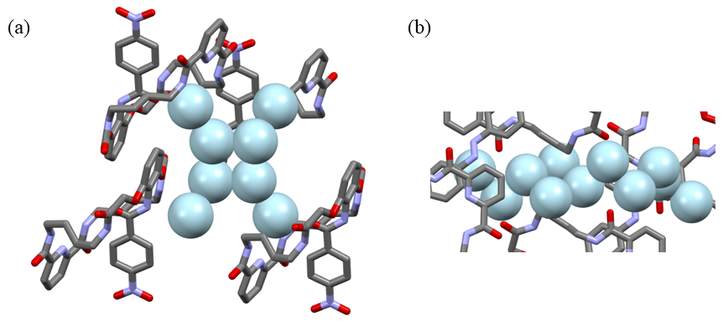

**Figure 1**. Selected water associates (a) water octamer (b) fragment of water tape

#### [1] Dąbrowa, K., Pawlak, M., Duszewski, P., Jurczak, J. (2012) *Org.* *Lett*., **14**, 6298.

[2] Niedbała, P., Majdecki, M., Dąbrowa, K., Jurczak, J. (2020) *J. Org. Chem.***85**, 5058.

[3] Tyszka-Gumkowska, A.; Jurczak., J. (2020) *J. Org. Chem*., **85**, 1308.

[4] Dąbrowa, K., Ceborska, M., Jurczak, J. (2014) *Cryst. Growth Des.*, **14**, 4906.

[5] Dąbrowa, K., Ceborska, M., Jurczak, J. (2018) *Supramol. Chem.*, **30**, 464.

[6] Niedbała, P., Ceborska, M., Mehmet, M., Ignacak, W., Jurczak, J., Dąbrowa, K. (2022) *Materials*, **15**, 692.