# Implementing electric field-stimulated X-ray crystallography at EMBL P14 T-REXX using Hadamard time-resolved X-ray crystallography

## M. Klureza1, J. Estengre Pérez1, E. Römer1, Y. Pulnova2, C. Gaman3, F. Tellkamp4, J. Leimkohl4, M. Kollewe4, M. Nikolova5, H. Schikora4, G. Beddard3, G. Bourenkov5, D. von Stetten5, D. Hekstra6, B. Yorke3, A. Pearson1

### 1University of Hamburg; Hamburg, Germany. 2ELI Beamlines Facility, Extreme Light Infrastructure; Dolní Břežany, Czech Republic. 3University of Leeds; Leeds, United Kingdom. 4Max Planck Institute for the Structure and Dynamics of Matter; Hamburg, Germany. 5European Molecular Biology Laboratory; Hamburg, Germany. 6Harvard University; Cambridge, MA, USA.

### margaret.klureza@uni-hamburg.de

There is an ongoing need for novel experimental methods that can probe biological macromolecules with high spatiotemporal resolution, as many of the cellular functions associated with such molecules originate not from a static molecular structure, but rather from the structural dynamics over time. However, any such methods must be sufficiently accessible to readily trial on new biological systems of interest. Electric field-stimulated X-ray crystallography (EF-X) promises to deliver the requisite spatiotemporal insight by combining the structural resolution of X-ray crystallography with an electric field perturbation that can induce molecular motions within the confines of a crystal lattice (Fig. 1a) [1]. The applied electric field creates a pattern of forces, localized to the presence of charges in each molecule. As these charges are natively present in both proteins (as charged amino acids) and nucleic acids (as the sugar-phosphate backbone), no molecular labeling or other alteration to the system is required in order to use the electric field to trigger a change. The resulting motions can then be detected through X-ray diffraction as changes in the electron density (Fig. 1b).

Until 2023, EF-X experiments had only been performed at the BioCARS Laue beamline of the Advanced Photon Source at Argonne National Laboratory (USA). Like many time-resolved crystallographic methods, EF-X used the polychromatic beam to achieve sufficient photon flux for very fine (ps) time resolution. There are very few Laue beamlines available worldwide, however, posing a barrier to researchers wishing to conduct EF-X experiments who are not based in the US. Moreover, processing Laue diffraction data is significantly more challenging than its monochromatic equivalent. To meet this need, we have recently begun work to expand access to EF-X by pairing it with Hadamard time-resolved X-ray crystallography (HATRX), thus making it compatible with monochromatic beamlines.

HATRX circumvents the flux-induced limitations on achievable time resolution at monochromatic synchrotron beamlines by multiplexing multiple time points into a single diffraction image [2]. Repeating this measurement with different combinations of time points, selected according to a Hadamard encoding matrix, enables subsequent deconvolution of the resulting diffraction intensities to yield the underlying time-resolved data (Fig. 1c). This method was first demonstrated in 2014, with a time resolution of 200 ms. Here, we present proof-of-concept data for a Hadamard implementation of EF-X (EF-HATRX) on the T-REXX endstation of the EMBL P14 beamline at the DESY synchrotron in Hamburg (Fig. 1d). Though an optimized EF-HATRX data processing pipeline is still under development, preliminary data analysis suggests that by weighting the encoding matrix (*i.e.*, including time points of different lengths), we can obtain signal down to sub-µs time resolution.

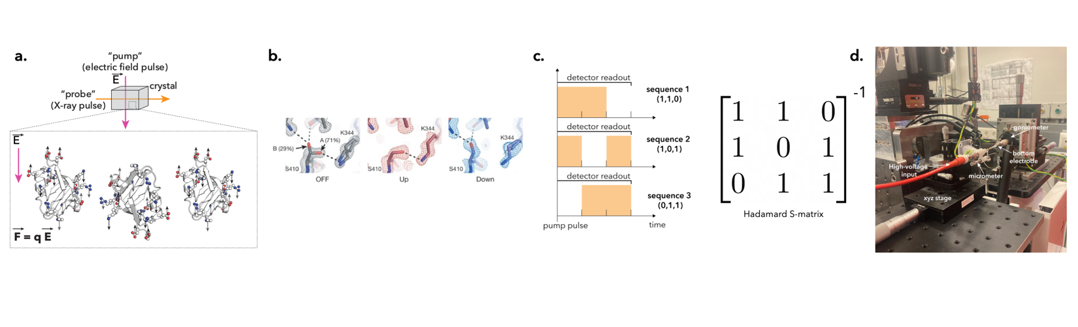

###### **Figure 1**. Fundamental principles of EF-HATRX. **A.** EF-X is fundamentally a time-resolved pump-probe technique, where changes are induced by the electric field and read out through X-ray diffraction. **B.** Electric field-induced changes to the electron density of an LX2 PDZ2 domain. *Reproduced from Ref. 1, Figure 4g, with permission*. **C.** Schematic of a HATRX experiment using a 3x3 encoding matrix (left); the resulting data can be deconvolved using the inverse matrix (right). **D.** EF-X experimental setup at T-REXX.

#### [1] Hekstra, D. R. *et al.* Electric-field-stimulated protein mechanics. *Nature*, 540(7633):400-405, 12 2016.

#### [2] Yorke, B. A. *et al.* Time-resolved crystallography using the Hadamard transform. *Nature Methods*, 11(11):1131-1131, 10 2014.