Orthorhombic symmetry and anisotropic properties of rutile TiO₂

N. Gonzalez Szwacki¹, P. Fabrykiewicz^{2,3}, I. Sosnowska¹, F. Fauth⁴, E. Suard⁵, R. Przeniosło¹

¹Faculty of Physics, University of Warsaw, Pasteura 5,02-093 Warsaw, Poland, ²Institute of Crystallography, RWTH Aachen University, Jägerstr. 17-19, 52066 Aachen, Germany, ³Jülich Centre for Neutron Science at Heinz Maier-Leibnitz Zentrum, Forschungszentrum Jülich GmbH, Lichtenbergstr. 1, 85747 Garching, Germany, ⁴CELLS-ALBA, Carrer de la Llum 2-26, Cerdanyola del Vallés, ES-08290 Barcelona, Spain, ⁵Institut Laue-Langevin, 71 avenue des Martyrs, F-38042 Grenoble, France

radek@fuw.edu.pl
The symmetry of the material is an important factor determining its properties. In this work [1], we demonstrate both experimentally and by numerical simulations that the actual symmetry of the rutile phase of TiO₂ is orthorhombic, described by the space group Pnnm, see Fig. 1, in contrast to the commonly held view that rutile TiO₂ has a tetragonal symmetry, described by the space group P4₂/mnm [2, 3]. We present very precise first-principles calculations for the determination of the structural properties of rutile TiO₂ and highlight the relevance of using the revised regularized SCAN meta-GGA density functional for the interpretation and analysis of neutron and synchrotron radiation diffraction measurements. The symmetry lowering has a small but not negligible influence on the elastic, vibrational, and optical properties of rutile TiO₂. The symmetry breaking observed for TiO₂ is similar to that reported for β-PbO₂ [4].

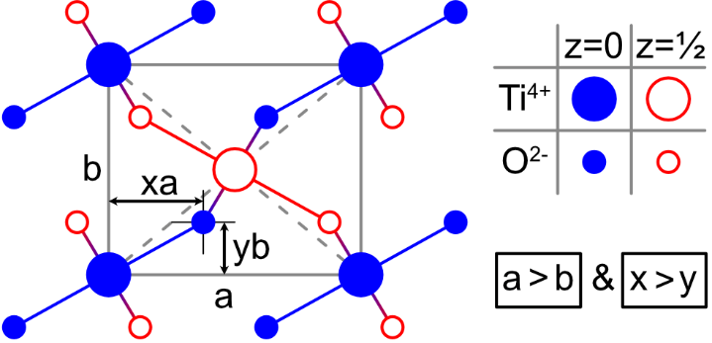
Figure 1. Schematic view of the Pnnm TiO₂ unit cell along the c-axis.
Note the correlation of the oxygen atom position with the unit cell parameters.

[1] Gonzalez Szwacki N., Fabrykiewicz P., Sosnowska I., Fauth F., Suard E. & Przeniosło R. (2023). J. Phys. Chem. C 127, 19240.
[2] Burdett J. K., Hughbanks T., Miller G. J., Richardson J. W. J. & Smith J. V. (1987). J. Am. Chem. Soc. 109, 3639.
[3] Cromer D. T. & Herrington, K. (1955). J. Am. Chem. Soc. 77, 4708.

[4] Fabrykiewicz P., Przeniosło R., Gonzalez Szwacki N., Sosnowska I., Suard E. & Fauth F. (2021). Phys. Rev. B 103, 064109.

