iSFAC modelling: experimental quantification of partial charges with electron diffraction

T. Gruene¹, S. Mahmoudi¹, Chr. Schroeder¹

¹Core Facility Crystal Structure Analysis, Faculty of Chemistry, University of Vienna, Waehringer Strasse 42, 1090 Vienna, ²Department of Computational Biological Chemistry, Faculty of Chemistry, University of Vienna, Waehringer Strasse 17, 1090 Vienna

Email: tim.gruene@univie.ac.at
Partial charges are an important concept in chemistry. The assignment of partial charges to the atoms within a molecule aids to understand their behaviour and reactivity. Quantum chemical computations provide means for a quantitative approach, but with substantial variations among different methods. Ultra-high resolution X-ray crystallography is an experimental method to determine partial charges, but many crystals are not of sufficient quality to reach the required data quality, and the measurement is time consuming. Often, partial charges are assigned only qualitatively through the labels δ⁺ or δ⁻.
Electrons interact with the electrostatic potential, that is, the combination between the electron cloud and the positively charged nuclei. This makes electron scattering sensitive to oxidation states, and electron diffraction seems a natural approach to probe partial charges. We developed iSFAC modelling in order to quantify partial charges of atoms from electron diffraction data. We found that meaningful results can be achieved with “normal” resolution data to about 0.8-0.9Å.
iSFAC modelling makes use of the SHELXL FVAR formalism and is based on a linear combination of neutral and ionic scattering factors. An unusual interpretation of the Mott-Bethe formula is used to compute the ionic scattering factors (Yonekura et al 2018 [1]).
We used XDS for data processing and SHELXL for refinement. Despite this simplified approach, ignoring dynamic scattering effects, we find striking details in our results, backed up by comparison with quantum chemical computations in several compounds like histidine, calcium tartrate from a bottle of Austrian wine, the chlorine salt of ciprofloxacin, and the zeolite ZSM-5. With future development in combination with more advanced programs specifically designed for electron diffraction, iSFAC modelling can be expected to provide unprecedented details and novel insight into the world of molecular interactions based on electron diffraction.

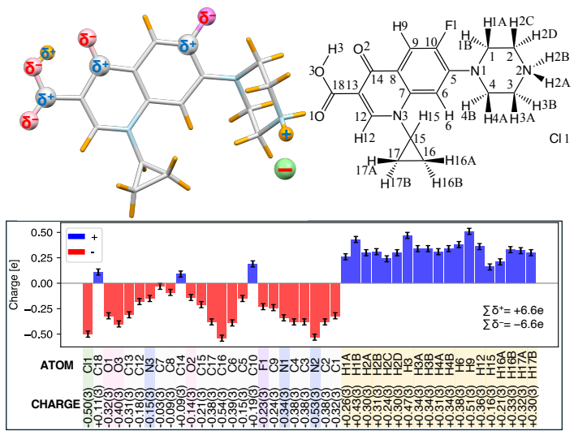Fig. 1: The molecule ciprofloxacin chloride and its partial charges determined with iSFAC modelling.

[1] Yonekura, K. et al. Ionic scattering factors of atoms that compose biological molecules. IUCrJ 5, 348–353 (2018).
We thank Richard Henderson, who triggered the idea of refining scattering factors for electron diffraction (Murnau Conference 2016). We are grateful to DECTRIS Ltd. (CH) for the loan lending a SINGLA 1M detector.. This research was funded in part by the Swiss National Science Foundation (SNSF) grant number: 215650. “Measuring the electrostatic potential of complex chemical com pounds and functional materials by electron diffraction”. This research was funded in part by the Austrian Science Fund (FWF): I 6546-N. “Electrostatic potential through charge-integration”.

