# High temperature phase transition in a 1:1 co-crystal of butyl *p*-hydroxybenzoate:isonicotinamide.

## M.R.J. Elsegood1, C. Li1, H. Yang1, J.P. Orton2

### 1Chemistry Dept. Loughborough University, Loughborough, LE11 3TU, UK (Heading 3 style, Times New Roman 10pt, italic), 2UK National Crystallography Service, School of Chemistry & Engineering, University of Southampton, SO17 1BJ, UK.

### Email of communicating m.r.j.elsegood@lboro.ac.uk

Butylparaben (butyl *p*-hydroxybenzoate) is used in cosmetics and pharmaceuticals and is a naturally-derived preservative, while isonicotinamide is a common co-former, with both considered safe materials. The crystal structure of butylparaben-isonicotinamide was first reported by our team in 2016 as a single crystal study at 150 K [1] {CCDC PAGCAE}. The structure shows a hydrogen-bonded, slightly undulating, sheet packing arrangement. Our recent studies, using other techniques, have indicated that there are structural changes that occur at elevated temperatures, approx. in the range 91-94°C.

Thermogravimetric analysis through this temperature range indicted no mass loss, indicating no decomposition of the constituent components. DSC scans (Fig. 1) showed a small, endothermic peak at around 93.6°C and a melting point of *ca*. 110°C. Optical analysis via photographic and video recording of images, showed single crystals jumping, moving, and changing morphology in response to heating. Variable-temperature PXRD experiments starting from 30°C, going past the proposed transition temperature, and back down to 30°C were largely inconclusive.

Thus, we have, very recently (May 2025), undertaken an extensive series of VT single crystal experiments to further understand the structural changes at these elevated temperatures. In total, 19 data sets were collected, and we have succeeded in identifying the second, high temp. polymorph. The poster will present the analysis of these latest SCXRD VT experiments.

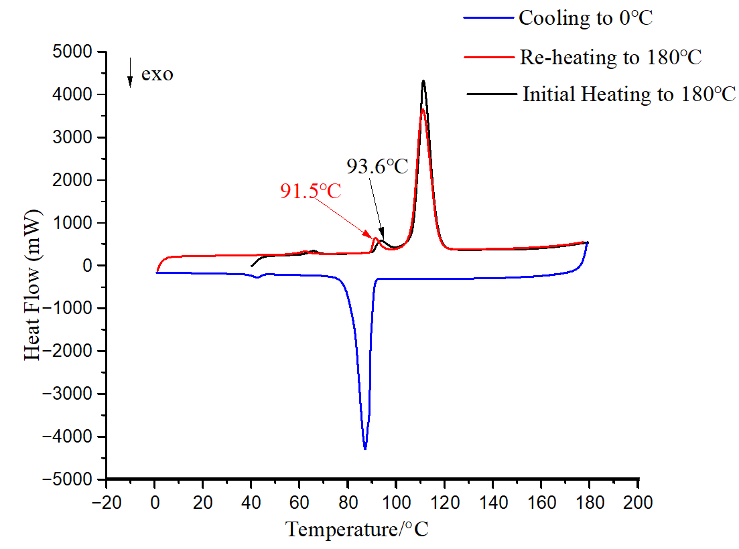

###### **Figure 1**. DSC curve of 1:1 co-crystal of butyl paraben:isonicotinamide.

#### [1] Bhardwaj, R. M, Yang, H., & Florence, A. (2016). *Acta Cryst.,* **E72**, 53-55.