Varied-temperature and high-pressure investigations of tris(pentafluorophenyl)borane

J. Dorna, A. Katrusiak, S. Sobczak

Faculty of Chemistry, Adam Mickiewicz University, Uniwersytetu Poznańskiego 8, 61-614 Poznań, Poland

jandor1@st.amu.edu.pl

Tris(pentafluorophenyl)borane, known as BCF (Figure 1), is a compound with uncommon Lewis acidity and remarkable thermal stability, distinguishing it from similar organoboranes.¹ Due to its unique “paddle-wheel” structure — three bulky perfluorophenyl groups arranged around an unsaturated boron center — BCF has become an important representative of frustrated Lewis pair systems (FLPs). FLPs are currently in the spotlight as heavy-metal-free catalytic agents, offering efficient acceleration of reactions that often surpasses that of conventional catalytic systems, particularly in the field of hydrogenation.²˒³˒⁴ The conformation of the BCF molecule and the spatial arrangement of the perfluorophenyl moieties are directly linked to its chemical properties, which underscores the importance of exploring the structure–property relationship in this class of materials.

In this work, BCF single crystals were investigated under variable temperature and high-pressure conditions using single-crystal X-ray diffraction, complemented by Raman spectroscopic measurements. The experiments were designed to probe structural deformations and changes in intermolecular interactions, with the aim of identifying conformational changes that may influence the Lewis acidity and reactivity of BCF.

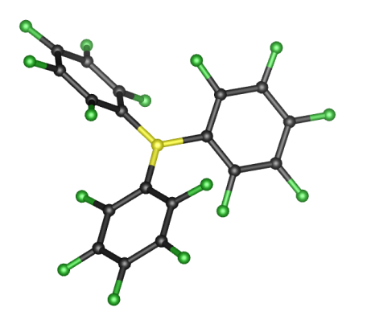

**Figure 1**. Paddle-wheel structure of the BCF molecule. Colour code: boron - yellow, carbon - black, fluorine - green.

[1] Massey, A. G., Park, A. J. (1964). *Journal of Organometallic Chemistry,* **2**, 245.

[2] Stephan, D., Erker, G. (2010). *Angew. Chem. Int. Ed.,* **49**, 46*.*

[3] Tamke, S., Qu, Z.-W., Sitte, N. A., Flörke, U., Grimme, S., Paradies, J. (2016). *Angew. Chem. Int. Ed.,* **55**, 4336.

[4] Paradies, J. (2018). *Coordination Chemistry Reviews*. **380**, 170.