**MS Microsymposium**

**Periodic trends of stereochemical activity of lone electron pairs: comparison between two models**

**M. Mangir Murshed1,2**

*1University of Bremen, Institute of Inorganic Chemistry and Crystallography, Leobener Straße 7, D-28359 Bremen, Germany, 2MAPEX Center for Materials and Processes, Bibliothekstraße 1, D-28359 Bremen, Germany*

*murshed@uni-bremen.de*

In a series of papers, Wang and Liebau [1-3] pointed out that the bond valence sum calculated for a lone electron pair (LEP) cation increases as the cation’s coordination environment becomes more distorted. They proposed to associate the geometric distortion of the LEP-coordination as the measures of the stereochemical activity of the LEP using the term eccentricity which we later coined as Wang-Liebau eccentricity (WLE) parameter [4]. Most of the polyhedral distortion indices [5-9] are purely geometric and cannot account for the interaction strength between the electronic environments around the atoms. In contrast, the WLE parameter describes the weighted bond length with an exponential function, allowing the electrostatic flux strength of a chemical bond to exponentially decrease with increasing bond length. Sampling on crystal information data of As-, Se-, Sn-, Sb-, Te-, Tl-, Pb- and Bi-oxide coordinations, a statistical approach demonstrates that the WLE parameter of the LEP-cations follows a periodic trend (Fig. 1). As such, materials with functional physico-chemical properties can be designed for crystalline samples with LEP containing cations. It is therefore predicted that the ferroelectric polarization follows the order GeTiO3 > SnTiO3 > PbTiO3 due to increasing upward WLE of the LEP-cations. This study also includes a detailed comparison between the WLE and Hamani approach [10] for the periodic trends of some LEP cations.

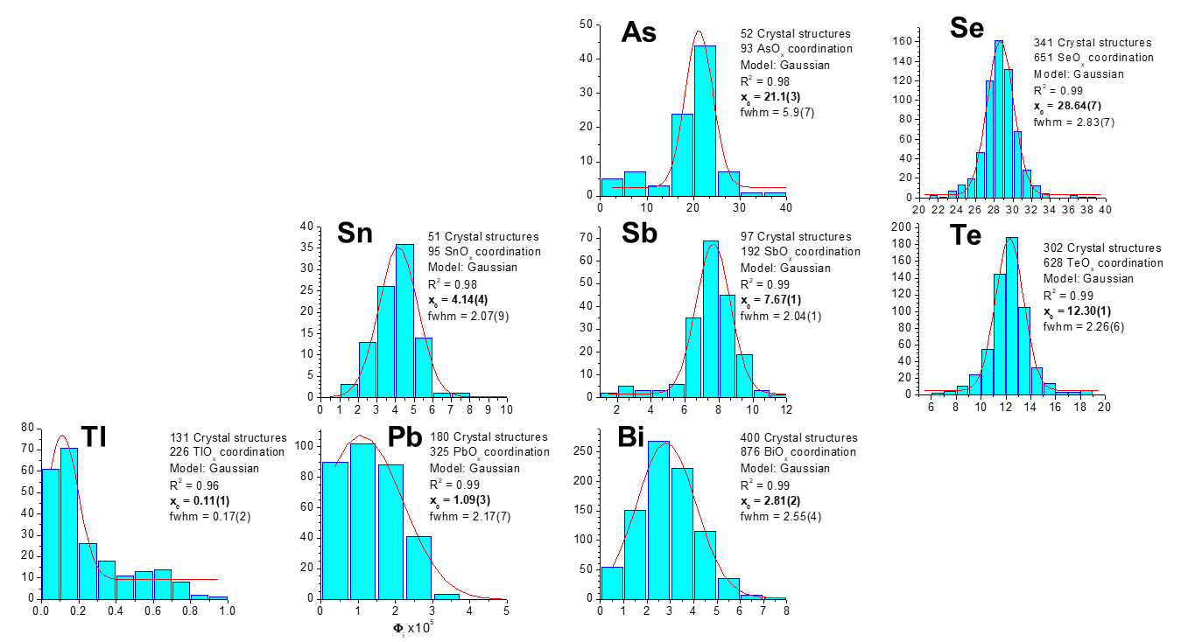

**Figure 1**. Statistical approach demonstrates that the WLE parameter of the LEP-cations of the selective metal oxides increases rightward and upward, showing a periodic trend.

[1] Wang, X. & Liebau, F. (1996). *Z. Kristallogr.* **211**, 437.

[2] Wang, X. & Liebau, F. (2007). *Acta Crystallogra*. *B.* **63**, 216.

[3] Liebau, F., Wang, X. & Liebau, W. (2009). *Chem. - A Eur. J.* **15**, 2728.

[4] M. Curti, M., Gesing, T.M., Murshed, M.M., Bredow, T. & Mendive, C.B. (2013). *Z. Kristallogr*. **288**, 629.

[5] Robinson, K., Gibbs, G.V. & Ribbe, P.H. (1971). *Science*. **172**, 567.

[6] Gaite, J.M. (1980). *Phys. Chem. Miner.* **6**, 9.

[7] Dollase, W.A. (1974). *Acta Crystallogr. A*. **30**, 513.

[8] Makovicky, E. & Balić-Žunić, T. (1998). *Acta Crystallogr. B.* **54**,766.

[9] Halasyamani, P.S. (2004). *Chem. Mater.* **16**, 3586.

[10] Hamani, D. Masson, O. & Thomas, P. (2020) *J. Appl. Cryst.* **53**, 1243.