# A score and nine years of irbesartan

## Farzaneh Fadaei-Tirani1, Philippe Ochsenbein2*, Michel Bonin3, Marie-Hélène Lemée4, Jérôme Kieffer5, Daniel Görl6, Mohamed El-Hajji1 and Kurt Schenk-Joß7*

### 1SB-ISIC-XRDSAP, École Polytechnique Fédérale, Lausanne (EPFL), Switzerland, 2SANOFI, Rue du Professeur Blayac, Montpellier, France, 3Departement für Chemie und Biochemie, Universität Bern, Freiestraße 3, Switzerland, 4Institut Laue-Langevin, Grenoble, France, 5ESRF, Grenoble, France, 6EPFL-STI-IMX-LMOM, Lausanne, Switzerland, 7EPFL-SB-PHYS-LQM, Lausanne, Switzerland

### kurt.schenk@epfl.ch

Irbesartan is a non-peptide antagonist of the angiotensin-II-AT1 receptor and is used for the treatment of hypertension. Here, the history, achievements and open questions related to irbesartan are examined [1]. Tautomery of the tetrazole moiety leads to two desmotropes [2], A and B. Roughly ten dozen data collections on single crystals at various temperatures, from X-rays and neutrons, are presented, deposited and interpreted; new structures are described and a detailed evolution of the thermal expansion is achieved. Disorder of the n-butyl-chains is observed in A and B. The trigonal desmotrope A builds its structure incorporating a hydrate channel upon nucleation. The hydrophobic nature of the *n*-butyl-chains induces the growth of a flat crown of chains in a meta-stable phase, disappearing after the thermally activated creation of a gauche conformer that distorts this wreath to a more prolate shape. This irreversible, conformational transition leads, henceforth, to a different evolution of lattice parameters and thermal expansion; the water inclusion explains the strained, imperfect crystallites, complex solubilities [3], a capricious packing coefficient and slow growth. In the triclinic desmotrope B, the all-*trans* → *gauche* disorder in the n-butyl-chain leads to random, diffuse changes in the structure between 265 and 165 K. As confirmed by calorimetry and thermal expansion, these subtle, local re-arrangements do not affect the space group and trigger a reversible, first-order phase transition at 208 K. The neutron study brings desirable clarity regarding the geometry of the tetrazole and its hydrogen, and precious reference values for the weak interactions. Focussing on the tetrazole and the n-butyl-chains, we propose an alternative interpretation of the 15N NMR spectra [4], published more than two decades earlier.

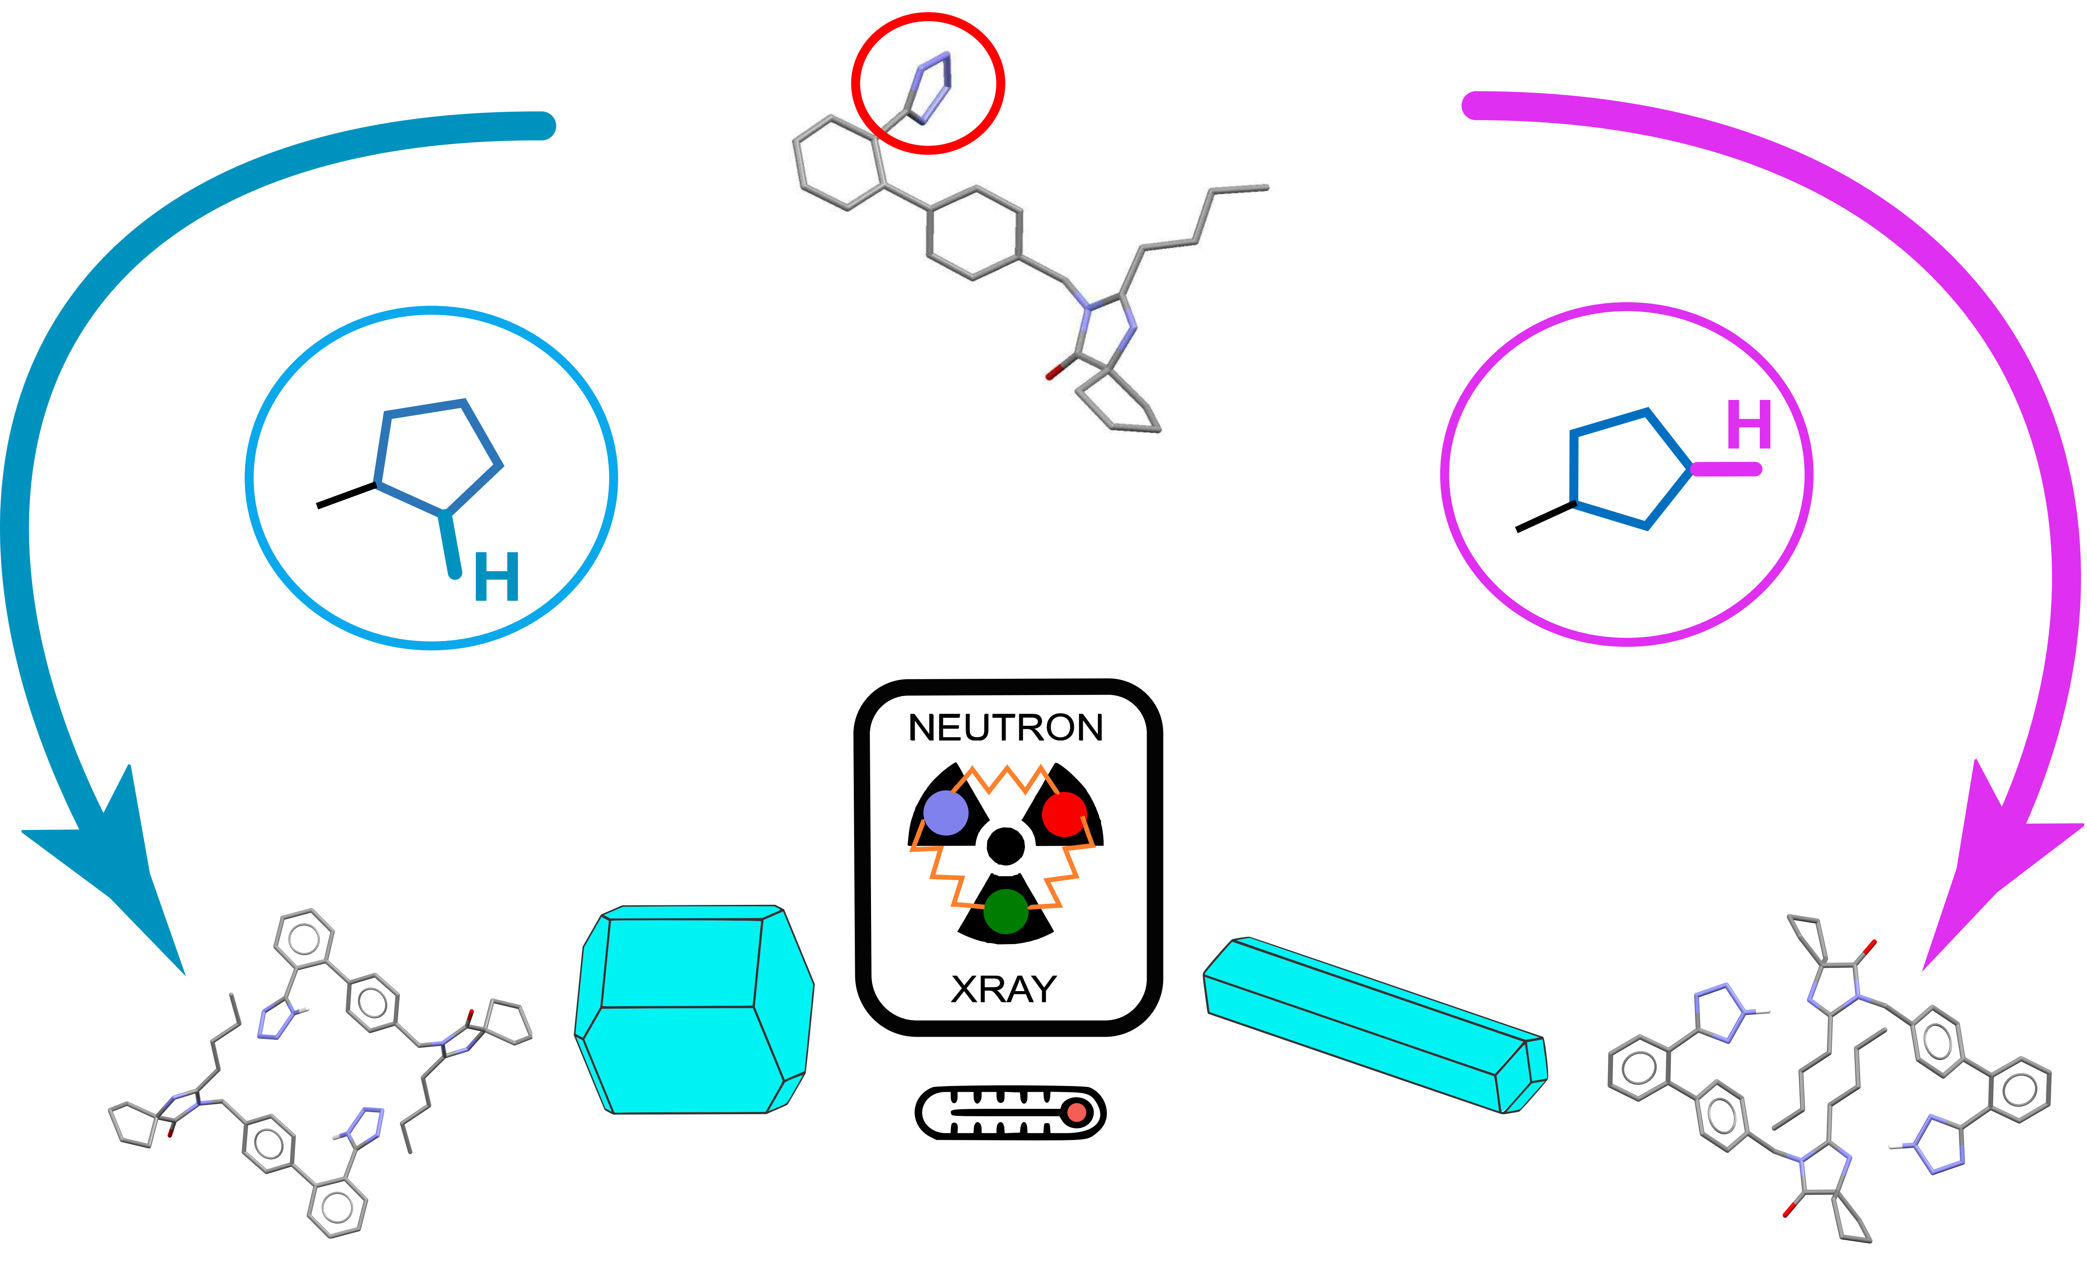

###### **Figure 1**. IRBESARTAN exists as two tautomers A and B, in diverse solvent-mixtures. Homogeneous nucleation leads to (pseudo)polymorphs with layer-wise or columnar growth.

###### The desmotropes present different habits, thermal expansion, stability and phase transitions.

References:

#### [1] C. Cazaubon, J. Gougat, F. Bousquet, P. Guiraudou, R. Gayraud, C. Lacour, A. Roccon, G. Galindo, G. Barthelemy, B. Gautret, C. Bernhart, P. Perreaut, J.-C. Breliere, G. Le Fur and D. Nisato, J. Pharmacol. Exp. Ther., 1993, 265(2), 826–834.

#### [2] J. Elguero, Cryst. Growth Des., 2011, 11, 4731–4738.

#### [3] P. Taulelle, G. Sitja, G. Pépe, E. Garcia, C. Hoff and S. Veesler, *Cryst. Growth Des.*, 2009, **9**, 4706–4709.

#### [4] M. Bauer, R. K. Harris, R. C. Rao, D. C. Apperley and C. A. Rodger, J. Chem. Soc., Perkin Trans. 2, 1998, 475–481.