In-situ investigation of water harvesting by CAU-10-OH MOF: a 2-steps process

G. Nénert¹, M. Gateshki¹, J. Gertenbach¹, D. Rega², M. van der Veen²

¹Malvern Panalytical B. V., Lelyweg 1, 7602 EA, Almelo, ²TU Delft, Delft, The Netherlands

gwilherm.nenert@malvernpanalytical.com
MOFs exhibits interesting harvesting water capabilities from the air or as heat pumps as they demonstrate a steep increase in water uptake in the range 10-30 RH% [1]. Optimal water isotherms are represented by an alternation of moderately hydrophilic and hydrophobic sites. However, even within MOFs exhibiting such alternation, the required steep uptake of water relevant for real applications is quite scarcely met [2]. Recently, we have studied the CAU-10-X (H = H, CH₃) members and unravelled the materials’ structural deformation and water ordering during absorption [3]. We have shown that the steric hindrance of the -CH₃ group lowers the number of average hydrogen bonds from 3.3 to 2.3 explaining the difference in the water uptake behaviour.
Among the various members of the CAU-10-X family, X = OH is particularly interesting as this is the only composition where a steep 2-step process is taking place within the isotherm [2]. Aiming to determine a conceptual understanding of the mechanism resulting from this water absorption to design “de novo” water harvesting materials, we have investigated the members X = OH using in-situ relative humidity powder diffraction. We present in Fig. 1 our results for X = OH. These results demonstrate for the first time the existence of an intermediate phase.

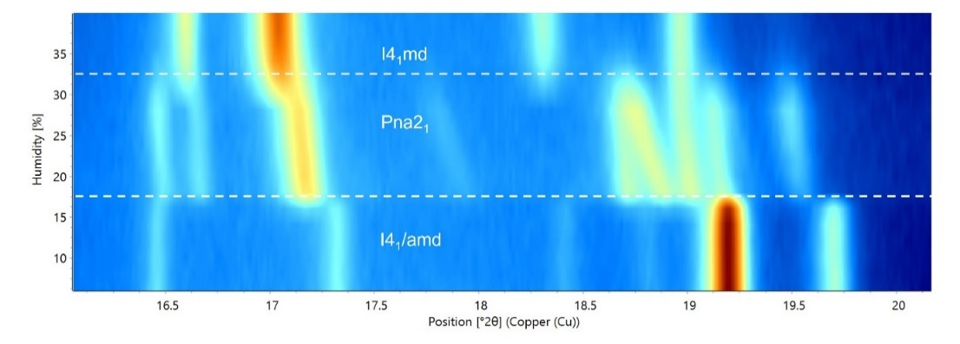

Figure 1. In-situ relative humidity study of CAU-10-OH carried out at T = 60°C.

The existence of this intermediate phase stabilized under temperature and moderate RH shed some new light in our understanding and call for further investigation of the water uptake mechanism. The possibility to stabilize and study an intermediate phase enables us to have further understanding of the water uptake mechanism

[1] M. J. Kalmutzki, C. S. Diercks, O. M. Yaghi, (2018) Adv. Mater., 30, 1.

[2] Reinsch, H. van der Veen, M.A. et al., (2013) Chem. Mater., 25, 17.

[3] van der Veen, M. et al., (2024) Adv. Mater. , 36, 2210050

