# High-*Z*’ phases of n-butanol

## *S. Sobczak1*

### 1Materials Chemistry Department, Adam Mickiewicz University, Poznan

### szymon.sobczak@amu.edu.pl

The amphiphilic molecule *n*-butanol (C4H9OH), despite its industrial relevance and long-standing chemical importance, has long posed experimental challenges due to its pronounced tendency to form amorphous states under cooling or compression. In this study, we present the single-crystal investigations of *n*-butanol conducted under both low-temperature and high-pressure conditions, enabled by *in situ* crystallization within a glass capillary and in a diamond anvil cell, respectively.

At ambient pressure and low temperature, *n*-butanol crystallizes in the triclinic space group *P*1 (phase α).[1,2] The asymmetric unit contains two symmetry-independent molecules, A and B (*Z*′ = 2). These molecules form O–H⋯O chains closely approximating 21 screw axis symmetry linking the alternating molecules A and B along the [100] direction. The compression above 1.2 GPa yield another form of butanol (phase β) of the monoclinic space group *P*21/*n*, with three independent molecules (*Z*′ = 3). In the structure, two distinct hydrogen-bonding chains are apparent: one composed of molecules A and C related by glide symmetry, and another formed solely by molecules B around a 21 screw axis.

Although differing in the conditions where they were obtained, both phases retain a similar aggregation motif, with H-bond chains in both forms formed by two independent molecules. This indicates a common mechanism for the formation of the pre-associated molecular clusters.[3] The emergence of *Z*′ > 1 in both structures underscores the influence of conformational frustration and directional intermolecular forces in shaping molecular packing under varying thermodynamic constraints.[4]

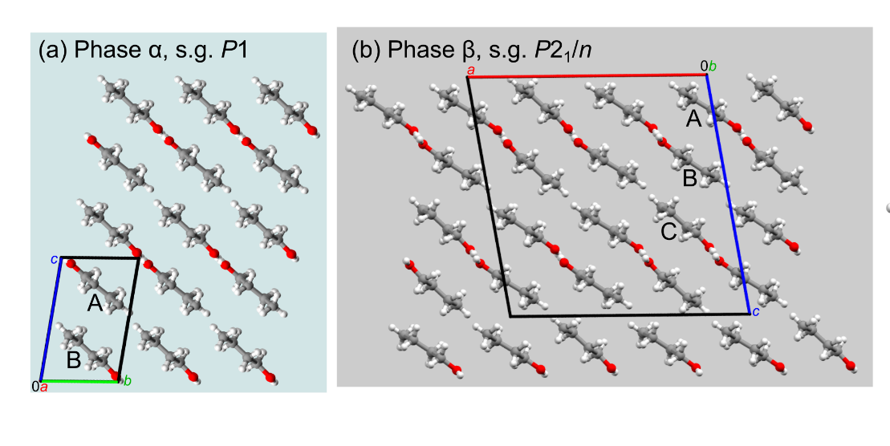

###### **Figure 1**. Structure of two polymorphs of n-butanol: (a) low-temperature phase α, and (b) high-pressure phase β.

#### [1] Shmyt’Ko, I. M., Jiménez-Riobóo, R. J., Hassaine, M. & Ramos, M. A. J. (2010) *Condens. Matter Phys*., **22**, 195102.

#### [2] Derollez, P., Hédoux, A., Guinet, Y., Danède, F. & Paccou, L. (2013) *Acta Crystallogr. B,* **69**, 195–202.

[3] Kuleshova, L. N., Antipin, M. Yu. & Komkov, I. V. (2003) *J Mol. Struct.* **647**, 41–51.

[4] Brock, C. P. & Duncan, L. L., (1994) *Chem. Mater.,* **6**, 1307-1312.