# Introducing Instruct Image Processing Center (I2PC), a cryo-EM image processing facility of the Spanish Instruct Center (Instruct-ES)

## Gragera M1,2., Herreros D.1, Melero R.1,2, Sorzano COS.1,2, Carazo JM.1,2

*1Centro Nacional de Biotecnología (CNB), CSIC, 28049, Madrid, Spain, 2Instruct Image Processing Center. Centro Nacional de Biotecnología (CNB), CSIC, 28049, Madrid, Spain.*

### mgragera@cnb.csic.es

Cryogenic electron microscopy (cryo-EM) is a well-established technique for determining the structure of macromolecular complexes at high resolution [1]. Single-particle analysis (SPA) enables the reconstruction of one or a few structures by aligning and averaging thousands of individual projections of a biological specimen in a cryo-EM dataset. However, these methods capture only discrete states of a protein’s conformational landscape, even though cryo-EM data contain valuable information about molecular motions.

Recent advances in image processing have begun to exploit this information, allowing researchers to explore conformational flexibility and improve the resolution of moving subregions within protein complexes. As interest in these methods grows, Instruct-ES, the Spanish center of Instruct, the European research infrastructure for Integrative Structural Biology, introduces *FlexibilityHub* [2], a new service designed to extract and analyze structural dynamics from cryo-EM data.

*FlexibilityHub* is now freely available to eligible users alongside our established SPA service. To illustrate the potential of this service, we present several key use cases that highlight its capabilities and the benefits it offers to researchers, all powered by Scipion, our in-house developed image processing platform from cryo-EM.

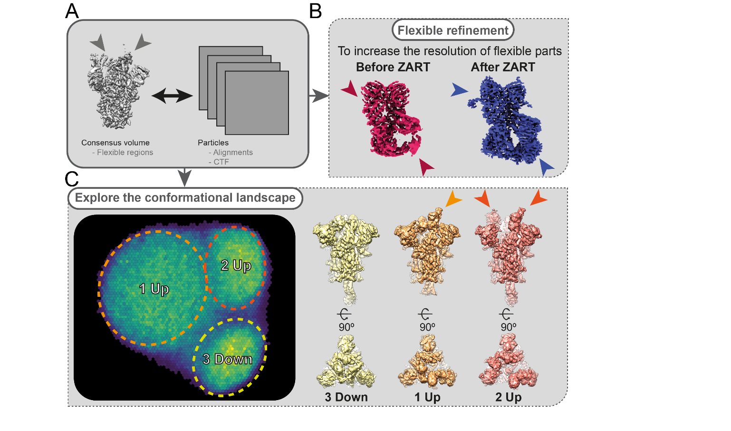

###### **Figure 1**. Two use cases of the methods offered in the FlexibilityHub service. (A) The starting material consists of a set of cryo-EM particles (with alignments and CTF) and a consensus volume obtained from such particles. Note that some regions are at lower resolution due to its flexibility (grey arrowheads). (B) Flexible regions, solved at poorer resolution (red arrowheads), can undergo a flexible refinement to improve their resolution locally (blue arrowheads) by leveraging the flexibility information contained in the particles. (C) Alternatively, an extensive assessment of the sample conformational space can be performed to identify populations of particles displaying different, but coexisting conformations (dashed circles in left panel). Representative volumes of each cluster in the conformational space are shown in the right panel. Arrowheads point at Receptor Binding Domains (RBDs) in “Up” conformation.

#### [1] Saibil H. R. (2022). *Molecular cell*, *82*(2), 274–284.

#### [2] Herreros, D., Krieger, J. M., Fonseca, Y., Conesa, P., Harastani, M., Vuillemot, R., Hamitouche, I., Serrano Gutiérrez, R., Gragera, M., Melero, R., Jonic, S., Carazo, J. M., & Sorzano, C. O. S. (2023). *Acta crystallographica. Section D, Structural biology*, 79(Pt 7), 569–584.