# Synthesis and crystal structure of two new Ag(I) complexes with 3-(1-pyrazolyl)- l-alanine

## Paul Thomashausen1,2, Dominik Triska1,2, Milica G. Bogdanović2, Goran N. Kaluđerović1, Mirjana M. Radanović2

### 1University of Applied Sciences Merseburg - Department of Engineering and Natural Sciences, Merseburg, Germany 2University of Novi Sad - Faculty of Sciences, Novi Sad, Serbia

### paul.thomashausen@stud.hs-merseburg.de

Pyrazole derivatives are key heterocycles in organometallic chemistry, known for coordinating with various metal centers and forming hydrogen bonds. Their chemical behavior varies, enabling applications from anti-inflammatory drugs like Antipyrine to anticancer complexes, such as Ga(III) coordinated with (N,N,O)-tridentate pyrazole-imine-phenol ligands [1]. Silver(I), with its *d*¹⁰ electron configuration, possesses characteristics that make it particularly well-suited as a central atom in coordination chemistry. It can accommodate diverse coordination geometries. Whether in the form of simple salts or more complex coordination compounds, silver(I) is also widely recognized for its pharmaceutical relevance, particularly in the treatment of microbial infections [2]. In this work, we report the synthesis and structural characterization of two novel silver(I) coordination complexes with the ligand   
3-(1-pyrazolyl)- l-alanine (L), formulated as [Ag₂(L)₂](NO3)2 (**1**) and [Ag(L)₂]ClO₄ (**2**).

The complexes were obtained throughout the reaction of the aqueous silver salt solution, either AgNO3 or AgClO4, and the ligand in a 1:1 molar ratio. From the resulting colorless solutions, after some weeks clear crystals were filtered off. The structure of the compounds was confirmed by X-ray diffraction (Fig. 1). The ligand exhibits a NO coordination mode. The asymmetric unit of **1** consists of two Ag+ ions, two L molecules in their zwitter-ionic form, and two nitrate anions. This formation yields a six-membered bimetallocycle with its metal centers in a distorted tetrahedral environment (τ4 = 0.673) in a somehow angled seesaw shape, that forms polymer strands. *Crystallographic data: for* ***1****:* monoclinic crystal system, *P*21, *a* = 5.2092(3), *b* = 24.737(2), *c* = 7.7314(6) Å, *β* = 90.241(6) °, *V* = 996.3(2) Å3, *Z* = 2. Refinement based on *F*2 (292 parameters): *R*1 = 0.0951, *wR*2 = 0.1425, *S* = 1.025, for all data, and *R*1 = 0.0645 for 4586 reflections with *I* ≥ 2*σ*(*I*). Complex **2** shows a molecular structure, which consists of one Ag+ central atom coordinated by two L molecules as well as one perchlorate anion. Formed a four-membered metallocycle, similarly to complex **1**, showing an angled seesaw geometry (τ4 = 0.693) that forms layers in the crystal lattice. *Crystallographic data for* ***2****:* monoclinic crystal system, *P*21, *a* = 10.0057(9), *b* = 9.3727(5), *c* = 10.6564(9) Å, *β* = 117.08(1) °, *V* = 889.8(2) Å3, *Z* = 2. Refinement based on *F*2 (255 parameters): *R*1 = 0.1002, *wR*2 = 0.2055, *S* = 1.052, for all data, and *R*1 = 0.0677 for 3202 reflections with *I* ≥ 2*σ*(*I*).

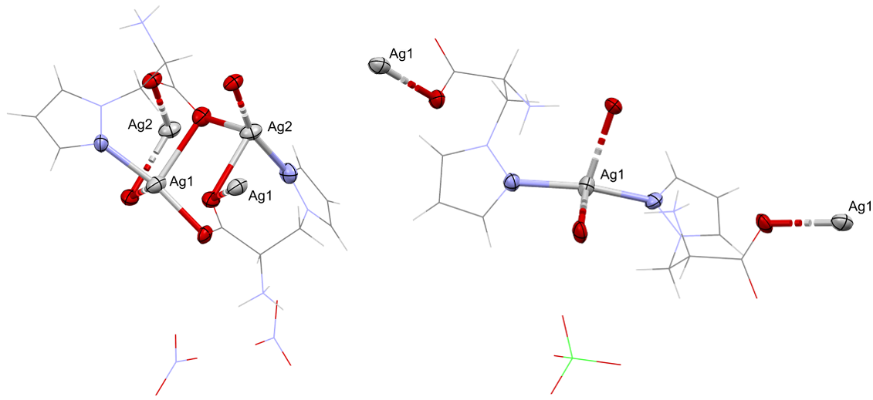

###### **Figure 1**. Crystal structure of **1** (left) and **2** (right)

#### [1] S. Gama, F. Mendes, F. Marques, I. C. Santos, M. F. Carvalho, I. Corrheia, J. C. Pessoa, I. Santos, A. Paulo, Journal of Inorganic Biochemistry, 2011, 105, 637.

#### [2] M.A. El-Naggar, H.H. Al-Rasheed, S.A. AL-khamis, A. El-Faham, M.A.M. Abu-Youssef, M. Haukka, A. Barakat, M.M. Sharaf, S.M. Soliman, Inorganics 2023, 11, 395.

The authors gratefully acknowledge the financial support of the Ministry of Science, Technological Development and Innovation of the Republic of Serbia (Grants No.