# Supramolecular confinement of antibacterial agent within macrocyclic hosts: a structural study

## O. Danylyuk1, K. Kravets1

### 1Institute of Physical Chemistry, Polish Academy of Sciences, Kasprzaka 44/52, 01-224 Warsaw, Poland

### odanylyuk@ichf.edu.pl

The host-guest complexes formed by non-covalent interactions are promising design elements for supramolecular architectures of biomedical applications, including antibacterial treatments [1]. The demanding properties of such supramolecular materials are bacteria inhibition, eradication of biofilms, combating bacterial resistance, and others. The initial reports suggest that macrocycle-based supramolecular materials can supplement traditional drugs and overcome their limitations in the fight against antimicrobial resistance. The supramolecular hosts of versatile structures, functionalities and host-guest properties have received increased attention as candidates for macrocycle-based antimicrobial platforms [2]. The structural insight into the host-guest complexes comprising antibacterial agents would be beneficial in terms of their potential supramolecular formulations and/or crystal forms. Here we discuss crystallization and crystal structure of antimicrobial drug chlorhexidine complexes with macrocyclic hosts of cucurbit[*n*]uril and *p*-sulfonato-calix[*n*]arene families, Fig. 1.

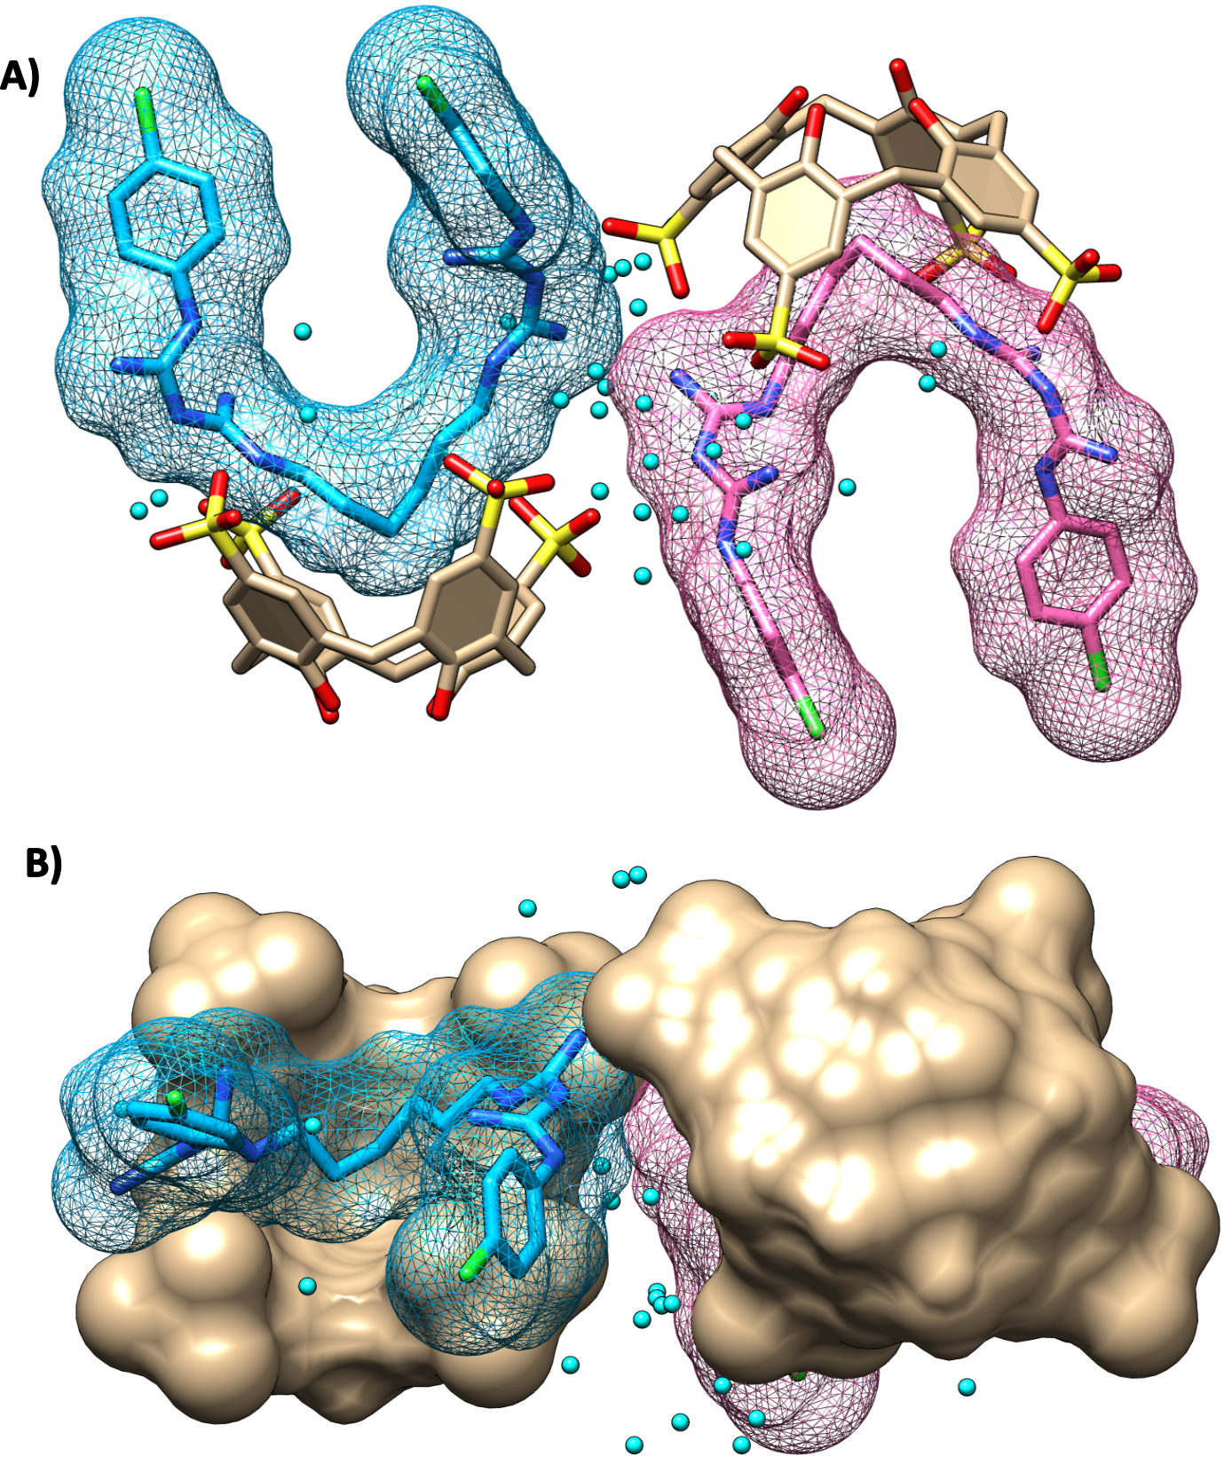

###### **Figure 1**. Host-guest complex of *p*-sulfonato-calix[4]arene with chlorhexidine: A) side view; B) top view. Two crystallographically non-equivalent chlorhexidine molecules colored in blue and pink. Water molecules in cyan.

#### [1] Wang, X., Ma, L., Li, C., Yang, Y.-W. (2024). *Chem. Mater.* **36**, 5, 2177.

#### [2] Panigrahi, S. D., Mayhan, C. M., Dar, A. A., Kelley, S. P., Greenwood, A. I., Hassett, D. J., Deakyne, C. A., Kumari, H. (2023). *Cryst. Growth Des.* **23**, 3, 1378.

The authors thank the Polish National Science Center for financial support (OPUS grant UMO-2023/49/B/ST5/01472)