# Why nanoparticle bulk matters: Vacancies shape morphology, morphology affects electrochemical and optical properties

## Ilia Smirnov1*, Zbigniev Kaszkur2 , Mohit Chaudhary3, Hans-Christian Weissker3, Riccardo Ferrando4 , Sylwia Zoladek1, Pawel Kulesza1

### 1 University of Warsaw, Warsaw, Poland; 2Institute of Physical Chemistry, Warsaw, Poland; 3 Aix-Marseille University, CNRS, CINaM UMR 7325, 13288 Marseille, France; 4 University of Genoa, Genoa, Italy

### Email of communicating i.smirnov@uw.edu.pl; ismirnov@ichf.edu.pl

The internal crystallographic structure of noble metal nanoparticles (NPs) significantly influences their electrochemical and optical properties. Among structural imperfections, stacking defects such as twin boundaries and stacking faults are of particular importance. While their presence is well-documented, strategies for intentional control of bulk crystallography remain underdeveloped.

Here, we introduce a computationally derived *vacancy-driven twinning* (VDT) mechanism, which enables the transformation of initially perfect face-centered cubic (fcc) nanoclusters into locally hexagonal close-packed (hcp) domains. When a critical concentration of vacancies (≥13%) is introduced, the fcc lattice becomes unstable, promoting the formation of stacking faults and twinned structures [[1]].

To explore this phenomenon, we employed ***multidomain X-ray diffraction (MDXRD)*** and **small-angle X-ray scattering (SAXS)** [[2]] on Au–Pt alloy nanoparticles, providing crystallographic evidence of bulk reorganization. Building on these insights, we synthesized bulk-modified Ag NPs, which displayed improved performance in oxygen reduction reaction (ORR) testing compared to unmodified particles.

We also examined how crystallographic morphology affects optical properties. Using ***TDDFT+U* simulations** [[3]], we analysed the localized surface plasmon resonance (LSPR) in spherical silver nanoclusters with and without twinning defects. The presence of twins resulted in broadening and dampening of LSPR features, consistent with known morphology effects in Raman spectroscopy [[4]].

This work highlights the ***critical role of crystallographic engineering in nanomaterials design***, offering new pathways for tuning their functional properties through bulk morphology control.

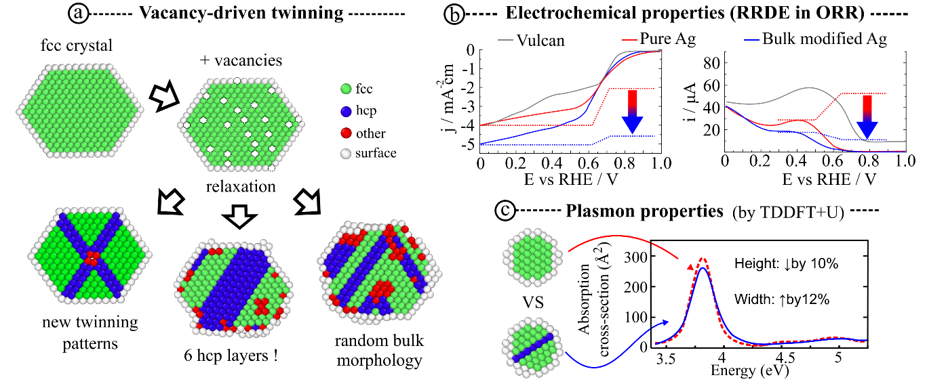

###### **Figure 1**. a) Schematic representation of the vacancy-driven twinning (VDT) mechanism. Starting from a strain-free cubic (CUB) nanocluster with 2869 atoms, 22% of atoms were randomly removed. Upon relaxation (Sutton–Chen potential), distinct structural outcomes emerged depending on the vacancy distribution. Cross-sections illustrate atom types identified by OVITO: fcc (green), hcp (blue), surface (white), and others (red). b) Rotating ring-disk electrode voltammograms for oxygen reduction on pure (2.6 wt%) and bulk-modified (~1 wt%) Ag nanoparticles. c) Simulated absorption spectra of an ideal fcc Ag NPs (red) and a twinned variant (blue), both composed of 321 atoms. Insets show corresponding cluster cross-sections.

1. #### [] Smirnov, I., Kaszkur, Z. & Ferrando, R. (2024). arXiv 2409.01254.

  
2. #### [] Smirnov, I., Kaszkur, Z. & Hoell, A. (2023). Nanoscale 15, 8633.

  
3. #### [] Chaudhary, M. & Weissker, H.-C. (2024). Nat. Commun. 15, 9225.

  
4. #### [] Shao, W. et al. (2021). Adv. Funct. Mater. 31, 2006738.

  