**Complexes of Magnesium Sulfate with Formamide**

## K. Mihaylova1, G. **Velyanova1, K.**Kossev1

*1Institute of Mineralogy and Crystallography, Bulgarian Academy of Sciences, Acad. G. Bonchev Str. 1113 Sofia, Bulgaria*

Magnesium plays a significant role in the functioning of living organisms. More than 300 enzymatic systems are known in which magnesium ions act as cofactors [1]. Understanding the interaction between the magnesium cation and amide-type ligands is crucial for comprehending the role of magnesium in biological systems. Among simple amide ligands, the complexes of magnesium salts, particularly magnesium sulfate, with urea **(U)** have been the most studied [2-4]. In contrast, complexes with acetamide **(AA)** and formamide **(FA)** have been less explored.

In this study, the crystallization in the MgSO4 – FA – H2O system at room temperature led to the formation of two new compounds, which are magnesium sulfate complexes with formamide: MgSO4 • FA • 3H2O and MgSO4 • 3FA • 2H2O (Fig.1). The first compound is isostructural with the well-known crystal phase MgSO4 • U • 3H2O [3], where the SO42- anion is incorporated into the magnesium coordination octahedron, resulting in the formation of polymeric chains through the sulfate groups. The second phase lacks direct analogs in the magnesium sulfate-urea complexes. In this case, the sulfate ion also participates in the formation of the magnesium coordination octahedron but does not act as a bridging group, and no polymeric chains are formed. The closest structural analogy is the phase MgSO4 • 4U • H2O [2], where the magnesium coordination octahedron consists of three formamide molecules and two water molecules in the formamide complex, and four urea molecules and one water molecule in the urea complex. In both cases, the coordination octahedron is complemented by the sulfate ion.

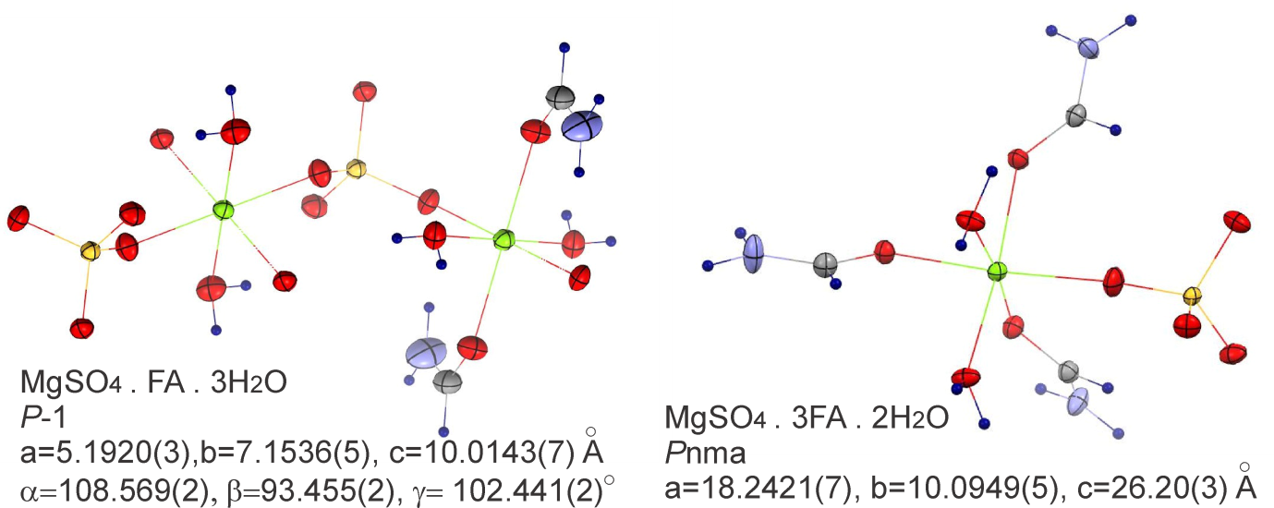

**Figure 1**. Crystal Structures of MgSO4 •FA • 3H2O and MgSO4 • 3FA • 2H2O complexes.

References:

[1] Nicolaou, K.C., Montagnon, T., (2008) Molecules That Changed The World, Wiley-VCH,. p. 11

[2] T.Todorov, R.Petrova, K.Kossev, J.Macicek, O.Angelova (1998), Aqua-(sulfato)-tetrakis(urea)-magnesium, (1998) Acta Crystallogr., Sect.C: Cryst.Struct.Commun., 54(4), 456, DOI: 10.1107/S0108270197012912/na1321sup2.hkl

[3] **Nikolova, R., Kostov-Kytin, V., Petrova, N., Kossev, K., Titorenkova, R., Velyanova, G.**. New Data on Crystal Phases in the System MgSO4–OC (NH2) 2–H2O. Crystals, 14, 3, MDPI, 2024, ISSN:20734352, DOI:10.3390/cryst14030227, 227

[4] T.Todorov, R.Petrova, K.Kossev, J.Macicek, O.Angelova (1998) Magnesium Sulfate Hexaurea Hemihydrate, Acta Crystallographica Sect. C Cryst.Struct.Commun., 54(12): 1758-1760, DOI: 10.1107/S0108270198007070/na1345sup2.hk

The authors thank the Bulgarian National Science Fund (grant agreement КП-06-Н64/4, 15.12.2022) for the financial support.