MS Microsymposium
Enhancing the physicochemical properties of antidepressant drugs through cucurbituril complexation
Natasza Jakubik¹, Ewelina Zaorska¹, Maura Malinska¹

¹ Faculty of Chemistry, Warsaw University, ul. Pasteura 1, 02-093 Warszawa
nm.jakubik@student.uw.edu.pl

Cocrystallization is a powerful strategy for solid-state optimization, as it enables the modulation of intermolecular interactions within the crystal structure, leading to desirable physicochemical properties such as improved solubility, stability, hygroscopicity, and melting point. Cocrystals are already widely used to tailor the properties of materials in various industries, including pigments, fertilizers, explosives, and, most importantly, pharmaceuticals [1]. Some marketed drugs are formulated as cocrystals, which has enhanced their bioavailability or reduced their hygroscopicity [2]. One promising class of coformers for improving drug performance is cucurbiturils (CB[n]), a family of macrocyclic compounds that exhibit low toxicity within therapeutic dosage ranges [3]. Cucurbiturils are well known for their strong binding affinity to cationic molecules, forming highly stable host-guest complexes with dissociation constants as low as 10⁻¹⁵ M [4]. These properties make them attractive candidates for drug delivery systems and molecular sensors [5].

In this project, I focus on the cocrystallization of commercially available tricyclic antidepressants (TCAs) with cucurbiturils. So far, I have obtained four distinct cocrystals: two involving Imipramine with CB[8] (one with a 1:2 host-guest ratio in the Pca2₁ space group and another with a 1:3 ratio in the P2₁/c space group) and two involving Amitriptyline with CB[6] (one with a 1:1 ratio in the C2/c space group and another with a 2:2 ratio in the R-3 space group). The presence of KI or ZnCl₂ was essential for successful crystallization, even though these additives were not incorporated into the crystal framework. The structures were determined using X-ray diffraction, providing a foundation for further DFT energy calculations.

Our findings suggest that the cocrystallization process exhibits selectivity, with Imipramine preferentially forming cocrystals with CB[8] and Amitriptyline with CB[6]. The interactions between TCAs and cucurbiturils involve ion-dipole interactions, hydrogen bonding, and π-π stacking. Imipramine forms both inclusive and exclusive complexes with CB[8] in cocrystals, with interaction energies of approximately -200 kJ/mol and -88 kJ/mol, respectively. In contrast, the Amitriptyline-CB[6] cocrystals contain only exclusive complexes, with interaction energies around -110 kJ/mol.

This study highlights the potential of cucurbit[n]urils in enhancing the physicochemical properties of TCA-based drugs. In my poster, I will present detailed structural analysis, molecular packing
arrangements, and an investigation into the factors contributing to the observed selectivity in
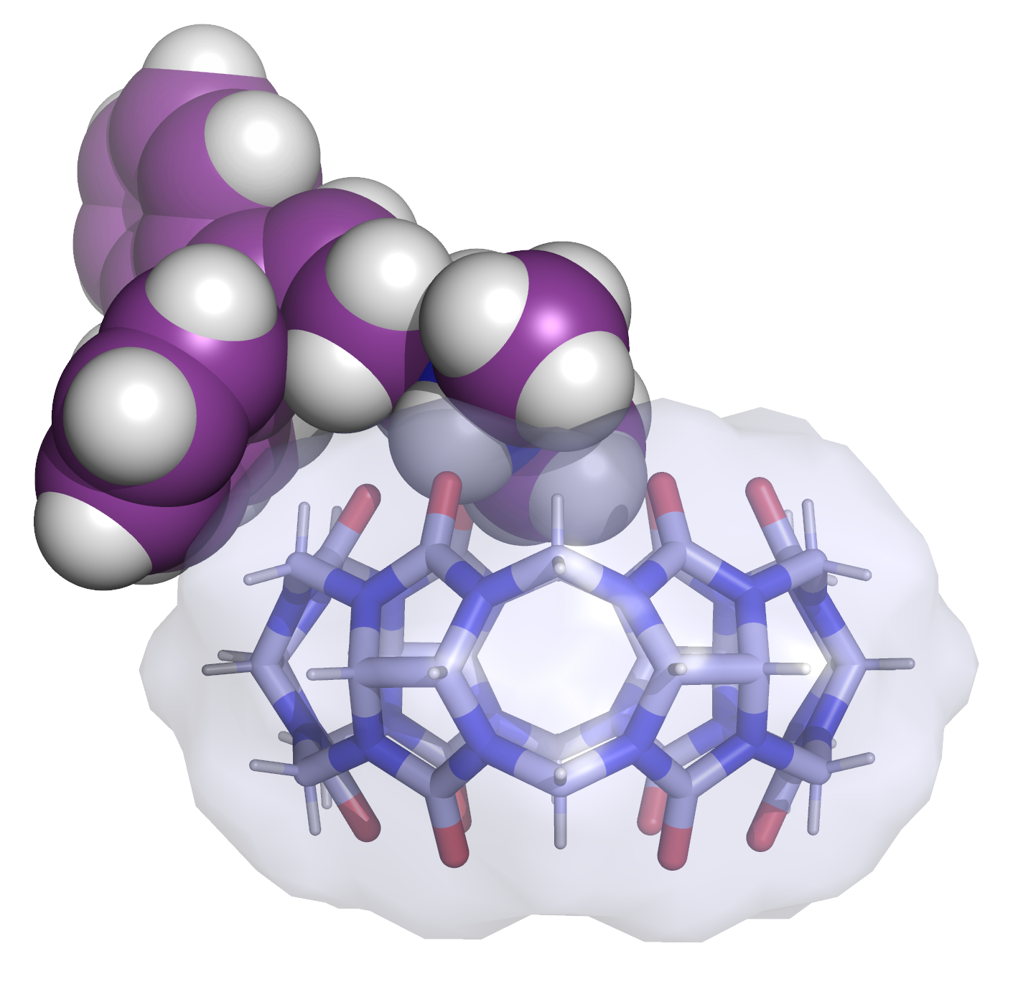
cocrystallization.
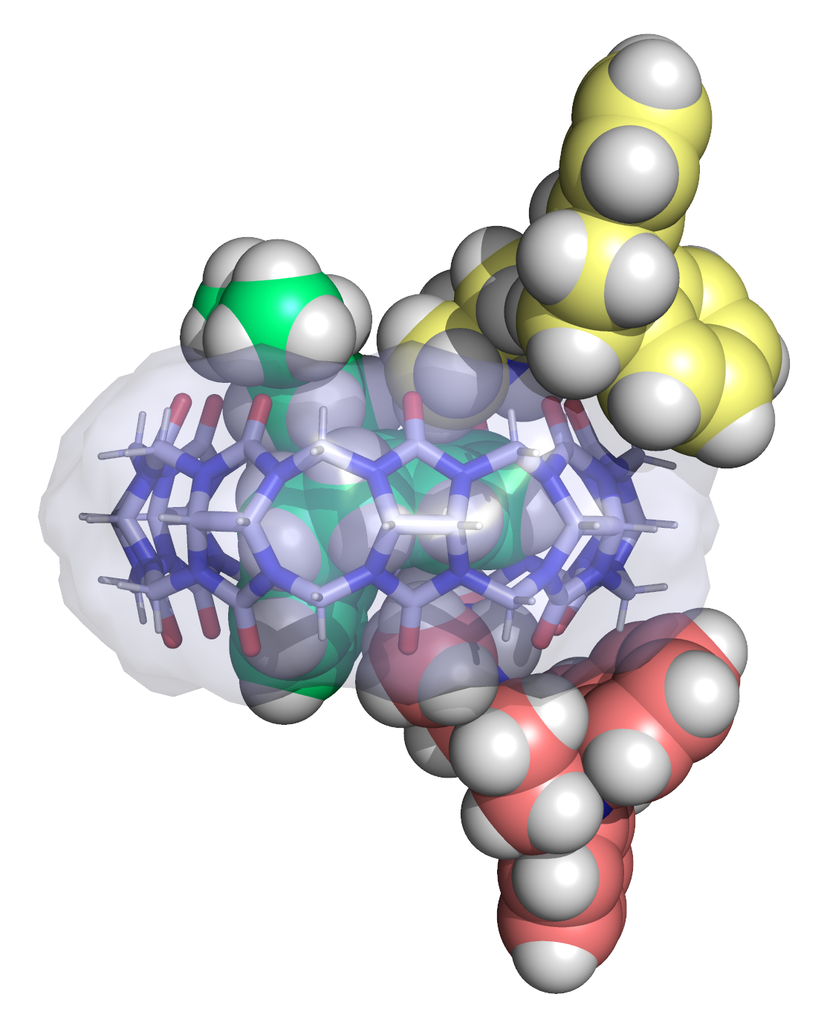

Fig 1. Observed complexes of Imipramine and CB[8] (left) and Amitriptyline and CB[6] (right)

[1] Karimi-Jafari, Maryam and Padrela, Luís and Walker, Gavin and Croker, Denise. (2018).
Crystal Growth & Design, 18(10), 6370-6387.
[2] Guo, Minshan and Sun, Xiaojie and Chen, Jiahui and Cai, Ting. (2021).
Acta Pharmaceutica Sinica B, 11 (8), 2537-2564.
[3] Hettiarachchi, Gaya and Nguyen, Duc and Wu, Jing and Lucas, Derick and Ma, Da and Isaacs, Lyle and Briken, Volker (2010). PLOS ONE 5 (5), 1-10.
[4] Assaf, Khaleel I. and Nau, Werner M. (2015). Chemical Society Reviews, 44 (2), 394-418.
[5] Barrow, Steven J. and Kasera, Setu and Rowland, Matthew J. and del Barrio, Jesús and Scherman, Oren A.(2015). Chemical Reviews, 115(22), 12320-12406.

