Heterobimetallic Mn(II)/Al(III) chalcogenides: Model systems for mixed-valent ferrates(II/III)

C. Röhr¹, M. Schwarz¹

¹Institut für Anorganische und Analytische Chemie, Universität Freiburg, Germany.

Email: caroline@ruby.chemie.uni-freiburg.de
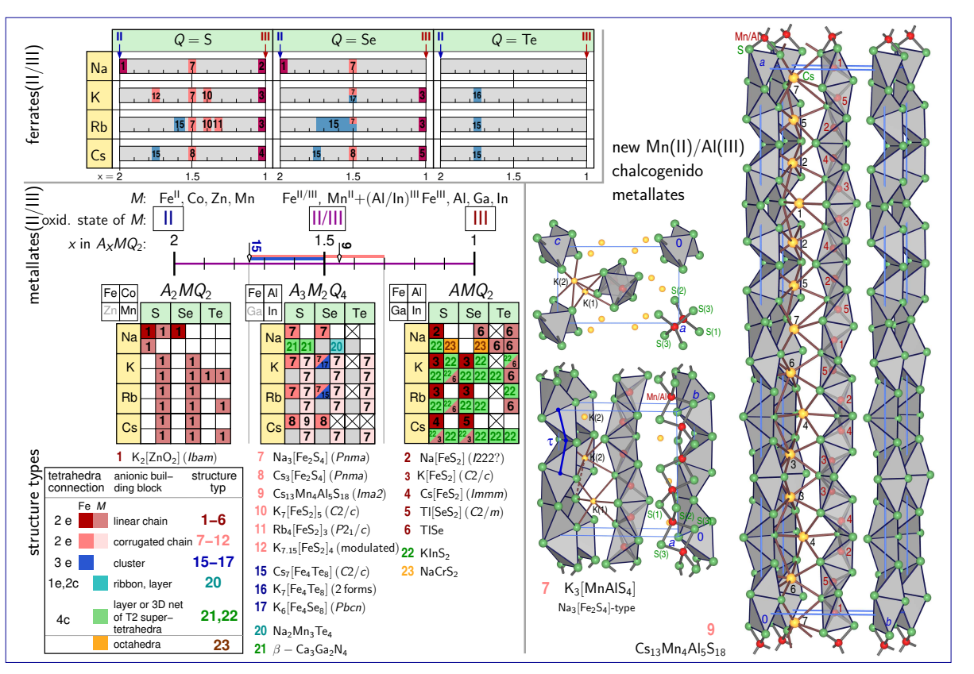
The heterobimetallic Mn/In [1] and Mn/Al (this work) metallates A₃MnAlQ₄ (A=K, Rb, Cs; Q=S, Se, Te) are model systems for the mixed-valent ferrates(II/III), where the M(II):M(III) ratio can be specifically adjusted during synthesis. While the pure p-block metallates(III) AAl^{III}Q₂ are dominated by layered structures of T2 supertetrahedra (KInS₂-type 22, i.e., pure corner connections). Both the ferrates(III) AFe^{III}Q₂ and the manganates(II) A₂Mn^{II}Q₂ exhibit linear chains of trans-edge-sharing [MQ_{4/2}] tetrahedra KFeS₂- 3 and K₂ZnO₂-type 1, respectively). In contrast, the mixed-valent salts A_{x}MQ₂, x=1-2), show a remarkably diverse crystal chemistry, which in the case of ferrates is accompanied by interesting magnetic properties: The entire series of of the hetero-bimetallic Mn(II):(Al/In)(III)=1:1 model systems A₃[MnInQ₄] (A=K-Cs, Q=S-Te, [1]) and A₃[MnAlQ₄] (A=K, Rb; Q=S-Te, this work, e.g. K₃[MnAlS₄]: orthorhombic, Pnma, a=716.5(3), b=1144.3(4), c=1147.5(2) pm, R1=5.06 %), which were obtained from stoichiometric melts, are isotypic to the analogous mixed-valent ferrates of the general composition A₃Fe₂S₄ 7 [2,3]. All of these compounds contain strongly corrugated tetrahedral chains, whereby - in the case of the Mn/Al and Mn/In compounds - the tetrahedra centers are statistically occupied by the two metal cations. Attempts to synthesize the analogous cesium Mn/Al metallates were unsuccessful, but in the case of sulfur they yielded the new orthorhombic compound Cs₁₃Mn₄Al₅S₁₈ (x=1.44, 9, Ima2, a=5270.7(5), b=1238.2(1), c=769.9(1) pm, R1=6.08 %) in virtually pure phase. With its complicated bent chains (running along the long a axis), this salt represents a model system for those mixed-valent ferrates in which the Fe(II):Fe(III) ratio deviates from 1:1 and which correspondingly exhibit large translation periods along the chains 10,11 [4], up to modulated structures e.g. in K_{7.15}[FeS₂]₄ 12 [5]. These similarities between the mixed-valent ferrates and the heterobimetallic Mn/Al and Mn/In metallates show, that only the 'odd' number of A⁺ counterions and by no means magnetic effects are responsible for the corrugation of the chains. Until now, 'tetrahedra stars' [M₄Q₈], which serve as model systems for the biologically relevant 4Fe4S clusters, are only observed in mixed-valence ferrates A₆₋₇[Fe₄Q₈] 15-17 with Fe(II):Fe(III) ratios between 1:1 and 3:1 (x=1.5-1.75) [6].
[1] M. Langenmaier, J. Brantl, C. Röhr, J. Solid State Chem., 292, 121455 (2020).
[2] K. Klepp, H. Boller, Monatsh. Chem., 112, 83-89 (1981); K. Klepp, W. Sparlinek, Z. Kristallogr. NCS, 211, 626 (1996).
[3] W. Bronger, U. Ruschewitz, P. Müller, J. Alloys Compd., 218, 22-27 (1995).
[4] M. Schwarz, M. Haas, C. Röhr, Z. Anorg. Allg. Chem., 639, 360-374 (2013).
[5] M. Schwarz, P. Stüble, K. Köhler, C. Röhr, Z. Kristallogr., 235, 275-290 (2020).
[6] M. Schwarz, C. Röhr, Inorg. Chem., 54, 1038-1048 (2015); P. Stüble, A. Berroth, C. Röhr, Z. Naturforsch., 71b, 485-501 (2016).
We would like to thank the Deutsche Forschungsgemeinschaft for financial support.

