# Structural elucidation and biophysical characterization of Retinol Binding Protein 3

## L. Gessa1, N. Kumar1,2, V. Kaushik2, H. Fernandes1,2

### 1International Centre for Translational Eye Research, Institute of Physical Chemistry, Polish Academy of Sciences, Skierniewicka 10A, 01-230 Warsaw, Poland, 2Institute of Physical Chemistry, Polish Academy of Sciences, Kasprzaka 44/52, 01-224 Warsaw, Poland

### lgessa@ichf.edu.pl

Retinol Binding Protein 3 (RBP3) is a soluble protein localized in the interphotoreceptor matrix (IPM) [1]. The role of RBP3 in the interphotoreceptor matrix is still under debate; however, it is now clear this protein plays a role in the shuttling of retinoids between the photoreceptors and the Retinal Pigmented Epithelium (RPE) [2]. Mammalian RBP3 is a single glycosylated peptide chain of around 1325 amino acids, the gene encoding this protein has undergone a quadruplication event, and, for this reason, is possible to identify within the peptide chain four homologous modules consisting of ~300 amino acids each [3]. The high flexibility of this protein is the major obstacle to full-length, high-resolution, structure determination [4]. So far, there are only X-ray crystallography structures of non-mammalian single modules and one Cryo-Electron Microscopy (Cryo-EM) structure determined for the full-length bovine protein at a resolution of 6-7 Å [5,6,7]. Here we use crystallography (Figure 1A) and Cryo-EM (Figure 1B) to determine the structure of the Module 4 and the structure of the full-length protein [8]. The effects induced by the ligand binding are analysed through Small Angle X-ray Scattering technique (Figure 1C) [8].

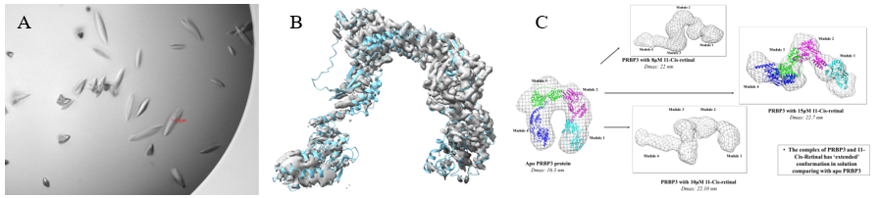

**Figure 1**. A) Crystals of *Sus scrofa* RBP Module 4. B) AB initio model of *Sus scrofa* full length RBP3. C) Conformational changes of *Sus scrofa* RBP3 induced by ligand binding.

#### [1] Gonzalez-Fernandez F, Landers RA, Glazebrook PA, Fong SL, Liou GI, Lam DM, Bridges CD (1984). *J Cell Biol*. 1984 Dec;99(6):2092-8.

#### [2] Liou GI, Bridges CD, Fong SL, Alvarez RA, Gonzalez-Fernandez F (1982). *Vision Res*. 1982;22(12):1457-67.

#### [3] Nickerson JM, Li GR, Lin ZY, Takizawa N, Si JS, Gross EA (1998). *Mol Vis*. 1998 Dec 31;4:33

#### [4] Gonzalez-Fernandez F, Sung D, Haswell KM, Tsin A, Ghosh D (2014). *Exp Eye Res*. 2014 Mar;120:167-74.

#### [5] Gonzalez-Fernandez F, Baer CA, Ghosh D (2007). *BMC Biochem*. 2007 Aug 4;8:15.

#### [6] Ghosh D, Haswell KM, Sprada M, Gonzalez-Fernandez F (2025). *Exp Eye Res*. 2015 Nov;140:149-158

#### [7] Sears AE, Albiez S, Gulati S, Wang B, Kiser P, Kovacik L, Engel A, Stahlberg H, Palczewski K (2020). *FASEB J*. 2020 Oct;34(10):13918-13934.

#### [8] Kaushik V, Gessa L, Kumar N, Pinkas M, Czarnocki-Cieciura M, Palczewski K, Nováček J, Fernandes H (2025). *Open Biol*. 2025 Jan;15(1):240180.

This work benefited from access to MX, Diamond, Harwell, UK and SAXS, Hamburg, EMBL and has been supported by iNEXT-Discovery, project number 871037, funded by the Horizon 2020 program of the European Commission. The authors also are thankful to Dr. Halina Mikolajek, Dr. Melissa Ann Graewert and Dr. Dmytro Soloviov. Spectrofluometer assays were carried out at the Institute of Biochemistry and Biophysics (IBB) with the use of equipment being sponsored in part by the Centre for Preclinical Research and Technology (CePT), a project co-sponsored by the European Regional Development Fund and Innovative Economy, The National Cohesion Strategy of Poland.