# Structure, function and regulation of NAD kinases

## G. Labesse1, M. Gelin1, C. Mary1, E. Donnier1, P. Praharaj2, M.H. Soflaee2, G. Hoxhaj2, C. Lionne1

### 1Centre de Biologie Structurale, CNRS – INSERM – Univ. Montpellier, 29 rue de Navacelles, Montpellier, France. 2Children's Medical Center Research Institute, University of Texas Southwestern Medical Center, Dallas, TX 75390, USA.

### Gilles.Labesse@cbs.cnrs.fr

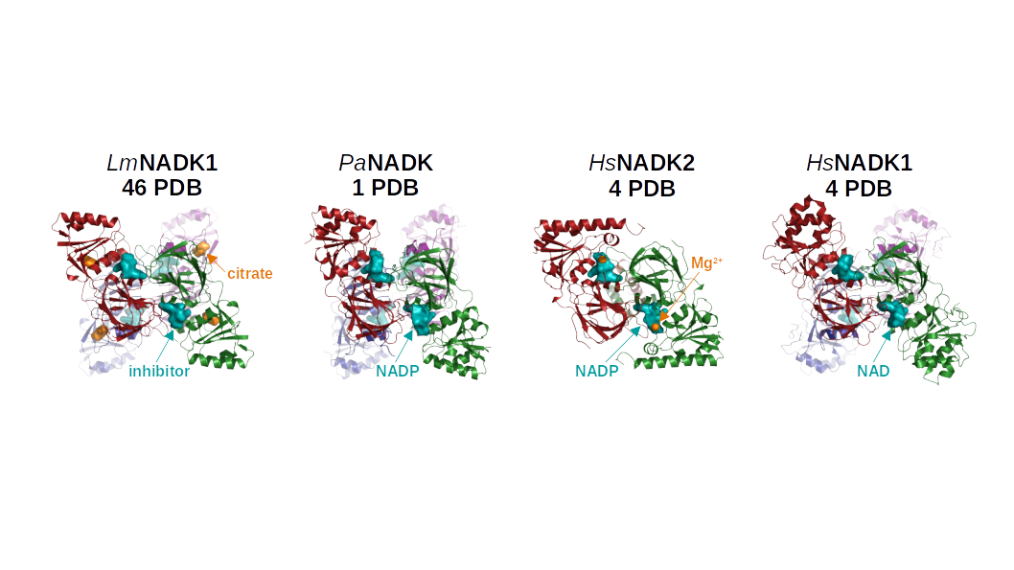NAD kinases (NADKs) are key enzymes in living systems and the unique proteins that catalyze the phosphorylation of NAD to NADP. NADKs belong to a highly divergent superfamily of kinases, that we defined earlier [1]. Their substrate, NAD, and product, NADP, are essential cofactors in all living organisms for catabolic reactions (e.g. glycolysis), cellular respiration, and many anabolic metabolisms (e.g.: lipid, amino acid and nucleic acid biosynthesis). NADPH acts as the main cofactor of antioxidant systems. Targeting essential metabolic steps is efficient in anti-infective or anti-cancer therapies, as exemplified by antimetabolites inhibiting DHFRs from bacteria, parasites or humans (e.g.: trimetropim, pyrimethamine or metrothexate). So we engaged in characterizing NADKs (bacterial and eukaryotic) as promising, but understudied orphan drug targets.

**Figure 1**. Structures of liganded NADKs from bacterial pathogens and human.

Taking advantages of their peculiar modes of ligand recognition and enzymatic catalysis in NADKs, we could design (Coll. S. Pochet, I. Pasteur, Paris) the first stable inhibitors of any NADK after deconstruction of NAD down to the adenine moiety [2]. Better mimicking of the nicotinamide moiety, led to a closely related chemical series, with enzyme inhibition down to the nanomolar range (20 – 40 nM) against bacterial [3] and/or mammalian NADKs (patent WO2024/013349A1). Recently, we have also solved the crystal structure of human mitochondrial NADK (*Hs*NADK2) in complex with Mg-NADP [4] and the cryo-EM structures of *Hs*NADK1, its cytosolic counterpart [5]. These works confirmed the substrate-driven mode of catalysis we have previously predicted, and demonstrated their distinct and complex mode of regulation. We shall discuss the particular functional features revealed by the comparisons of all those new structures and the link with metabolic regulation.

#### [1] Labesse, G., Douguet, D, Assairi, L, Gilles, A.M., (2002) *Trends Biochem Sci.* **27**, 273-275.

#### [2] **Gelin, M., Paoletti, J., Nahori, M.A., Huteau, V., Leseigneur, C., Jouvion, G., Dugué, L., Clément, D., Pons, J.L., Assairi, L., Pochet, S., Labesse, G., Dussurget, O. (2020) *ACS Infect Dis.* 6, 422-435*.***

#### [3] Rahimova, R., Nogaret, P., Huteau, V., Gelin, M., Clément, D.A., Labesse, G., Pochet, S., Blanc-Potard, A.B., Lionne, C (2022) *FEBS J*., 290, 482-501.

#### [4] Soflaee, M.H., Kesavan, R., Gelin, M., Brown, H., Zacharias, G., Mathews, T.P., Lemoff, A., Lionne, C., Labesse, G., Hoxhaj, G. (2022) *Mol. Cell.* 82*,* 3299-3311.

#### [5] Praharaj. P.P., Li, Y., Mary, C., Soflaee, M.H., Ryun, K., Kimn, D., Trann, D.H., Deyn, T., Tom, H.J., Rion H., Gelin, M., Lemoff, A., Zacharias, L.G., Patricio, J.S., Mathews, T.P., Chen, Z., Lionne, C., Hoxhaj, G., Labesse, G. (2025) *Sci. Adv.,* **11**, eads2664.

Acknowledgement: FRM 202303016265