# Crystallographic insights into multi-component pharmaceutical solids

## L. S. de Moraes1,3*, J. Najorka2, A. J. Surman1, A. R. Kennedy3

### 1Department of Chemistry, King’s College London, 7 Trinity Street, London SE1 1DB, U.K., 2Natural History Museum, Department of Earth Science, Cromwell Rd, London SW7 5BD, U.K., 3WestChem, Department of Pure & Applied Chemistry, University of Strathclyde, 295 Cathedral Street, Glasgow G1 1XL, U.K.

### lygia.silva_de_moraes@kcl.ac.uk

The development of new solid-state pharmaceutical formulations often relies on optimizing critical physicochemical properties of the active pharmaceutical ingredient (API), such as hygroscopicity, bioavailability, dissolution, solubility, and melting point [1]. These properties can be enhanced through the design of multi-component crystals - salt forms, co-crystals, or solvates (Figure 1) – which are engineered by leveraging intermolecular interactions between the API and co-formers [2–4].

This work presents a series of novel multi-component crystalline forms with pharmaceutical relevance, designed to alter the solid-state properties of APIs. Structural characterization was performed using single-crystal X-ray diffraction, allowing the identification of key molecular interactions and solid-state features. Furthermore, we explore structure–property relationships to contribute to the broader understanding of solid-state behaviour in multi-component pharmaceutical systems and support the search for the most stable and efficient crystalline form of APIs.

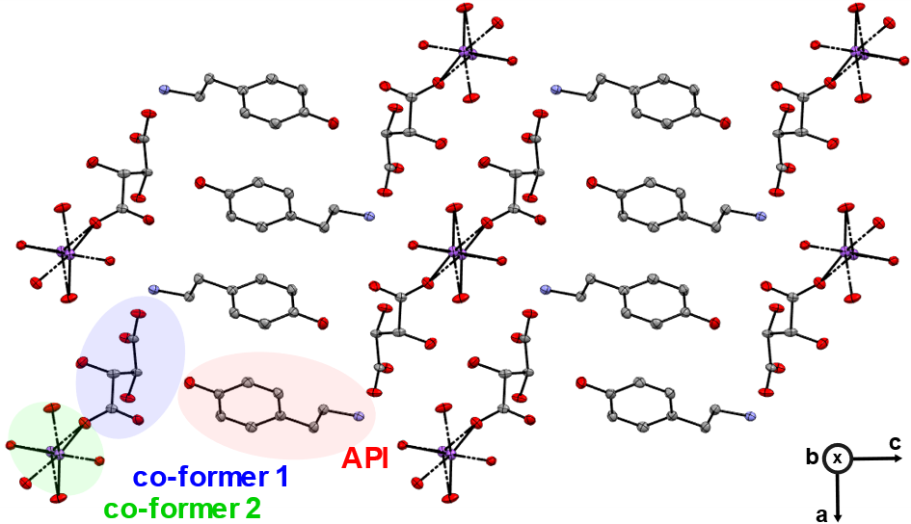

###### **Figure 1**. Double salt of API, counterion and Na.

#### [1] Stahl, P.H. & Wermuth, C.G. (2002). *Handbook of Pharmaceutical Salts.* Zurich: Wiley-VCH.

#### [2] de Moraes, L. S., Edwards, D., Florence, A. J., Johnston, A., Johnston, B. F., Morrison, C. A. & Kennedy, A. R. (2017). *Cryst. Growth Des.* **17**, 6, 3277–3286.

#### [3] Qiao N., Li, M., Schlindwein, W., Malek, N., Davies, A. & Trappitt G. (2011). *International Journal of Pharmaceutics.* **419**, 1–11.

#### [4] Duggirala, N. K., Perry, M. L., Almarsson, O. & Zaworotko, M. J. (2016). *Chem. Commun.*, **52**, 640–655.

Acknowledgements: The authors would like to thank Mr. Oscar Ayrton (King’s College London).