## Piezo-solvatomorphism of iHOF — a porous, hydrogen bond-assisted ionic organic framework

## G. Russ1, T. Holczbauer2,3, S. De2, P. Bombicz2, A. Katrusiak1, S. Sobczak1

1Department of Materials Chemistry, Faculty of Chemistry, Adam Mickiewicz University, Poznan; 2Centre for Structural Research, HUN-REN research Centre for Natural Sciences, Budapest, Hungary; 3Institute of Organic Chemistry, Research Centre for Natural Sciences, H-1117 Budapest, Magyar Tudósok körútja 2.

### 1grarus@st.amu.edu.pl

Hydrogen bond-assisted ionic organic frameworks (iHOFs)[1] represent an emerging class of porous organic materials characterized by the ability to form porous three-dimensional aggregates stabilized by charge-assisted hydrogen bonds and anion⋯π interactions. These frameworks have attracted growing attention due to their broad application potential in drug delivery,[2] adsorption, heterogeneous catalysis,[3] molecular storage[4] and many more.[5] While polymorphism and solvatomorphism have been widely investigated in porous materials, pressure-induced solvatomorphism remains relatively underexplored and offers new perspectives for modulating the structural and functional properties of such compounds.

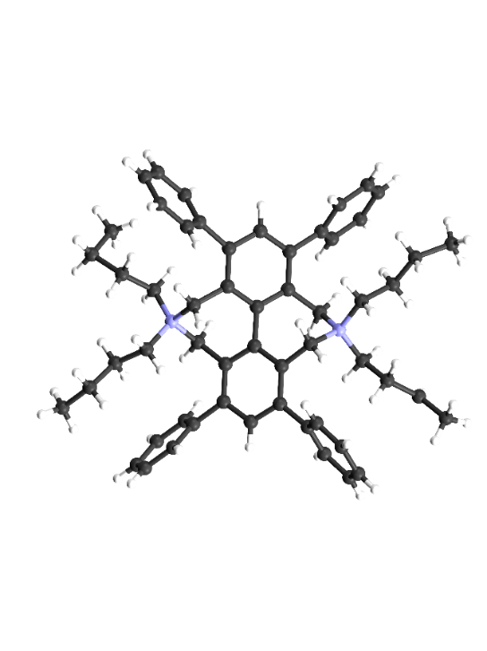

###### **Fig. 1** The iHOF molecule present in iHOF·xMeOH at 0.55 GPa, bromine anions and methanol molecules omitted for clarity.

We report the piezo-solvatomorphism[6] of an iHOF observed through *in situ* isochoric recrystallizations from methanol and water under high-pressure. Remarkably, despite the general tendency of pressure to promote closely packed crystal structure, all high-pressure isochoric recrystallization experiments consistently yielded porous framework structures. Recrystallization from methanol resulted in two forms of iHOF·*n*MeOH that differ in guest methanol content: the low-pressure structure, stable up to 0.4 GPa crystallizing in the triclinic space group $P\overline{1}$, and a higher-pressure form, stable above 0.4 GPa adopting a tetragonal *P*42/*n* space group (Fig. 1). Similarly, recrystallization from water led to two forms of the iHOF hydrate (iHOF·*x*H₂O), also differing in guest content: a low-pressure tetragonal structure stable up to approx. 0.2GPa, and a high-pressure structure crystallizing in the cubic space group *Ia $\overline{3}$ d*. As observed before for [H3O][PbI3]·*n*H2O obtained at high-pressure,compression can lead to the desorption of small, co-crystallized, guest molecules,[7] which aligns with the reduced void volume observed in both iHOF·*n*MeOH and iHOF·*x*H₂O.

These results underscore the complex relationship between molecular flexibility, solvation effects, and supramolecular interactions in governing the structural aggregation of three-dimensional frameworks at high pressure. The demonstrated examples show a huge perspective for the application of high-pressure in exploring novel topologies of complex framework materials.

#### [1] Vajk Horváth D., Holczbauer T., Bereczki L., Palkó R., May N. V., Soós T., Bombicz P. (2018) *CrystEngComm*, , **20**, 1779-1782

#### [2] Vallet-Regí, M., Balas, F., Arcos, D. (2007), *Angew. Chem., Int. Ed*., **46**, 7548–7558.

#### [3] Seo, J. S., Whang, D., Lee, H., Jun S. I., Oh, J., Jeon, Y. J., Kim, K. (2000), *Nature*, **404**, 982–986.

#### [4] Morris, R. E., Wheatley, P. S. (2008), *Angew.* *Chem., Int. Ed*., **47**, 4966–4981.

#### [5] Prakash, M. J., Lah, M. S. (2009), *Chem. Commun*., 3326–3341.

[6] Sobczak, S., Katrusiak, A. (2024) *IUCrJ*, **11**, 528–537.

#### [7] Sobczak, S., Fidelli,  [A. M.](https://pubs.rsc.org/en/results?searchtext=Author%3AAthena%20M.%20Fidelli), Do, [J-L.,](https://pubs.rsc.org/en/results?searchtext=Author%3AJean-Louis%20Do) Demopoulos, [G. P.,](https://pubs.rsc.org/en/results?searchtext=Author%3AGeorge%20P.%20Demopoulos) Moores, [A.,](https://pubs.rsc.org/en/results?searchtext=Author%3AAudrey%20Moores) Friščić, [T.,](https://pubs.rsc.org/en/results?searchtext=Author%3ATomislav%20Fri%C5%A1%C4%8Di%C4%87) Katrusiak, A. (2024) *Inorg. Chem. Front*. **11**, 735–744.

Th support of the Hungarian Research, Development and Innovation Office, research grant no.  2021-4.1.2-NEMZ_KI-2022-00022 is gratefully acknowledged.