Serendipitous Discovery of a New Polymorph of L-Serine
A. Skórska-Stania¹, Sz. Grabowski^{1,2}, M. Gryl¹

¹Faculty of Chemistry, Jagiellonian University, Gronostajowa 2, Kraków, 30-387, Poland, ²Doctoral School of Exact and Natural Sciences, Jagiellonian University, Prof. St. Łojasiewicza 11, Kraków, 30-348, Poland

agnieszka.skorska-stania@uj.edu.pl

A new anhydrous polymorph of L-serine (form V) was obtained under ambient pressure conditions via additive-mediated crystallization. This polymorph represents the second anhydrous form of L-serine crystallized at ambient pressure (form I), in contrast to other known forms that require high-pressure conditions (form II, III, IV) [1-4].
Structural analysis reveals that form V shares key hydrogen-bonding motifs with the hydrate (form IH), including zwitterionic dimers stabilized by N–H⋯O and O–H⋯O interactions (Fig 1). In form V, these dimers propagate into a three-dimensional network without incorporating solvent molecules suggesting a solvent-mediated nucleation pathway, where the hydrogen-bonding motifs observed in the final structure may originate from pre-organized aggregates in solution.
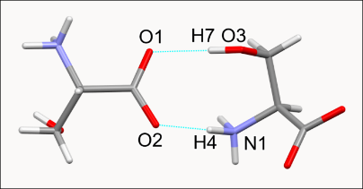 | 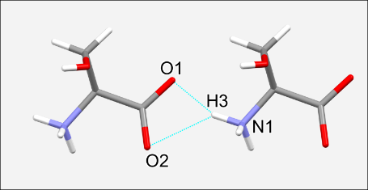 | 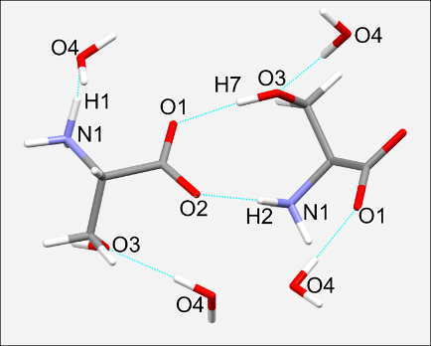
Form V | Form I | Form IH
Figure 1. Dimers of L-serine in form V, I and IH-monohydrate
Thermodynamic calculations using periodic DFT indicate that form V has lower lattice energy than the stable form I at 0 K. However, temperature-dependent Gibbs free energy calculations reveal a stability crossover, with form V favored at lower temperatures and form I becoming more stable above a certain threshold, supported by experimental observations of solid-state transformations over time or upon heating. These results highlight the importance of supramolecular assembly and solution environment in directing polymorphic outcomes and illustrate the necessity of integrating crystallographic and thermodynamic perspectives in polymorph discovery.

- Kistenmacher, T. J.; Rand, G. A.; Marsh, R. E. Refinements of the Crystal Structures of {\sc Dl}-Serine and Anhydrous {\sc L}-Serine. Acta Crystallogr. Sect. B 1974, 30 (11), 2573–2578.
- Moggach, S. A.; Allan, D. R.; Morrison, C. A.; Parsons, S.; Sawyer, L. Effect of Pressure on the Crystal Structure of L-Serine-I and the Crystal Structure of L-Serine-II at 5.4 GPa. Acta Crystallogr. Sect. B Struct. Sci. 2005, 61 (1), 58–68.
- Drebushchak, T. N.; Sowa, H.; Seryotkin, Y. V.; Boldyreva, E. V.; Ahsbahs, H. L-Serine III at 8.0 GPa. Acta Crystallogr. Sect. E Struct. Reports Online 2006, 62 (9), 4052–4054.
- Fisch, M.; Lanza, A.; Boldyreva, E.; Macchi, P.; Casati, N. Kinetic Control of High-Pressure Solid-State Phase Transitions: A Case Study on l-Serine. J. Phys. Chem. C 2015, 119 (32), 18611–18617.

This research was supported in part by PL-Grid infrastructure (grant no. PLG/2025/018105).

This research was supported by the National Science Centre, grant No 2023/51/B/ST5/02843.

