Variable temperature diffraction and polymorph screening with the XtaLAB Synergy-ED

E. Buchsteiner¹, K-N Truong¹, R. Bücker^{1,2} , C. Göb¹, C. Schürmann¹, J. Wojciechowski¹, M. Jasnowski³, M. Meyer³, F. White^{1,2}

¹Rigaku Europe SE, Neu-Isenburg, Germany, ²Rigaku Corporation, Tokyo, Japan, ³Rigaku Polska, Wroclaw, Poland

Emilia.buchsteiner@rigaku.com
Since its launch in 2021, the XtaLAB Synergy-ED has produced many structures, with more than 60 peer-reviewed publications and over 400 unique structures from Rigaku labs alone. While many of these structures were analyzed at ambient temperature, the availability of low-temperature techniques, particularly cryo-transfer, have proven invaluable for the preservation of sensitive samples both those sensitive to vacuum and those sensitive to electron beam damage. Additionally, the instrument’s enhanced automation capabilities, such as unattended measurement queues and automatic unit cell clustering, have opened new avenues for polymorph screening.
The XtaLAB Synergy-ED’s compatibility with existing TEM instrument holders provides structural scientists with the ability to conduct various experiments traditionally performed in X-ray crystallography. Cryo-transfer and air-free transfer specimen holders protect samples prior to vacuum introduction [1], enabling the study of solvates and other vacuum- or air-sensitive species, and allowing for the investigation of phase behaviour. Examples of crucial findings made possible by cryo-transfer will be discussed.
Furthermore, a MEMS biasing/heating holder allows for the increase in temperature, facilitating the exploration of polymorphism of structures such as porous materials. Recent studies utilizing single-crystal data from electron diffraction on a MOF system, Cu(ta)₂ (Hta=1H-1,2,3-triazole), have yielded significant insights at both room temperature and 200°C. These findings are compared with previous studies by Grzywa et al. (2012) using SC-XRD and PXRD, demonstrating the instrument’s capability in polymorphism research.
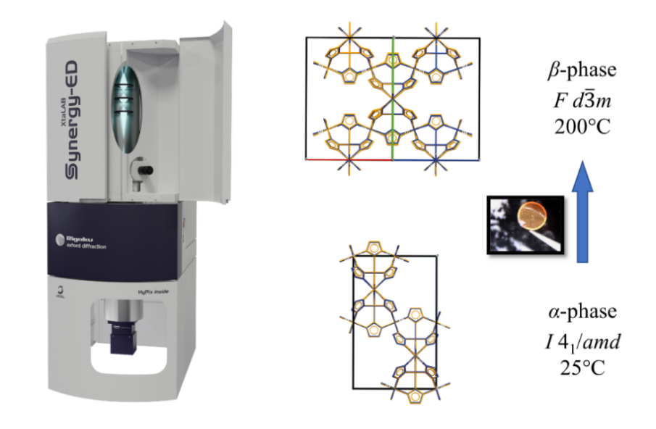

Figure 1. Overlays of the ambient and high temperature phases of Cu(ta)₂ from the XtaLAB Synergy-ED (blue) and the X-ray structures by Grzywa et al. (orange).

[1] K.-N. Truong, S. Ito, J. M. Wojciechowski, C. R. Göb, C. J. Schürmann, A. Yamano, M. Del Campo, E. Okunishi, Y. Aoyama, T. Mihira, N. Hosogi, J. Benet-Buchholz, E. C. Escuerdo-Adán, F. J. White, J. D. Ferrara, R. Bücker (2023). Symmetry, 15(8), 1555.

[2] M. Grzywa, D. Denysenko, J. Hanss, E.-W. Scheidt, W. Scherer, M. Weil, D. Volkmer. (2012). Dalton Transactions, 14, 4239.

