# Pressure-induced structural changes and their impact on the properties of alkyl-substituted perylene diimides

## P. Ratajczyk,1 S. Sobczak,1 M. Andrzejewski,2 P. Woźny,1 L. Maini,3 A. Katrusiak1

### 1Faculty of Chemistry, Adam Mickiewicz University, Uniwersytetu Poznańskiego 8, 61-614 Poznań, Poland, 2 Paul Scherrer InstituteForschungsstrasse 111, Villigen CH-5232, Switzerland, 3Department of Chemistry "G. Ciamician", University of Bologna, via Selmi 2, 40126 Bologna, Italy

### paulina.ratajczyk@amu.edu.pl

Perylene diimides (PDIs) represent a prominent class of organic materials that have recently garnered significant attention due to their high electron mobility, strong light absorption, exceptional stability, and facile chemical modification [1]. These properties have established them as leading electron-accepting materials, enabling their use in electronic devices such as organic field-effect transistors (OFETs) and organic photovoltaics (OPVs) [2]. However, for the successful commercialization of PDIs in such applications, a detailed understanding of their structure-properties relationships is essential. High-pressure single-crystal diffraction, combined with spectroscopic techniques, offer a powerful approach to elucidate these relationships, as even subtle molecular changes (e.g., in molecular conformation, bond lengths, or angles between atoms) can significantly impact their optoelectronic performance [3].

Here, we present a study on the pressure-induced changes in the structure and optical properties of a series of four PDIs with alkyl substituents of varying lengths at the imide positions (PDI-Cn, n = 5–8, Fig.1). By employing synchrotron and in-lab X-ray diffraction, UV-Vis and photoluminescence spectroscopy, supported by theoretical calculations, we systematically analysed the structural changes and correlated them with the absorption and emission characteristics of these four PDIcompounds. The packing interactions of these PDIs, dominated by π-stacking and weak C-H···O bonds, resulted in strikingly similar crystal structures, all adopting triclinic *P $\overline{1}$* symmetry. Pressure-induced structural transformations of PDI-Cn were mainly attributed to deformations within the alkyl chains, influencing the intermolecular interactions, crystal packing, and consequently the optoelectronic properties. Our findings provide valuable insights into the response of this important class of organic semiconductors under extreme conditions and suggest pathways for tailoring their optoelectronic properties through controlled structural modifications.

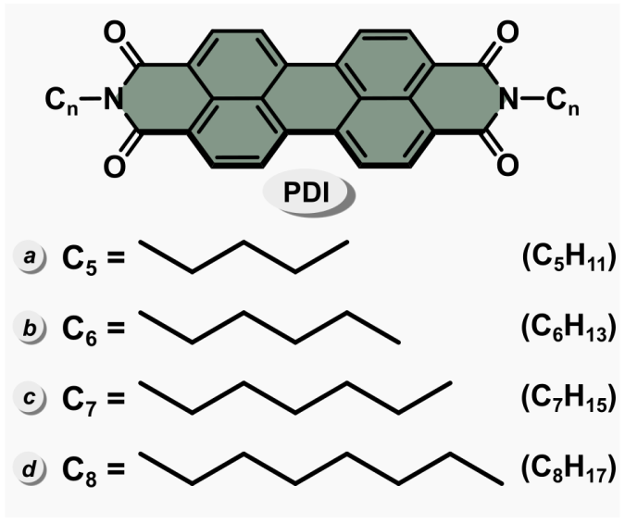

###### **Figure 1**. Molecular structures of the investigated PDIs N-substituted as indicated and abbreviated: PDI-C5 (a), -C6 (b), -C7 (c), and -C8 (d).

#### [1] Liu, Z., Wu, Y., Zhang, Q., Gao, X. (2016). *J. Mater. Chem. A*., **4**, 17604-17622.

[2] Huang, C., Barlow, S., Marder, S. R. (2011). *J. Org. Chem.*, **76**, 2386-2407.

#### [3] Ratajczyk, P., Sobczak S., Woźny, P., Wcisło, A., Poręba, T., Katrusiak, A. (2023). *J. Mater. Chem. C*, **11**, 11055-11065.

P. R. is grateful to the Polish Ministry of Education and Science (Diamentowy Grant DI2019/0160/49) for their financial support.