## Novel copper(I) chloride π,σ-coordination compounds based on 3-(pyridin-2-yl)-5-allylsulfanyl-4*H*-1,2,4-triazoles

## D. Dmytriv1, Yu. Slyvka1, E. Goreshnik2, N. Pokhodylo1

### 1Faculty of Chemistry, Ivan Franko National University of Lviv, Kyryla i Mefodiya Str., 6, 79005, Lviv, Ukraine, 2Department of Inorganic Chemistry and Technology, Jožef Stefan Institute, Jamova 39, SI-1000 Ljubljana, Slovenia

### dmytro.dmytriv@lnu.edu.ua

1,2,4-Triazoles have a wide range of applications in pharmaceutical chemistry and were found to be excellent instruments for the crystal engineering of versatile transition metal organometallic compounds, possessing catalytic, luminescent, nonlinear, biochemical and spin‐crossover activities. Previously triazole allyl-derivatives, namely 3-phenyl-4-allyl-5-allylsulfanyl-4*H*-1,2,4-triazole and 3,4-diphenyl-5-allylsulfanyl-4*H*-1,2,4-triazole were used in the preparation of heterometallic and mixed-valence copper(I/II) chloride π,σ-coordination compounds with magnetic and nonlinear optical properties and also has proven to be a good precursor for a design of novel copper(I) π,σ-coordination compounds [1, 2]. The obtained π-complex can be represented as being constructed from the cationic organometallic moiety {CuI2(*Triaz*)2}2+, which is formed by two *η*2-π-coordinated copper(I) ions and two pairs of N atoms of triazole cycles, and bound to the inorganic subunit. In order to diversify the coordination abilities of such triazole ligands in our previous work we focused on two new ligands obtained through the incorporation of 2-pyridyl substituent in position 3 of 1,2,4-triazole-5-thiole. 3-(pyridin-2-yl)-4-allyl-5-allylsulfanyl-4*H*-1,2,4-triazole (*L*1) and 3-(pyridin-2-yl)-4-phenyl-5-allylsulfanyl-4*H*-1,2,4-triazole (*L*2) were synthesized in several steps starting from pyridine-2-carboxylic acid hydrazide and corresponding allyl or phenyl isothiocyanate. By means of the alternating-current electrochemical method two novel π,σ-coordination compounds [Cu2(*L*1)Cl2] (**1**) and [Cu5(*L*2)2Cl5]·2CH3CN (**2**) were obtained in single crystalline form.

In crystal structure **1** there are two crystallographically independent Cu(I) atoms with different coordination environment: Cu1 adopts trigonal pyramidal coordination environment composed of allylic C=C bond, two triazole N and Cl atoms, while Cu1 has distorted tetrahedral environment of pyridyl N atom and three *μ*2-Cl atoms (Fig. 1). The angle between pyridyl and triazole planes is 77.20(1)°.

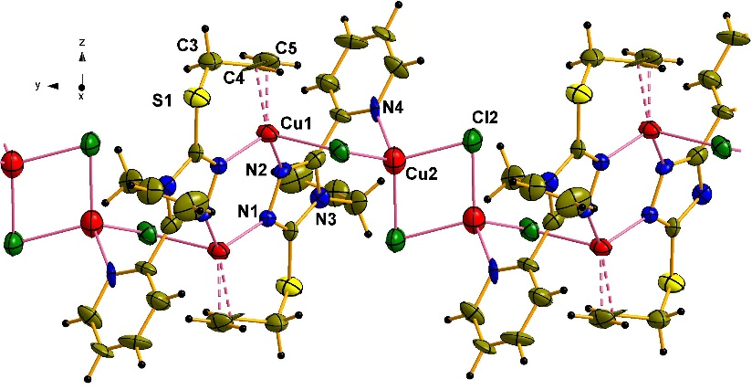

###### **Figure 1**. Fragment of crystal structure **1**. Displacement ellipsoids are drawn at the 50% probability level.

In contrast to **1** in which the coordination of pyridine substituent doesn’t interfere the formation of organometallic dimers having {Cu2N4} cycles, in crystal structure **2** 4-phenyl substituent obviously obstructs the rotation of pyridine core and forces the π,σ-coordination of two independent *L*2 ligands having almost coplanar pyridyl and triazole cycles (6.77(1) and 10.10(1)° for each *L*2 molecule, correspondingly). As the result in **2** realizes the complicated infinite inorganic chains {Cu5Cl5}n with linear, triangular, trigonal pyramidal and tetrahedral surroundings of copper atoms.

#### [1] Hordiichuk, O. R., Slyvka, Yu. I., Kinzhybalo, V. V., Goreshnik, E. A., Bednarchuk, T. J., Bednarchuk, O., Jedryka, J., Kityk, I. & Mys’kiv, M. G. (2019). *Inorganica Chim. Acta* **495**, 119012.

#### [2] Fedko, A. M., Slyvka, Yu. I., Goreshnik, E. A., Jȩdryka, J., Rakus, P. & Morozov, D. (2025). *J. Mol. Struct.* **1319**, 139552.

Yu. Slyvka and N. Pokhodylo are thankful to the Simons Foundation (PD-Ukraine-00014574) for financial support.