# How kinases bind their pharmacological inhibitors *via* the hinge motif

## U. Derewenda1, S. Scheiner2, Z.S. Derewenda1

### 1Department of Mol Physiology and Biological Physics, University of Virginia School of Medicine, Charlottesville, VA. USA 2Department of Chemistry and Biochemistry, Utah State University, Logan, USA

### zsd4n@virginia.edu

The human genome encodes 518 protein kinases (PKs), often selectively overexpressed in cancer [1]. These enzymes are now recognized as anti-cancer drug targets [2]. As of Jan 2024, there were 80 PK inhibitors approved for clinical use, including 69 used to treat cancer [2]. PKs are multi-domain proteins, with the catalytic activity harboured within catalytic domains, which show significant amino acid and structural conservation, particularly within the ATP-binding pocket, targeted by most inhibitors. These domains are made up of two ‘lobes’: the N-terminal lobe (N-lobe)—highly malleable and subject to regulation—and the stable C-lobe which binds substrate [3]. The solvent-accessible cavity between the two lobes binds ATP, so that the adenine moiety penetrates most deeply, and is recognized via hydrogen bonds by a short stretch of the polypeptide chain linking the two lobes, i.e. *the hinge motif* [4]. Kinase inhibitors belong to six types. *Types I and II, which include the vast majority clinical drugs, occupy the ATP-site and are therefore ATP competitors*. These inhibitors show a pattern of H-bonding engaging the same main groups of the hinge as adenine in ATP. However, kinase-inhibitor interactions are also mediated also by C-H…O bonds, which—while weaker—have the potential to make significant contribution [5]. We showed before that the vast majority of kinase inhibitor scaffolds contain a specific core—typically of an aromatic nature—which binds the hinge with three H-bonds, both canonical and/or C-H…O [6]. We identified three distinct templates where one or two of the potential H-bond sites involve a C-H donor from the inhibitor. Although the presence of cohesive H-bonds can be inferred from interatomic distances and angles, the latter fail to provide insights into energetic contributions. It is also not clear, for example, if the core-hinge interaction is a major determinant of the binding affinity (or kD), or if such interactions are optimal or if they are hindered by secondary enzyme-inhibitor contacts. Dissection of these questions is of paramount importance in structure-based drug design.

To address these important questions, we resorted to quantum mechanics (QM) as implemented in Gaussian 16 and Atoms-In-Molecules (AIM), and the available X-ray crystallographic structures of a number of FDA-approved kinase-inhibitor complexes. We analyzed representative complexes and in each case dissected the energetic contribution of each of the H-bonds involved. For each bond we calculated E(bond) to the aromatic core using Gaussian 16 using DFT with M06-2x functional and def2tzvp basis set was used; we also calculated potential energy V using AIM, and derived corresponding E(bond)values. The discrepancies between results obtained by the two methods can be attributed in most cases to the fact that AIM does not take into account repulsion effects between the heavy atoms. The results are also often affected by the lack of precision of crystallographic coordinates, resulting from insufficient refinement and/or exclusion of hydrogen atoms from the refined model. Taking all those issues into account, we conclude that that C-H…O bonds add small but significant component to the interaction energy, and for the relatively common C-N-C motif found in inhibitor cores (Fig 1), *account for ~40% of the interaction energy*.

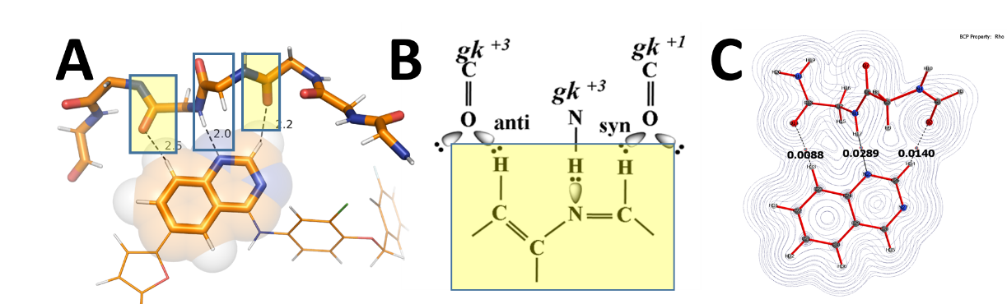

###### **Figure 1**. Example of inhibitor (lapatinib) bound to kinase (A); diagram of H-bonds (B); and electron density from AIM.

#### [1] Cicenas, J.; Zalyte, E.; Bairoch, A.; Gaudet, P.,. (2018) Cancers (Basel), 10, 63

#### [2] Roskoski, R., Jr.,. (2024),Pharmacol Res 200, 107059.

#### [3] Taylor, S. S.; Wu, J.; Bruystens, J. G. H.; Del Rio, J. C.; Lu, T. W.; Kornev, A. P.; Ten Eyck, L. F.,. (2021), J Biol Chem, 296, 100746.

#### [4] Xing, L.; Klug-Mcleod, J.; Rai, B.; Lunney, E. A., (2015). Bioorg Med Chem, 23, 6520.

#### [5] Scheiner, S.; Kar, T.,. (2008), J Phys Chem A 112, 1854.

#### [6] Derewenda, Z. S.; Hawro, I.; Derewenda, U.,. (2020) IUBMB Life, 72, 1233.