# Structure and phase transition of ferroelectric quinuclidinium copper(II) bromide

## D. A. Kowalska1, A. Ciżman2, M. Gusowski2, M. Trzebiatowska1, E. Jach2

### 1Institute of Low Temperature and Structure Research, Polish Academy of Sciences, Okólna 2, 50-422 Wrocław, Poland, 2Department of Experimental Physics, Wrocław University of Science and Technology, Wybrzeże Wyspiańskiego 27, 50-370 Wrocław, Poland

### d.kowalska@intibs.pl

Hybrid organic-inorganic compounds (HOICs) are of increasing interest due to their multifunctional properties arising from the synergy between organic cations and inorganic frameworks. Among these, quinuclidinium-based metal halides have shown promising applications in dielectric switching, ferroelectricity, and optoelectronics [1-3]. Particularly, their phase transitions are often associated with dynamic reorientations of the organic cations and reorganization of the hydrogen-bonding (HB) network, affecting the material's electric and optical behaviour.

Recent studies have demonstrated that quinuclidine-like molecules, such as dabco [4], are effective in designing switchable dielectric and ferroelectric materials due to their ability to undergo reversible structural phase transitions. In the high-temperature phase (HTP), these materials typically exhibit a high-dielectric "ON" state, linked to the dynamic reorientation of dipolar cations. Upon cooling, the transition to the low-temperature phase (LTP) freezes this motion, resulting in a low-dielectric "OFF" state.

Here, we report on a newly synthesized compound, (C7H14N)2CuBr4 (Q2CuBr4), where the inorganic component is copper(II) bromide [5]. This compound was expected to show distinct phase behavior based on analogies with previously studied Mn, Co, and Cd analogs [3]. A combination of thermal (DSC), structural (X-ray diffraction), and spectroscopic (IR, Raman) techniques was used to characterize the phase transition and its effects. Our results reveal temperature-induced structural changes involving ordering of the quinuclidinium (Q) cation and rearrangement of the HB network, which is strongly tied to the material’s dielectric response. Fig. 1 illustrates the structural differences between the two phases, highlighting cation ordering.

These findings contribute to the broader understanding of structure–property relationships in HOICs and underscore the potential of Q2CuBr4 as a candidate for switchable dielectric applications.

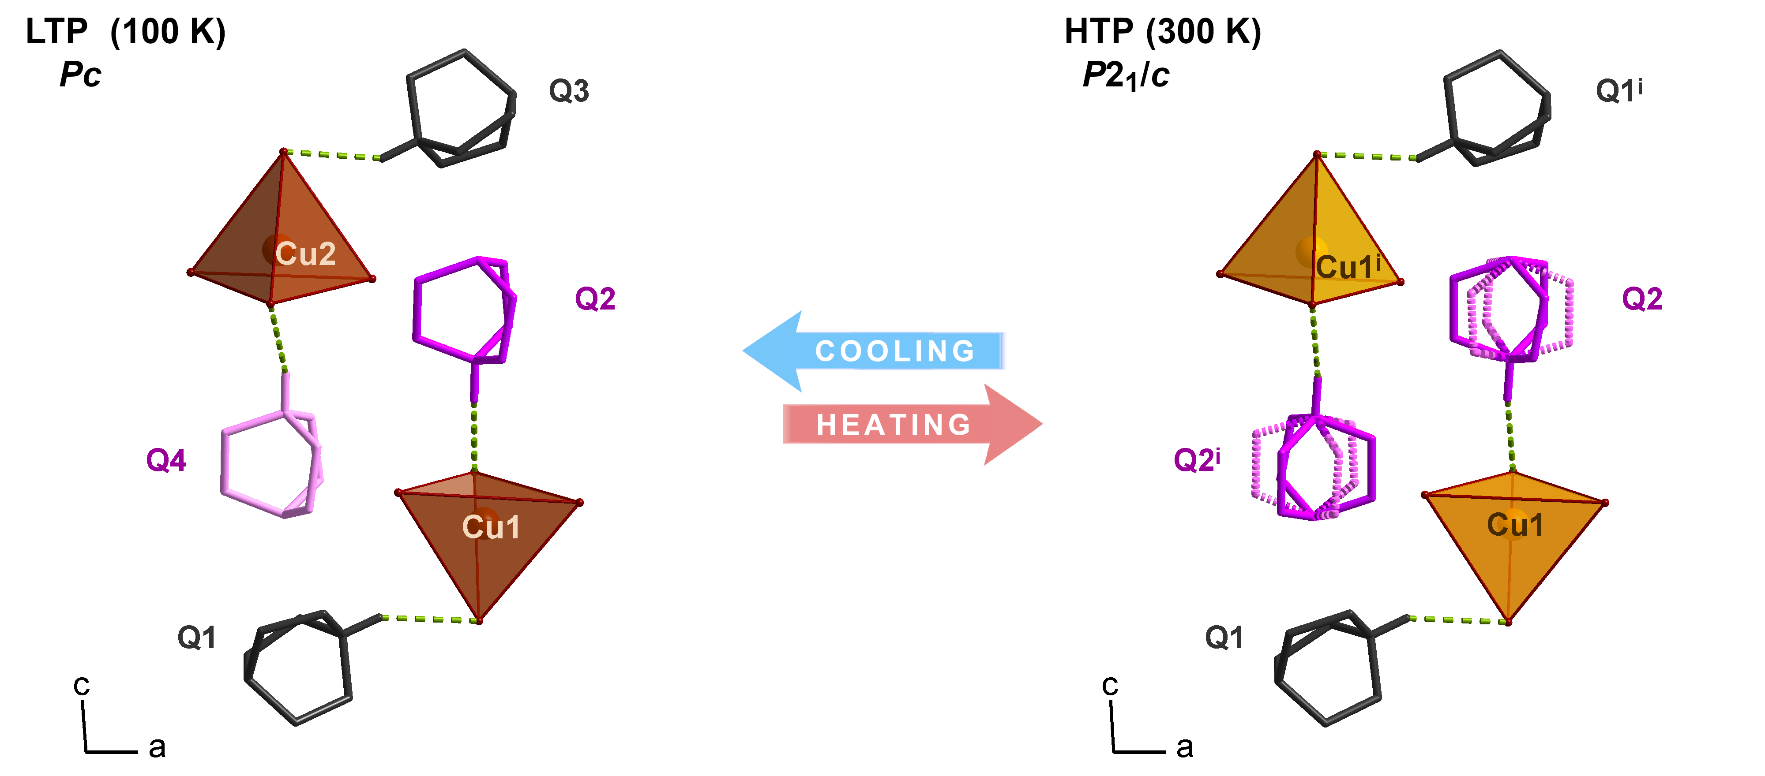

###### **Figure 1**. Fragment of Q2CuBr4 structure viewed along the *b*-axis, showing Q cation ordering across the phase transition. The Q ions are presented in two different colors to differentiate two positions. The disordered cations in are presented with dotted pink lines. For clarity, C—H hydrogen atoms are omitted. N—H···Br hydrogen bonds are marked with green dashed lines.

[1] Wojcik, N. A., Kowalska, D. A., Trzebiatowska, M., Jach, E., Ostrowski, A., Bednarski, W., Gusowski, M., Staniorowski, P.& Ciżman, A. (2021). *J. Phys. Chem. C* **125**, 16810-16818.

#### [2] Jach, E., Kowalska, D. A., Gusowski, M. A., Trzebiatowska, M., Krupinski, M., Medycki, W., Jędryka, J., Staniorowski, P. & Ciżman, A. (2023)., *J. Phys. Chem. C*. **127** (5), 2589-2602.

[3] Jach, E., Kowalska, D. A., Trzebiatiowska, M., Medycki, W., Ostrowski, A., Bednarski, W., Gusowski, M., Staniorowski, P., Bartoszewicz, A., Diu, U. & Ciżman, A. (2025). *Inorg. Chem.* **64**, 7422-7436.

[4] Ciżman, A., Kowalska, D. A., Trzebiatowska, M., Medycki, W., Krupiński, M., Staniorowski, P.& Poprawski, R. (2020) *Dalton Trans.* **49**, 10394-10401.

[5] Ciżman, A., Kowalska, D. A., Szarek, P., Medycki, W., Wójcik, N. A., Gusowski, M., Trzebiatowska, M., Bartosiewicz, A., Filevskaya, L., Staniorowski, P. & Jach, E. (submitted 2025).